
UNITED STATES
SECURITIES AND EXCHANGE COMMISSION
Washington, D.C. 20549

___________________________________

SCHEDULE 14A
(Rule 14a-101)
INFORMATION REQUIRED IN PROXY STATEMENT

SCHEDULE 14A INFORMATION

Proxy Statement Pursuant to Section 14(a) of the
Securities Exchange Act of 1934

(Amendment No. )

___________________________________

Filed by the Registrant ☒

Filed by a Party other than the Registrant

☐

Check the appropriate box:

- Preliminary Proxy Statement

- Confidential, for Use of the Commission Only (as permitted by Rule 14a-6(e)(2))

- Definitive Proxy Statement

- Definitive Additional Materials

- Soliciting Material Pursuant to §240.14a-12

Carter's, Inc.

(Name of Registrant as Specified In Its Charter)

Not applicable.
(Name of Person(s) Filing Proxy Statement, if other than the Registrant)

Payment of Filing Fee (Check the appropriate box):

- No fee required.

- Fee paid previously with preliminary materials.

- Fee computed on table in exhibit required by Item 25(b) per Exchange Act Rules 14a-6(i)(1) and 0-11.


April 4, 2025

Dear Shareholder,

It is my pleasure to invite you to attend our 2025 Annual Meeting of Shareholders on Wednesday, May 14, 2025 (the “Annual Meeting”). The meeting will be held in a virtual format.


The attached 2025 Notice of Annual Meeting of Shareholders and Proxy Statement describe the formal business to be conducted at the meeting. Whether or not you plan to attend the Annual Meeting, your shares can be represented if you promptly submit your voting instructions over the internet, by telephone, by completing, signing, dating, and returning your proxy card in the enclosed envelope, or by following the instructions you have received from your broker or other nominee.

On behalf of our Board of Directors and Leadership Team, thank you for your investment in Carter's, Inc.

Sincerely,

William J. Montgoris

Non-Executive Chairman of the Board
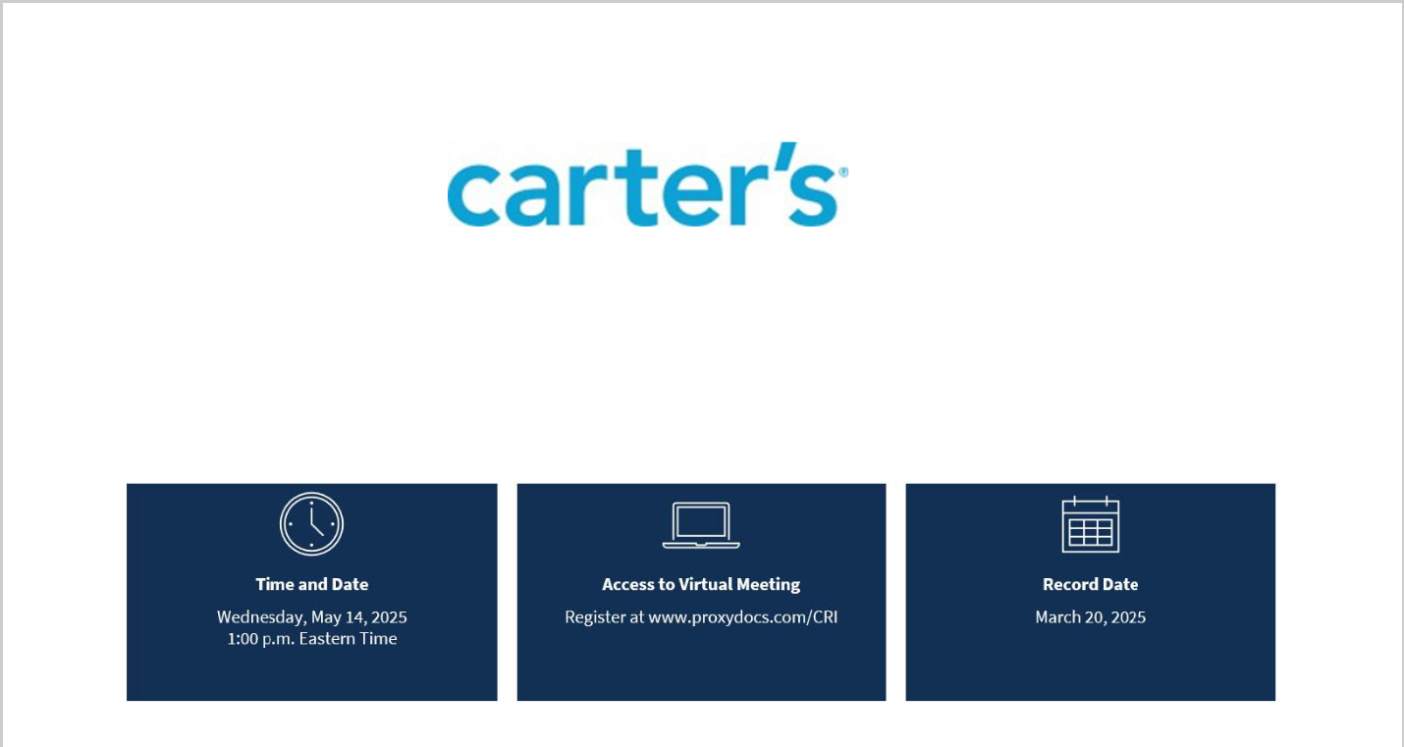

2025 NOTICE OF ANNUAL MEETING OF SHAREHOLDERS

This Meeting Notice highlights information described in other parts of this 2025 Proxy Statement and does not contain all information you should consider in voting. Please read the entire 2025 Proxy Statement carefully before
voting.

To our shareholders,

You are invited to attend our 2025 Annual Meeting to be held as follows in a virtual meeting format:

ITEMS OF BUSINESS

Item |  | Board's | Voting Approval | Effect of Abstention |  | Effect of Broker Non-
 |  | Recommendation | Standard |  |  | Vote
Election of 11 nominated |  | FOR | More votes “For” than | No effect |  | No effect
directors |  |  | "Against"
Advisory approval of |  | FOR | More votes “For” than | No effect |  | No effect
compensation of named |  |  | "Against"
executive officers
Ratification of |  | FOR | Majority of votes | No effect |  | Not applicable
appointment of |  |  | properly cast at the
PricewaterhouseCoopers |  |  | meeting
LLP for fiscal 2025

In addition, at the Annual Meeting we will conduct any other business that may properly come before the meeting. See Question 18 of the “Questions and Answers About the 2025 Annual Meeting” beginning on page 78 for more information.

PROXY SOLICITATION

The Board solicits the enclosed proxy for the 2025 Annual Meeting and any adjournment or postponement of the 2025 Annual Meeting. Any proxy may be revoked at any time prior to its exercise at the 2025 Annual Meeting.

VOTING

You may vote if you held shares of Carter's common stock as of the record date (March 20, 2025). You are able to vote your shares by providing instructions to the proxy holders who will then vote in accordance with your instructions. We urge you to read the 2025 Proxy Statement carefully and to vote in accordance with the recommendations of the Board.

QUESTIONS AND ANSWERS ABOUT THE 2025 ANNUAL MEETING

We encourage you to review the section "Questions and Answers About the 2025 Annual Meeting" for answers to common questions about the virtual meeting, proxy materials, voting, and other topics.

By order of the Board of Directors,

Secretary

Approximate Date of Mailing of Proxy Materials or Notice of Internet Availability:

April 4, 2025


TABLE OF CONTENTS

BOARD OF DIRECTORS AND CORPORATE GOVERNANCE INFORMATION | 2
PROPOSAL NUMBER ONE – ELECTION OF DIRECTORS | 26
COMPENSATION OF DIRECTORS | 27
EXECUTIVE OFFICERS’ BIOGRAPHICAL INFORMATION AND EXPERIENCE | 29
COMPENSATION DISCUSSION AND ANALYSIS | 34
COMPENSATION & HUMAN CAPITAL COMMITTEE REPORT | 52
COMPENSATION & HUMAN CAPITAL COMMITTEE INTERLOCKS AND INSIDER PARTICIPATION52
FISCAL 2024 SUMMARY COMPENSATION TABLE | 53
FISCAL 2024 GRANTS OF PLAN-BASED AWARDS | 55
OUTSTANDING EQUITY AWARDS AT FISCAL 2024 YEAR-END | 57
OPTION EXERCISES AND STOCK VESTED IN FISCAL 2024 | 59
NONQUALIFIED DEFERRED COMPENSATION | 60
POTENTIAL PAYMENTS UPON TERMINATION OR CHANGE OF CONTROL | 61
PAY RATIO DISCLOSURE | 64
PAY VERSUS PERFORMANCE DISCLOSURE | 65
TRANSACTIONS WITH RELATED PERSONS, PROMOTERS, AND CERTAIN CONTROL 69PERSON
SECURITIES OWNERSHIP OF CERTAIN BENEFICIAL OWNERS, DIRECTORS, AND EXECUTIVE70
OFFICERS
DELINQUENT SECTION 16 REPORTS | 72

PROPOSAL NUMBER TWO — ADVISORY VOTE ON APPROVAL OF EXECUTIVE COMPENSATIO73

 | AUDIT COMMITTEE REPORT | 74
 | PROPOSAL NUMBER THREE — RATIFICATION OF INDEPENDENT REGISTERED PUBLI75C
 | ACCOUNTING FIRM
 | OTHER MATTERS | 77
 | QUESTIONS AND ANSWERS ABOUT THE 2025 ANNUAL MEETING | 78
 | APPENDIX | 85


FORWARD-LOOKING STATEMENTS

Statements contained in this proxy statement that are not historical fact and use predictive words such as “estimates”, “outlook”, “guidance”, “expect”, “believe”, “intend”, “designed”, “target”, “plans”, “may”, “will”, “are confident” and similar words are forward-looking statements (as such term is defined in the Private Securities Litigation Reform Act of 1995). These forward-looking statements and related assumptions involve risks and uncertainties that could cause actual results and outcomes to differ materially from any forward-looking statements or views expressed in this proxy statement. These risks and uncertainties include, but are not limited to, those discussed in the subsection entitled “Risk Factors” under Part I, Item 1A, of our most recent Annual Report on 10-K, and otherwise in our reports and filings with the Securities and Exchange Commission, as well as the following factors: changes in global economic and financial conditions, and the resulting impact on consumer confidence and consumer spending, as well as other changes in consumer discretionary spending habits; risks related to public health crises; risks related to consumer tastes and preferences, as well as fashion trends; the failure to protect our intellectual property; the diminished value of our brands, potentially as a result

of negative publicity or unsuccessful branding and marketing efforts; delays, product recalls, or loss of revenue due to a failure to meet our quality standards; risks related to uncertainty regarding the future of international trade agreements; increased competition in the marketplace; financial difficulties for one or more of our major customers; identification of locations and negotiation of appropriate lease terms for our retail stores; distinct risks facing our eCommerce business; failure to forecast demand for our products and our failure to manage our inventory; increased margin pressures, including increased cost of materials and labor and our inability to successfully increase prices to offset these increased costs; continued inflationary pressures with respect to labor and raw materials and global supply chain constraints that have, and could continue, to affect freight, transit, and other costs; fluctuations in foreign currency exchange rates; unseasonable or extreme weather conditions; risks associated with corporate responsibility issues; our foreign sourcing arrangements; a relatively small number of vendors supply a significant amount of our products; disruptions in our supply chain, including increased transportation and freight costs; our ability to effectively source and manage inventory; problems with our Braselton, Georgia distribution facility; pending and threatened lawsuits; a breach of our information technology systems and the loss of personal data or a failure to implement new information technology systems successfully; unsuccessful expansion into international markets; failure to comply with various laws and regulations; failure to properly manage strategic initiatives; retention of key individuals; acquisition and integration of other brands and businesses; failure to achieve sales growth plans and profitability objectives to support the carrying value of our intangible assets; our continued ability to meet obligations related to our debt; changes in our tax obligations, including additional customs, duties or tariffs; our continued ability to declare and pay a dividend; volatility in the market price of our common stock; and the cost or effort required for our shareholders to bring certain claims or actions against us, as a result of our designation of the Court of Chancery of the State of Delaware as the sole and exclusive forum for certain types of actions and proceedings. Except for any ongoing obligations to disclose material information as required by federal securities laws, the Company does not undertake any obligation to publicly update or revise any forward-looking statements, whether as a result of new information, future events, or otherwise. The inclusion of any statement in this proxy statement does not constitute an admission by the Company or any other person that the events or circumstances described in such statement are material.



1


BOARD OF DIRECTORS AND CORPORATE GOVERNANCE INFORMATION

Each of our directors stands for election annually and thereafter holds office for a one-year term. At our Annual Meeting, we are asking our shareholders to elect the 11 proposed nominees set forth below, including Douglas C. Palladini, who was appointed as our Chief Executive Officer & President and a member of the Board of Directors effective April 3, 2025. The following table and charts show the committee assignments of each of our independent director nominees, information regarding the composition of Carter's Board of Directors (the “Board”), the definition of skills used for our Board skills matrix, the Board skills matrix, and a chart showing the skills and experience held by the Board.

 |  |  | Compensation | Nominating & | Business
Director |  | Audit | & Human | Corporate | Business
Director |  | Audit | & Human | Corporate | Transformation
 |  |  | Capital | Governance | Transformation
Rochester Anderson, Jr. |  |  | •
Jeffrey H. Black |  | •
Hali Borenstein |  |  |  | • | •
Luis Borgen |  | • | •
Jevin S. Eagle |  |  | ℂ
Mark P. Hipp |  | • | •
William J. Montgoris |  |  |  | ℂ
Stacey S. Rauch |  | • |  | • | •
Gretchen W. Schar |  | ℂ |  |  | •
Stephanie P. Stahl |  |  | • | • | ℂ
 | ℂ = Chair |  | • = Member

2


DIRECTOR SKILLS MATRIX

The Board believes that the combination of backgrounds, skills, and experiences collectively possessed by the members of the Board well-qualifies the Board to exercise oversight responsibilities on behalf of our shareholders in light of Carter's current and future strategic plans. The following tables describe the key skills and definitions of those skills, a breakdown of the number of directors that hold each skill, and the self-identified skills for each independent member of our Board nominated for election at the 2025 Annual Meeting. We use the general Board membership criteria listed in our Corporate Governance Principles, along with the desired skills and qualifications listed in the following tables, to identify, screen, and recruit director candidates and make director nomination recommendations to the full Board.

Skill Definitions

Senior

Leadership

Governance

Retail Industry Experience

Consumer Strategy

Digital /

Technology

Financial

Expertise

HR and Talent Management

ESG

International Expansion

Global Supply

Chain

Experience in an executive officer role

Public company board experience, including more than three years on Carter's board

Executive officer level experience or service on the board of directors at a retail and/ or consumer products company

Executive officer level experience in marketing, brand management, consumer insights, and brand strategy, or service on the board of directors of a retail or consumer products company

Executive officer experience with technology, digital platforms and new media, data security, and data analytics; or service on the board of directors of a digital platforms, digital media, data security, or data analytics company

Expertise with financial reporting, accounting, risk management, and capital allocation. Qualifies as an audit committee financial expert as defined under SEC and NYSE rules

Executive or board level experience in managing large workforce and/or experience with executive compensation, employee engagement, and Chief Executive Officer (“CEO”) succession

Executive officer or board level experience with relevant environmental, social, and governance (“ESG”) matters

Executive officer or board level experience in managing business operations and growth in global markets

Executive officer or board level experience with a company with global supply chain operations

3


SKILLS AND EXPERIENCE

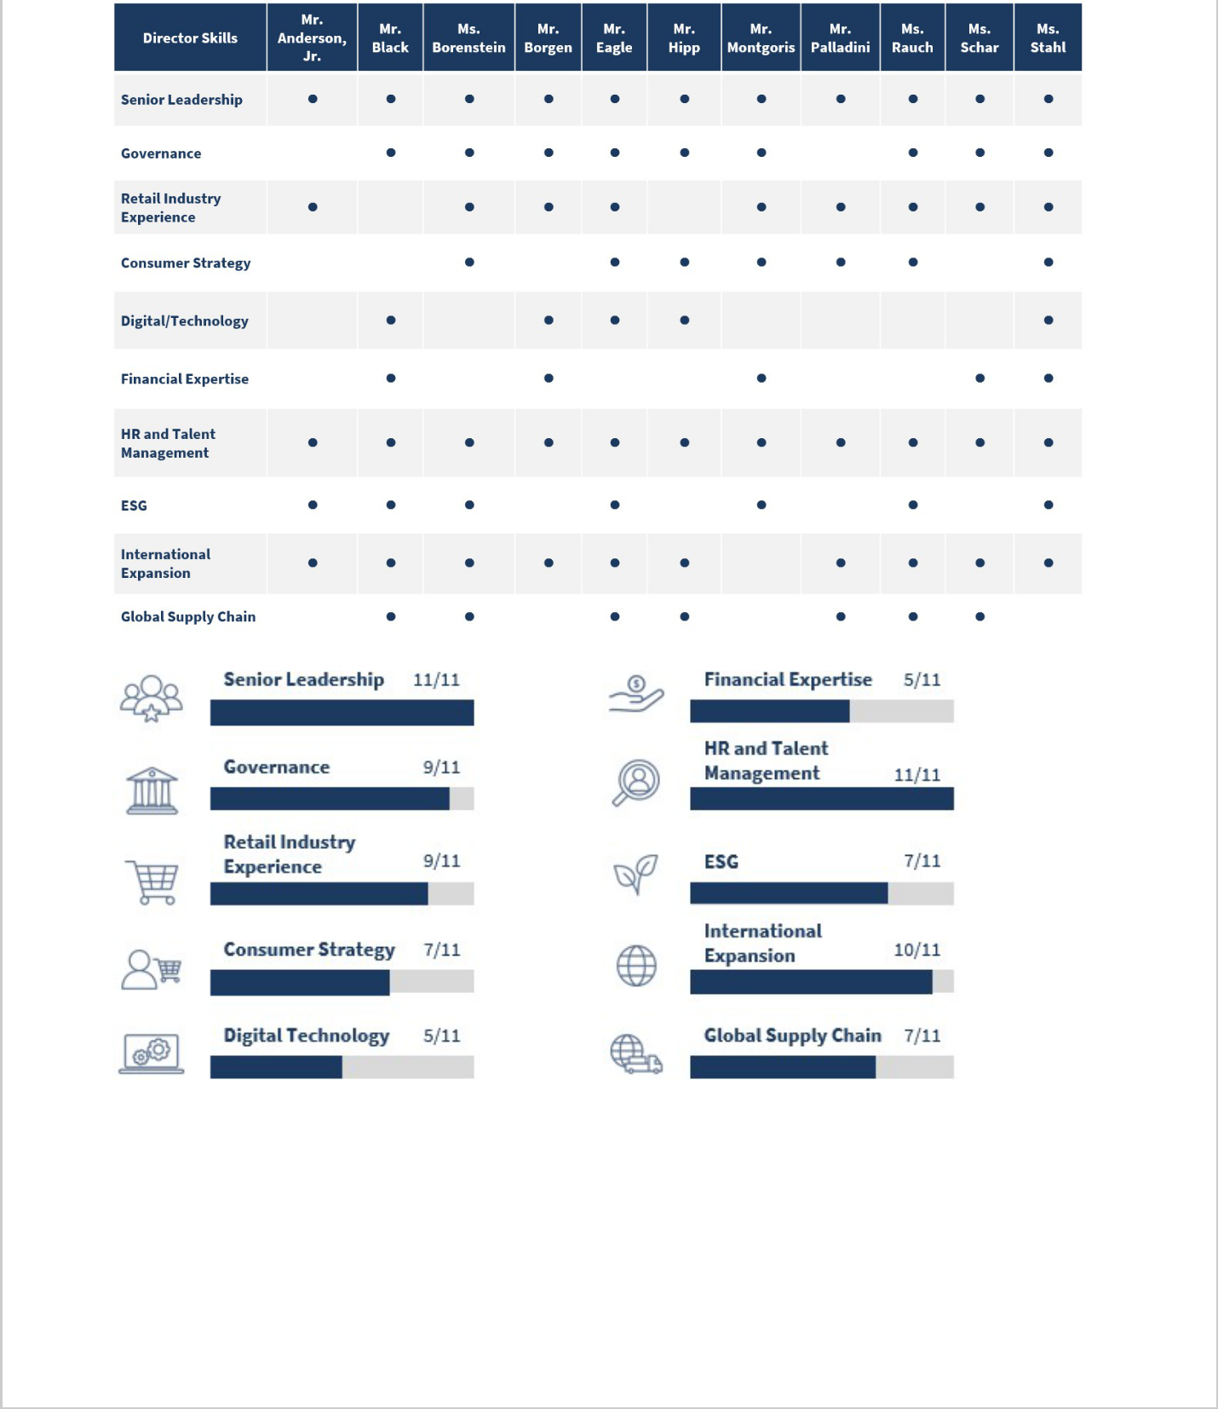

4


2025 NOMINEES FOR DIRECTOR

After considering the recommendations of the Nominating & Corporate Governance Committee, the Board has set the number of directors at 11 and nominated all current directors to stand for re-election. Mr. Casey retired as an officer and director in January 2025 and is not standing for re-election, and Mr. Palladini was appointed to the Board on April 3, 2025 and is standing for re-election. The Board believes that each of the nominees is qualified to serve as a director of Carter's and, in addition to the skills listed in the table on page 4, certain key qualifications of each nominee that were considered by the Board follow each nominee’s biographical description.

We believe that all nominees will be able and willing to serve if elected. However, if any nominee should become unable or unwilling to serve for any reason, proxies may be voted for another person nominated as a substitute by the Board, or the Board may reduce the number of directors.

WILLIAM J. MONTGORIS

Non-Executive Chairman Director since 2007 Age:78

Committee:

- Nominating & Corporate Governance (Chair)

Prior Public Company Directorships:

- Stage Stores, Inc. (2004 to 2020, serving as Chair of Board from 2010 to 2020)

William J. Montgorisretired as Chief Operating Officer of The Bear Stearns Companies, Inc. (“Bear Stearns”) in 1999, a position he held since August 1993, after spending 20 years with the company. While at Bear Stearns, Mr. Montgoris also served as the company’s Chief Financial Officer from April 1987 until October 1996. Mr. Montgoris is a trustee of the Hackensack Meridian School of Medicine and a trustee emeritus of Colby College and St. John’s University.
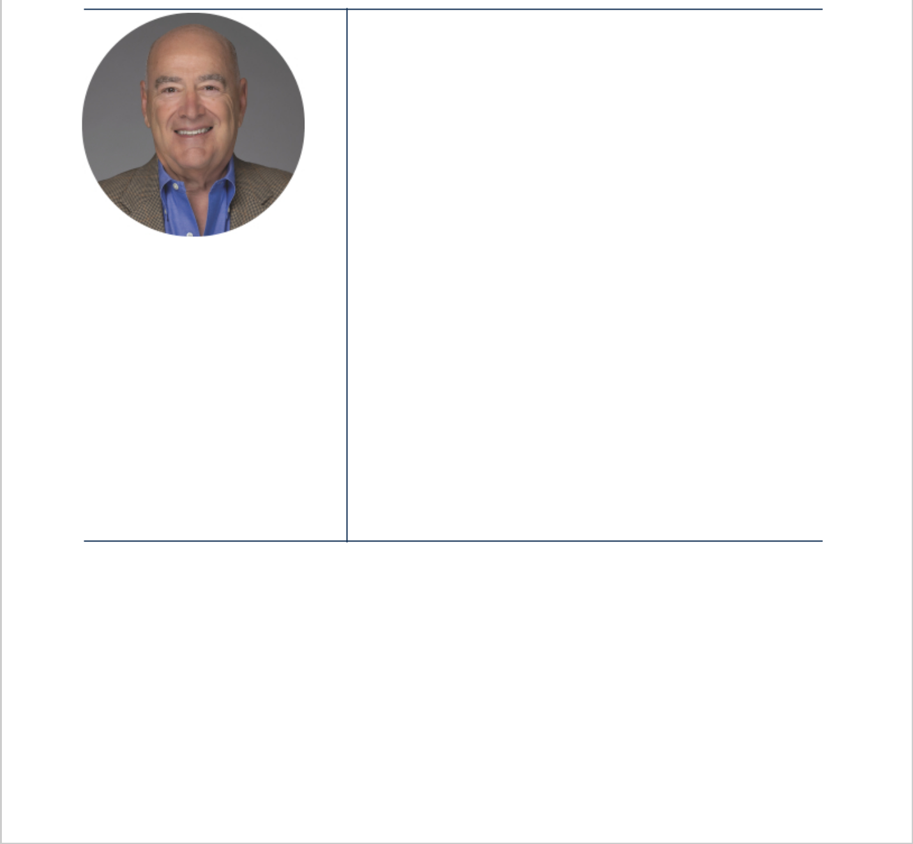

Director Qualifications:

- Valuable perspectives and insights with respect to finance and accounting after spending over 20 years in the investment banking industry. His financial expertise provides our Board a deep understanding of financial and audit-related matters

- Valuable insight with respect to the retail industry and the oversight of public companies

5


ROCHESTER ANDERSON, JR.

Independent Directorsince 2022 Age:63

Committee:

- Compensation & Human Capital

Rochester Anderson, hasJr. over 30 years of human resources and operational experience at various public and private corporations, including more than 15 years of experience leading human resource organizations and more than 15 years of operational experience with public and private corporations and non-profit organizations. Mr. Anderson is currently Chief Human Resources Officer, Emory Healthcare, which he joined in September 2022. Previously, from February 2020 to September 2022, Mr. Anderson served as Chief Human Resources Officer of AutoNation, Inc., a publicly-traded company and the nation’s largest automobile dealer with over 21,000 associates, working in over 400 locations across 18 states.

Mr. Anderson previously served as Senior Vice President, People Solutions for the Financial Industry Regulatory Authority, from May 2019 to February 2020, and served from 2006 to 2018 in various human resource focused and operational roles at Cox Automotive Inc., including serving as Chief Human Resources Officer and Executive Vice President from 2014 to 2018. Mr. Anderson’s experience focuses on human capital management, career development and training, operational management, and diversity and inclusion.

Director Qualifications:


- Significant human capital management, organizational improvement, compensation and benefits, and executive management experience
- Valuable insights into workforce dynamics, diversity, equity and inclusion, and executive development
- Substantial operational experience in retail and consumer-focused businesses

6
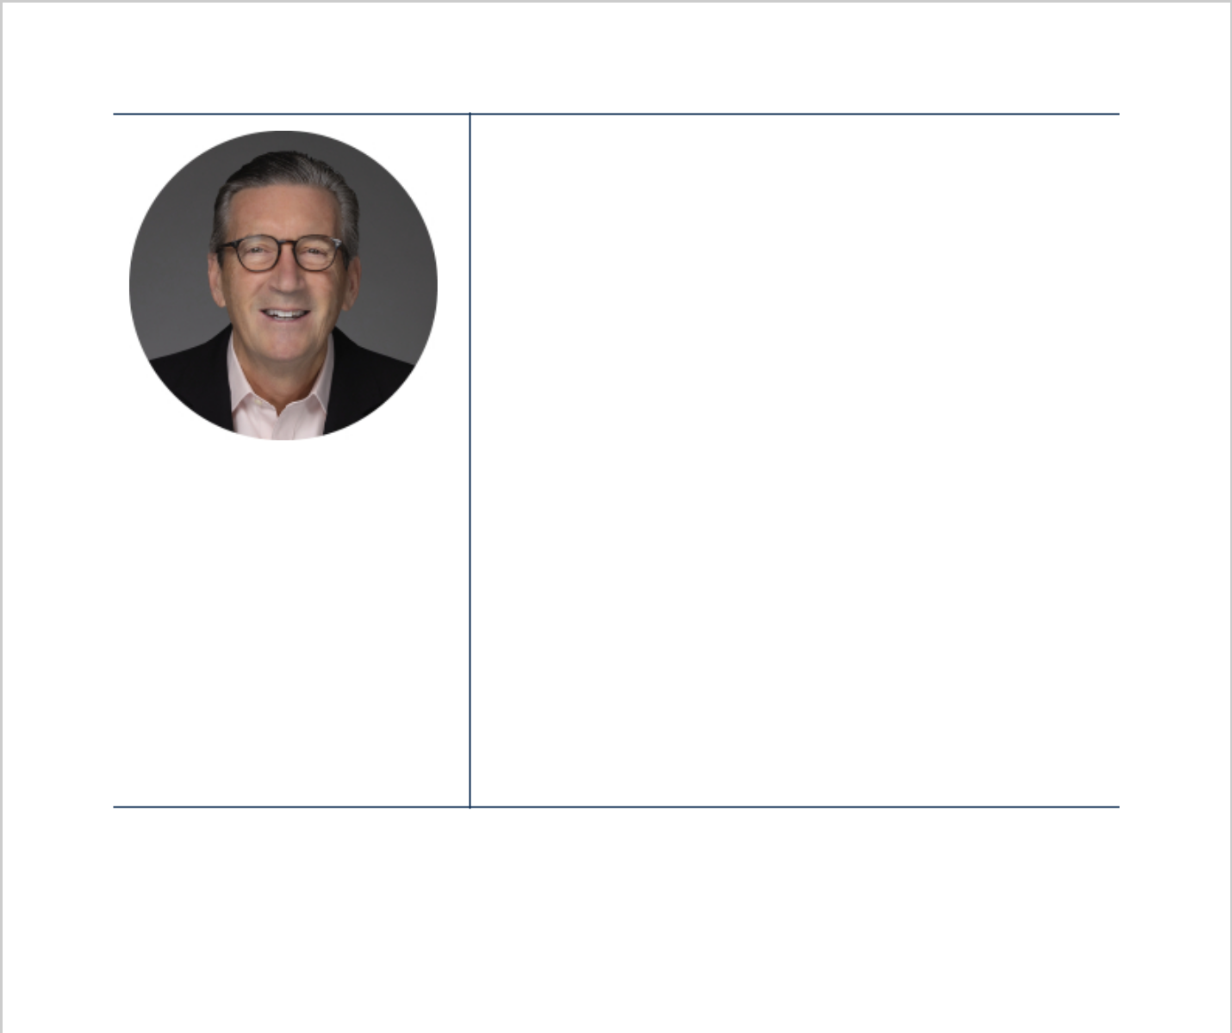

 | Jeffrey H. Blackserved as Senior Partner and Vice Chairman of
 | Deloitte LLP from 2002 to 2016 and as Partner-in-Charge of
 | Arthur Andersen LLP’s Metro New York audit practice from 1988
 | to 2002. Mr. Black has 40 years of experience leading teams
 | serving those firms’ largest and most complex global clients.
 | Director Qualifications:
 | • Significant accounting, financial reporting, and executive
 | leadership experience, as well as valuable insights into risk
 | and crisis management and oversight of publicly-traded,
 | global businesses
JEFFREY H. BLACK | • Valuable experience in cyber and information governance
JEFFREY H. BLACK | oversight and has earned a Computer Emergency Readiness
Independent Directorsince 2022 | Team (“CERT”) Certificate in Cybersecurity Oversight issued by
Independent Directorsince 2022 | the CERT Division of the Software Engineering Institute at
Age:70 | the CERT Division of the Software Engineering Institute at
Age:70 | Carnegie Mellon University, as well as the National
Committee: | Association of Corporate Directors master course in
• Audit | Cybersecurity
Other Public Company
Directorships:

- Otis Worldwide Corp. since 2020 (Chair, Audit Committee Member, Nominations and Governance Committee)

Hali Borensteinis the Chief Executive Officer of Reformation LLC, a women’s lifestyle brand focused on fashion and sustainability, a position she has held since June 2020. From December 2017 until June 2020, Ms. Borenstein was President of Reformation LLC, and from 2014 to 2017, Ms. Borenstein held various merchandising and design roles of increasing responsibility at Reformation LLC. Prior to joining Reformation

HALI BORENSTEIN

Independent Directorsince 2019 Age:40

Committee:

- Business Transformation
- Nominating & Corporate Governance

LLC, Ms. Borenstein was a senior merchandiser at Gymboree Group, Inc., and began her career at Bain & Company.


Director Qualifications:

- Deep strategic and leadership experience in a consumer-focused retail apparel business

- Valuable perspective and insight in eCommerce, brand marketing, sustainability, and retail businesses
- Expansive expertise in apparel marketing and merchandising

7


LUIS BORGEN

Independent Directorsince 2021 Age:55

Committees:

- Audit
- Compensation & Human Capital

Other Public Company Directorships:

- Eastern Bankshares, Inc., since 2016

- Synopsys, Inc., since 2022

Luis Borgenhas over 25 years of finance and operational experience at various public and private equity-backed companies. He was the Chief Financial Officer of athenahealth, Inc., a healthcare technology company from 2019 to 2022. Prior to that, he was Chief Financial Officer for Vistaprint, an e-commerce company that produces marketing products for small and microcap businesses, from 2017 to 2019. Prior to that, he served from 2012 to 2017 as Chief Financial Officer for DAVIDsTEA Inc., a specialty tea retailer in the United States and Canada that became publicly-traded in 2015, and from 2010 to 2012 he served as Chief Financial Officer of DaVita Inc. (“DaVita”), a publicly traded healthcare provider. Prior to DaVita, Mr. Borgen spent 13 years at Staples, Inc. culminating in his role as Senior Vice President Finance and Chief Financial Officer for the U.S. Retail division. Mr. Borgen began his career as an officer in the U.S. Air Force.

Director Qualifications:

- Broad experience in finance, accounting, capital markets, investor relations, M&A and international expansion
- Meaningful experience in the oversight of executive compensation, risk management, and corporate governance

- Substantial operational experience in retail and consumer-focused businesses



8


JEVIN S. EAGLE

Independent Directorsince 2010 Age:58

Committee:

- Compensation & Human Capital (Chair)

Jevin S. Eaglehas served as Professor of the Practice, Strategy and Innovation, and Executive Director of Social Impact Initiatives for Boston University’s Questrom School of Business since September 2022, and as Chief Executive Officer of Boston University Hillel since 2017. Mr. Eagle served as Chief Executive Officer and director of DAVIDsTEA Inc., a specialty tea retailer in the United States and Canada, from April 2012 to April 2014. Mr. Eagle previously held several senior leadership positions at Staples, Inc. from 2002 to 2012, including Executive Vice President, Merchandising and Marketing. Prior to joining Staples, Inc., Mr. Eagle worked for McKinsey & Company, Inc. from 1994 to 2001, ultimately serving as a partner in the firm’s retail practice.

Director Qualifications:

- Broad experience in a number of areas as the former Chief Executive Officer and director of DAVIDsTEA Inc. and Executive Vice President, Merchandising and Marketing of Staples, Inc., including retail, management, merchandising, sourcing, strategic planning, and brand marketing

- Valuable experience with developing strategies and programs for teaching social impact business education, including matters relating to environmental, social, and governance (“ESG” through his role as Professor and Executive Director of Social Impact Initiatives for Boston University's Questrom School of Business

- Meaningful experience in business strategy and the retail industry provides our Board with critical insights

9


 |  | Mark P. Hipphas been the Chief Executive Officer of H2IDD,
 |  | an advisory firm focused on public and private mergers and
 |  | acquisitions since January 2013. From November 2013 until
 |  | April 2017, Mr. Hipp was the operating partner at Sterling
 |  | Partners, a private equity firm. Prior to that, he spent over 28
 |  | years at Hewlett Packard Enterprise Company, most recently
 |  | as Vice President & General Manager, HP Software and Global
 |  | Networking Business Management.
 |  | Director Qualifications:
MARK P. HIPP |  | • Valuable perspective and insight with respect to issues
 |  | relating to information technology, including cybersecurity
Independent Directorsince 2018 |  | and eCommerce, as well as global supply chain and
 |  | logistics
Age:63 |  | • Meaningful experience in strategic growth transactions
Committees: |  | including through investments, strategic relationships, and
 |  | mergers and acquisitions
• | Audit
• | Compensation & Human
 | Capital

DOUGLAS C. PALLADINI

Director since 2025

Age:58

Douglas C. Palladinijoined Carter’s on April 3, 2025 as Chief Executive Officer & President and a member of the Board. Mr. Palladini served as the founder and owner of Kickstand, LLC, a consulting and advisory business focused on brand and consumer strategy, from April 2022 until March 2025. Prior to founding Kickstand, LLC, from June 2004 to March 2022, Mr. Palladini served in various roles of increasing responsibility at Vans, a subsidiary of V.F. Corporation, culminating in his role as Global Brand President of Vans from July 2016 through March 2022.

Director Qualifications:

- Deep experience with growing brands and consumer-driven strategies, and expertise in creating global brand connections

- Valuable perspective as an executive with decades of experience working in the retail and apparel industry and operating within multiple sales channels

10


Stacey S. Rauchis a Senior Partner Emeritus of McKinsey & Company (“McKinsey”). Ms. Rauch was a leader in McKinsey’s Retail and Consumer Goods Practices, served as Head of the North American Retail and Apparel Practice, and as Global Retail Practice Convener. A 24-year veteran of McKinsey, Ms.

STACEY S. RAUCH

IndependentDirector since 2022

Age:67

Committees:

- Audit

- Business Transformation
- Nominating & Corporate Governance

Other Public Company Directorships:

- Heidrick & Struggles International, Inc. since 2019

Prior Public Company Directorships:

- Ascena Retail Group (2017 to 2021)

- Land Securities Group PLC (2012 to 2021)
- Fiesta Restaurant Group, Inc. (2012 to 2023) (Chair from 2017 to 2023)

Rauch led engagements for a wide range of retailers, apparel

wholesalers, and consumer goods manufacturers in the U.S. and internationally. Ms. Rauch was a co-founder of McKinsey’s New Jersey office and was the first woman at McKinsey appointed as an industry practice leader. Since retiring from McKinsey, Ms. Rauch has served as a member or chair of various companies’ boards.

Director Qualifications:

- Strategic leadership expertise and deep experience in international business with a significant focus on the retail, apparel, and consumer goods industries

- Meaningful experience in the oversight of executive compensation, corporate governance, and financial reporting

11


GRETCHEN W. SCHAR

Independent Directorsince 2019 Age:70

Committee:

Gretchen W. Scharserved as Executive Vice President and

Chief Financial and Administrative Officer of Arbonne
International LLC, a beauty and nutritional products company,
from 2011 until 2018 and from 2008 until 2011 served as
Executive Vice President and Chief Financial Officer of
philosophy, inc., an international prestige beauty brand. Prior
to that, Ms. Schar spent over 30 years at The Procter & Gamble
Company in finance, general management, and global
operations roles of increasing responsibility.

Director Qualifications:

- Broad experience in finance, accounting, auditing and financial reporting, capital management, investor relations, and global operations
- Meaningful experience with strategic growth, including mergers and acquisitions

• | Audit (Chair) | • Significant public company board oversight experience,
• | Audit (Chair) | including in financial and accounting controls, public
• | Business Transformation
• | Business Transformation | company reporting, engagement with independent public
Other Public Company
 |  | accounting firms, corporate governance, and executive
Directorships: |  | compensation

- Cincinnati Financial Corp. since 2002

12


STEPHANIE P. STAHL

Independent Directorsince 2022 Age:58

Committees:

- Business Transformation (Chair)

- Compensation & Human Capital
- Nominating & Corporate Governance

Other Public Company Directorships:

Stephanie P. Stahlis currently a Senior Advisor and Executive Coach at the Boston Consulting Group (since 2022), and is a former Global Marketing & Strategy Officer of Coach, Inc, where she served from 2012 through 2015. She is the Founder of her investment and advisory company Studio Pegasus LLC, which she launched in 2015 to focus on supporting early-stage consumer ventures. Ms. Stahl previously held executive positions at several leading retail and consumer products companies and served as a Partner at The Boston Consulting Group from 1992 until 2003.

Director Qualifications:

- Significant experience in the retail/consumer sector including experience developing, executing, and optimizing major change initiatives including fundamental business transformations, mergers and acquisitions, and post-merger integrations

- Deep experience in marketing, data analytics, digital strategy, sustainability, brand building, and strategy

- Meaningful experience in the oversight of corporate governance, investor engagement, and ESG

- Dollar Tree, Inc., since 2018

- Newell Brands, Inc., since 2023
- Edgewell Personal Care Company, since 2024

Prior Public Company
Directorships:
- Knoll, Inc. (2013 to 2021)

13


BOARD LEADERSHIP STRUCTURE

Carter’s Corporate Governance Principles provide that the positions of Chairman and Chief Executive Officer may be combined if the non-management directors determine it is in the best interest of Carter's. While Carter's had previously combined the Chief Executive Officer and Chairman of the Board roles since 2009, in connection with Mr. Casey's retirement as an officer and director in January 2025, Mr. Montgoris, who has served as our Lead Independent Director since May 2022, was appointed as Non-Executive Chairman. The Board currently believes that a separate Chairman and Chief Executive Officer leadership structure is appropriate at this time to enable the Chief Executive Officer to focus on executing on the strategic direction and operation of the Company, while allowing the Non-Executive Chairman to focus on day-to-day management of Board matters. However, the Board may choose to change this separation of roles if it determines to be best for the Company under the then existing circumstances. Should the Chairman of the Board position be held by the CEO, the Board will appoint a lead independent director as required under the Company's Corporate Governance Principles.

DIRECTOR INDEPENDENCE

The New York Stock Exchange (“NYSE”) listing standards and Carter’s Corporate Governance Principles require a majority of Carter’s directors to be independent from Carter's and Carter’s management. For a director to be considered independent, the Board must determine that the director has no direct or indirect material relationship with Carter's. The Board considers all relevant information provided by each director regarding any relationships each director may have with Carter's or management. As a result of this review, our Board has determined that all of our current directors are independent and meet the independence requirements under the listing standards of the NYSE, the rules and regulations of the U.S. Securities and Exchange Commission (the “SEC”), and Carter’s Corporate Governance Principles.

BOARD AND COMMITTEE EVALUATIONS

The Board recognizes that a robust and constructive evaluation process is an essential component of good corporate governance and Board and committee effectiveness. Through this process, directors provide feedback and assess Board, committee and director performance, including areas where the Board believes it is functioning effectively and areas where the Board believes it can improve. The Board and the committees may, from time to time, engage outside third parties to help with this process.

In fiscal 2024, under the leadership of Mr. Montgoris, the Nominating & Corporate Governance Committee oversaw the Board’s annual evaluation process, which focused on the Board as a whole and each of the committees, as well as individual peer-to-peer assessments. These assessments were facilitated by Carter's legal department and included individual interviews with each director with

feedback given to each director.


RETIREMENT POLICY

Our Corporate Governance Principles include a retirement policy providing that each independent director’s retirement will be automatic at the annual meeting of shareholders following such director reaching the age of seventy-five (75), and no person shall be eligible for nomination or election as an independent director after reaching the age of seventy-five (75), subject to the following exceptions:

- In connection with Mr. Casey's retirement and Mr. Montgoris' appointment as Non-Executive Chairman, the Board approved an amendment to its Corporate Governance Principles to extend the retirement date for Mr. Montgoris to coincide with the annual meeting of shareholders following his seventy-ninth (79th) birthday (in 2026) to the extent he is still serving as a director at such time; and

14


- The Board may waive this policy with respect to an individual upon the recommendation of the Nominating & Corporate Governance Committee. A waiver may be granted on a case-by-case basis for any reasonable purpose including, but not limited to, the particular skills and experiences the director brings to the Board, the director’s past performance and ability to continue to constructively contribute going forward, and the then-current composition of the Board. The affected director shall not participate in any vote regarding the waiver if he or she is an incumbent director.

The Board determined that the above exception was appropriate in order to promote continuity of experience on the Board in the short- term by allowing Mr. Montgoris to serve beyond his seventy-fifth (75th) birthday if the Nominating & Corporate Governance Committee and the Board determine it is otherwise appropriate. More broadly, the Board, as recommended by the Nominating & Corporate Governance Committee, may use reasonable discretion to allow a director to serve past his or her seventy-fifth (75th) birthday in the future.


15


BOARD AND ANNUAL MEETINGS

Our Corporate Governance Principles require at least four regularly scheduled Board meetings each year, and each director is expected to attend each meeting. The Board held four regularly scheduled quarterly meetings during fiscal2024; and held eleven additional special meetings to discuss business developments and the overall strategy and performance of Carter's.

In fiscal 2024, no director participated in less than 75% of the aggregate number of all the Board and applicable committee meetings that they were eligible to attend.

Although Carter's does not have a policy regarding director attendance at annual meetings of shareholders, all directors are encouraged to attend the Annual Meeting. All of the directors then standing for election attended Carter’s virtual annual meeting of shareholders in fiscal2024.

EXECUTIVE SESSIONS

Executive sessions of non-management directors are held at least four times a year. Any non-management director can request that additional executive sessions be scheduled. The Non-Executive Chairman presides at the executive sessions of non-management directors.

BOARD COMMITTEES

Our Board has the following standing committees: the Audit Committee, the Compensation & Human Capital Committee, the Nominating & Corporate Governance Committee, and the Business Transformation Committee (formed in September 2024). The Board may also establish other committees to assist in the discharge of its responsibilities.

All members of each committee are independent directors. Each committee operates under a written charter, a current copy of which is available on the Investor Relations section of our website at ir.carters.com, or in print by contacting Mr. Robinson at Carter's address: 3438 Peachtree Road NE, Suite 1800, Atlanta, Georgia 30326. In fulfilling the oversight and other responsibilities delegated by the Board, each Committee:

- provides the Board with regular reports of its activities;

- has the sole authority to retain or terminate its consultants and other advisors;

- receives appropriate funding to pay for necessary resources and administrative expenses; and

- annually evaluates its performance.

16

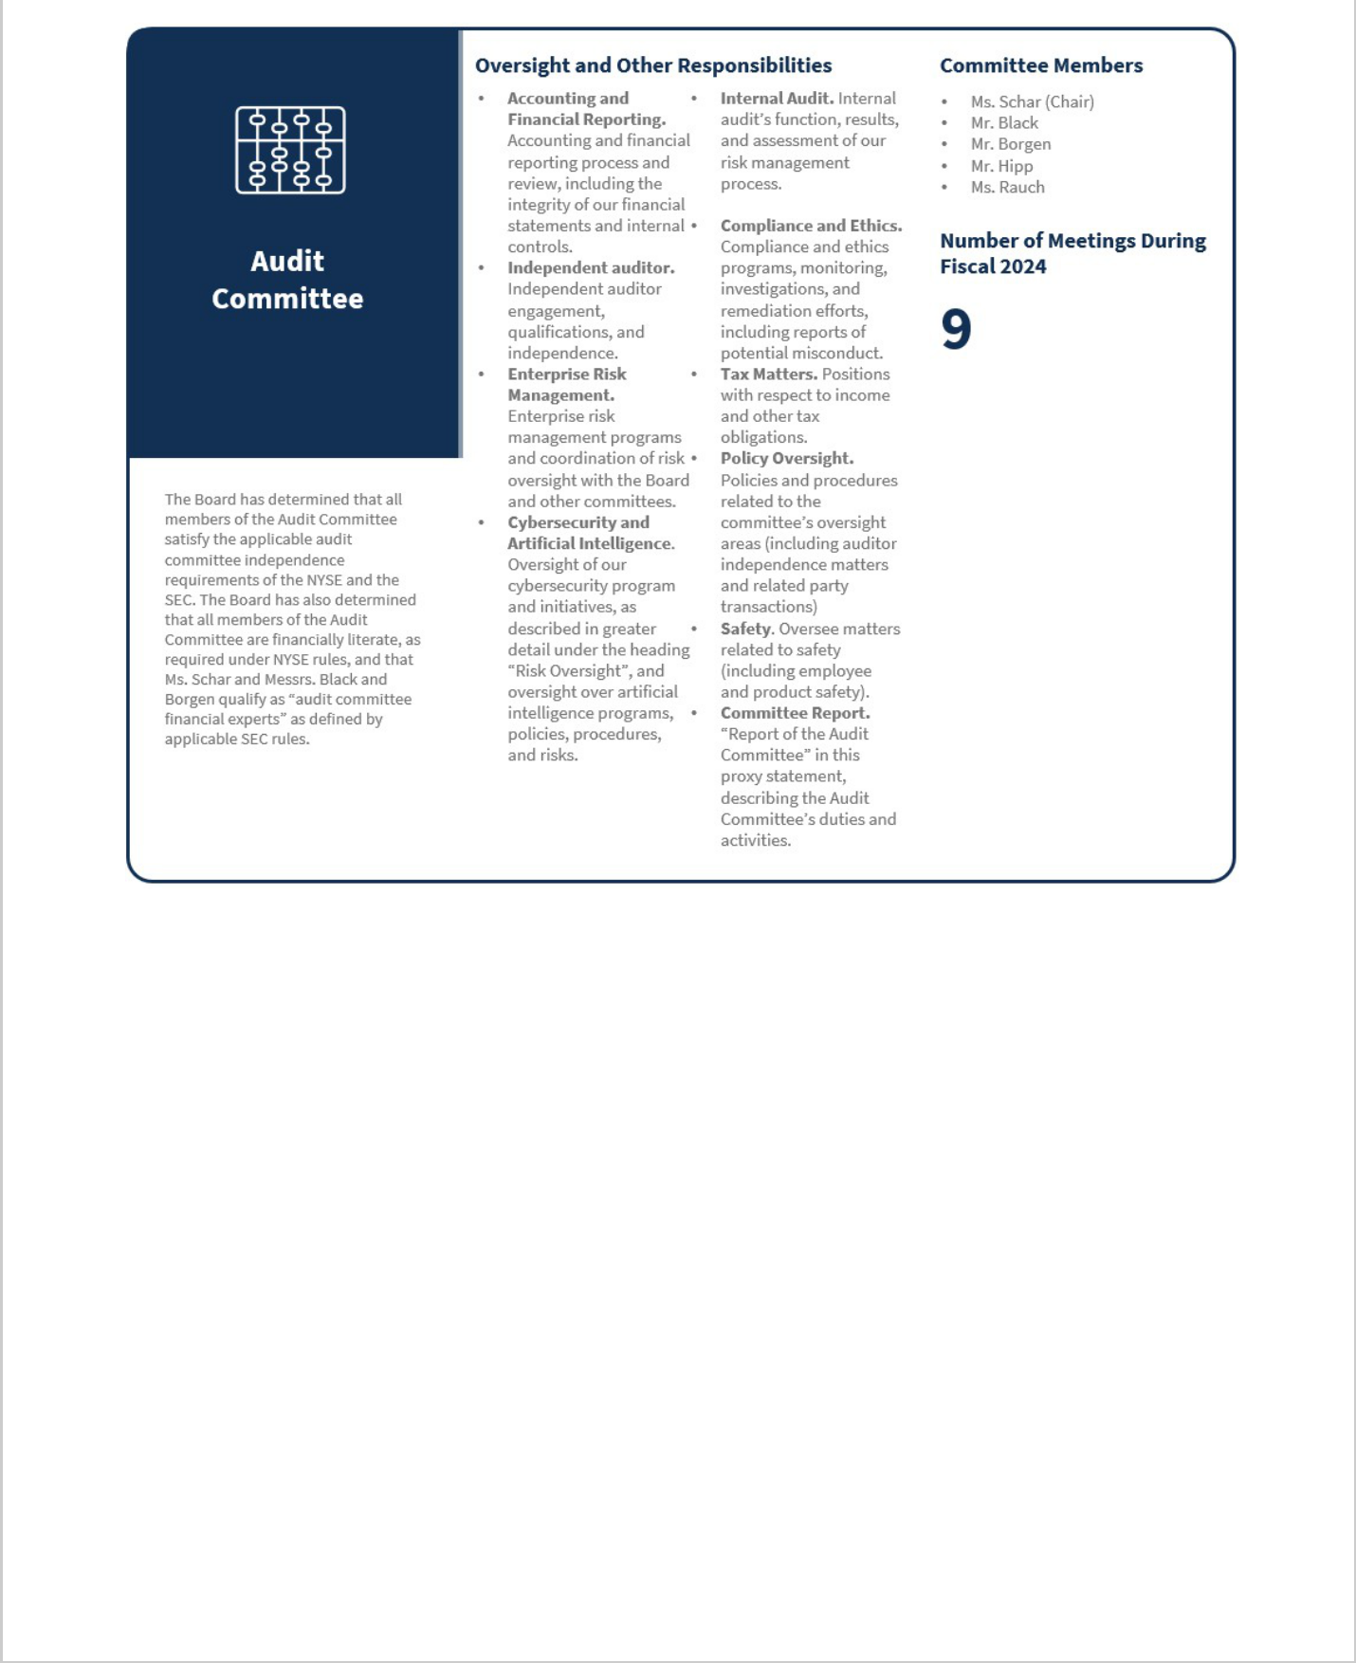

17


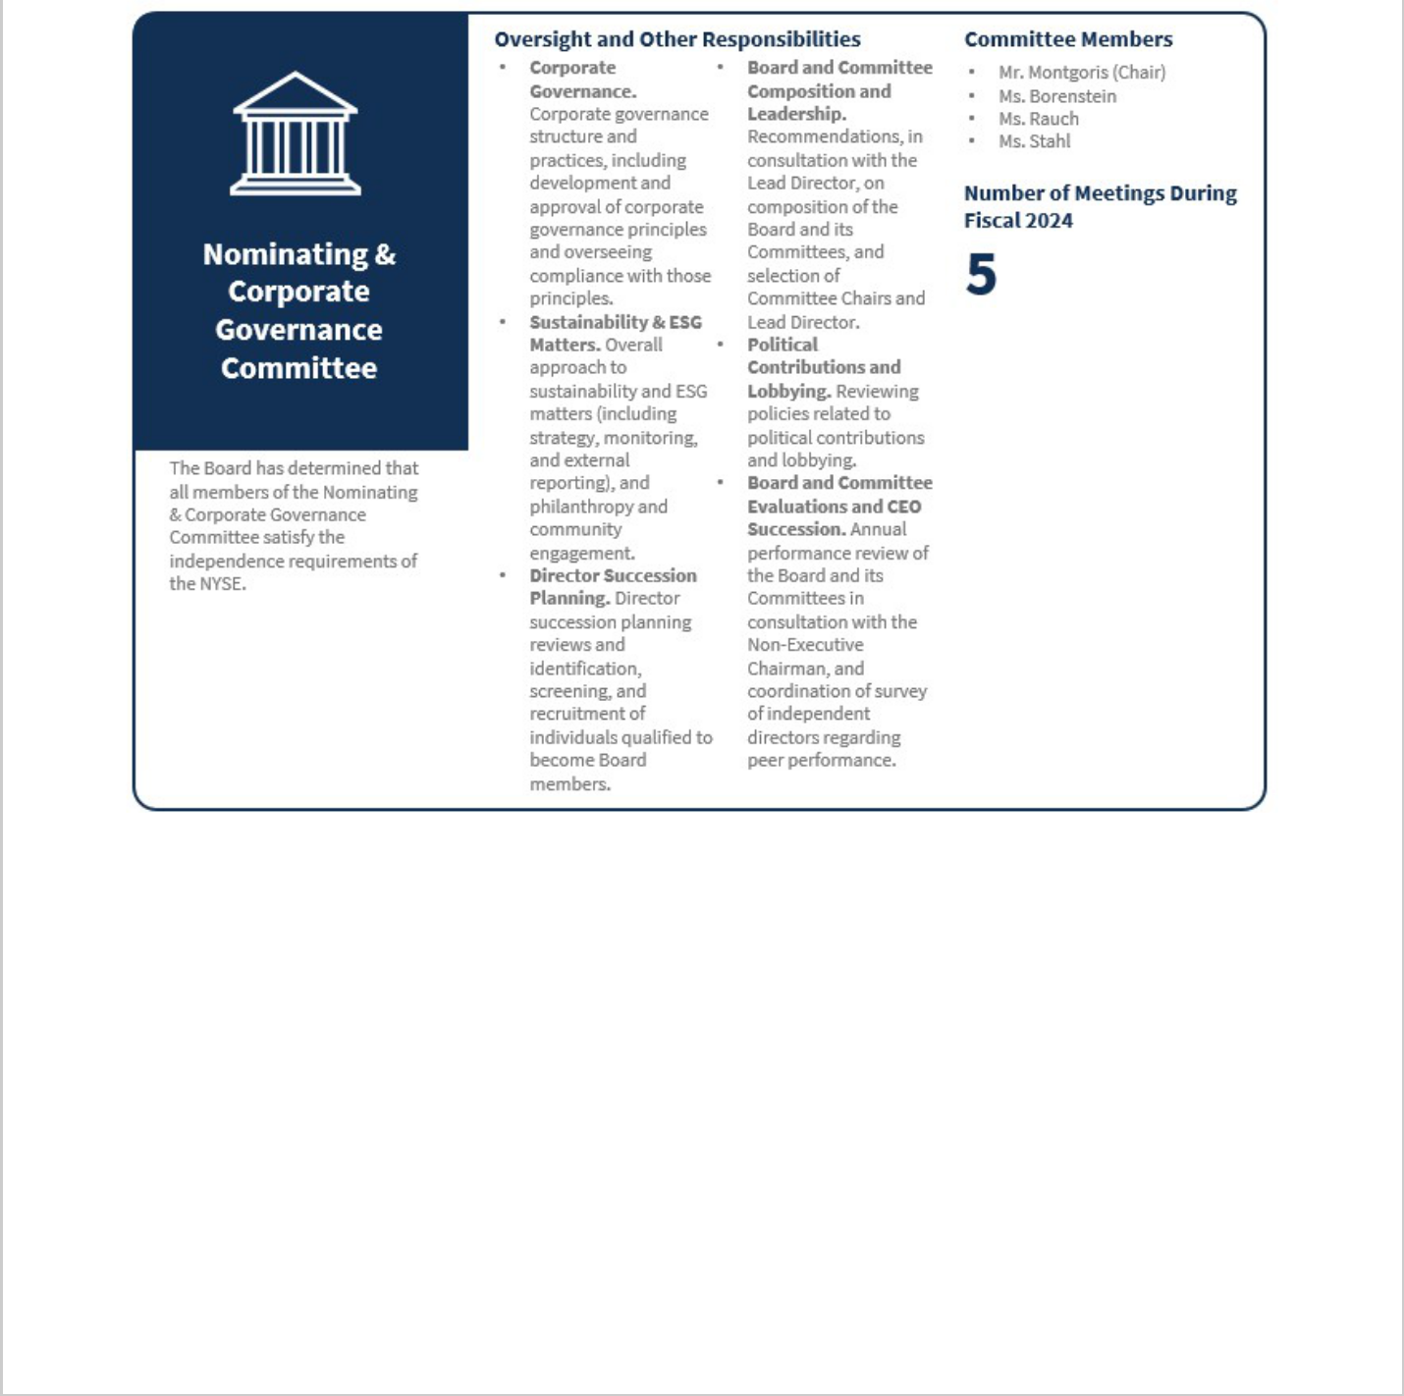

18


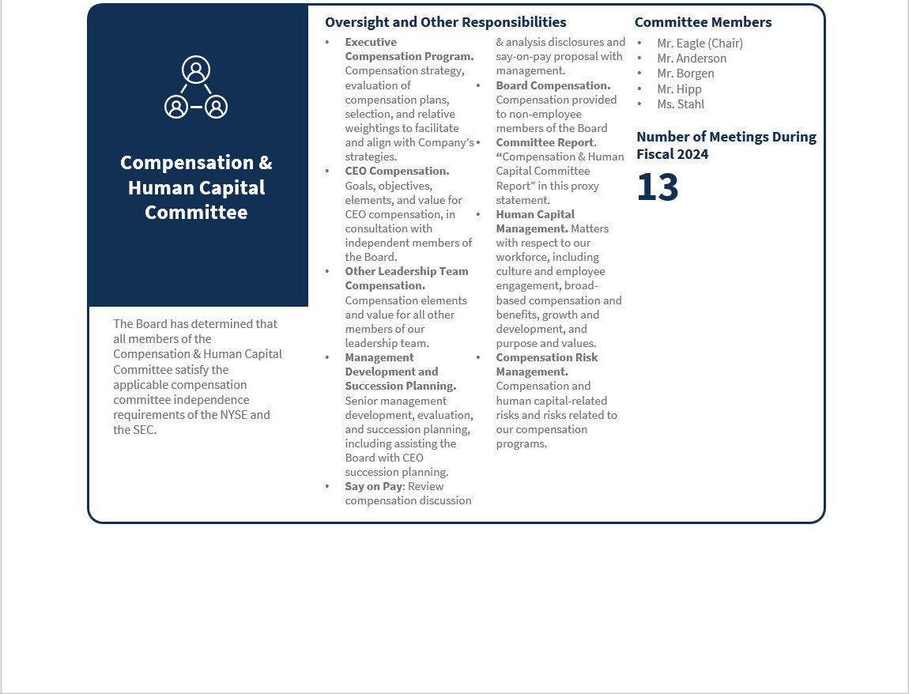

19
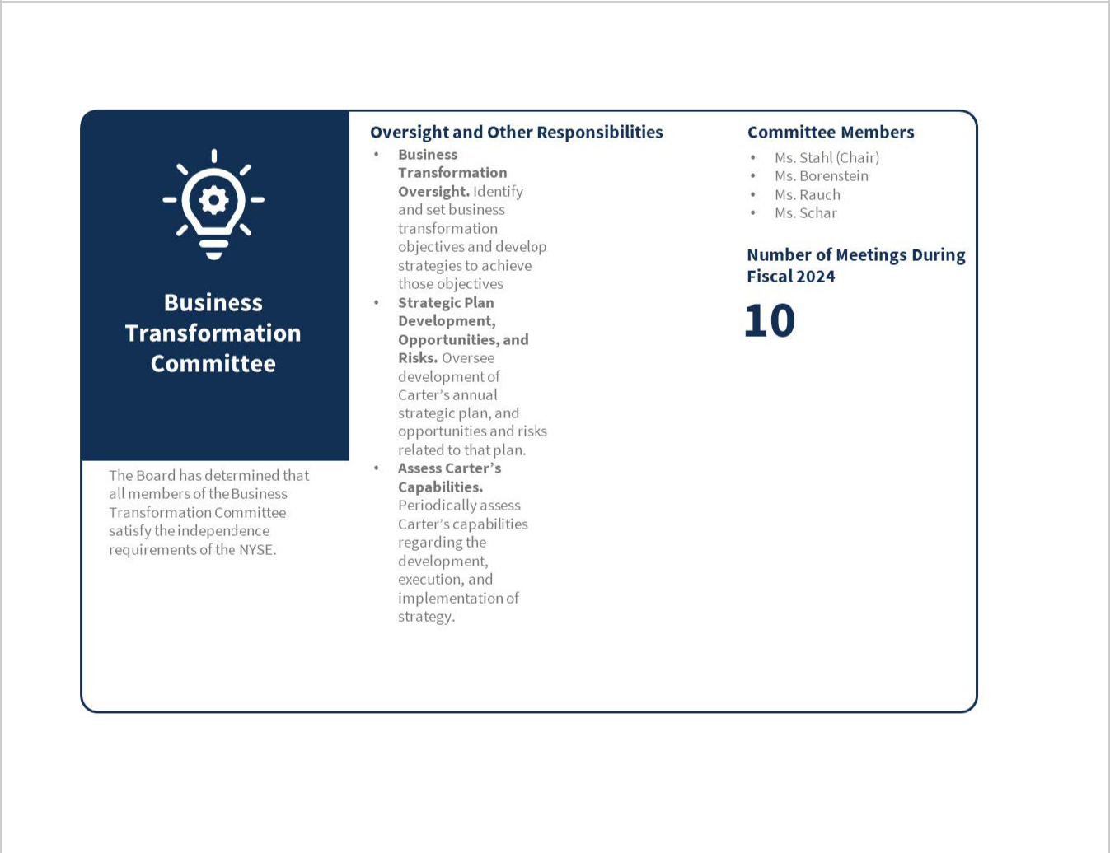



20


ELECTION NOMINATION PROCESS

Governance Principles

Our process for election of directors is based on the following core principles:

- All directors are elected annually.

- ”Majority Voting” standard for election of directors — each director in an uncontested election must receive more votes “For” his or her election than votes “Against” in order to be elected.

- A director nominee who is not re-elected under our majority voting standard must tender his or her resignation for consideration by the Board. The Nominating & Corporate Governance Committee is then required to make a recommendation to the Board as to whether it should accept or reject such resignation, and the Board must accept or reject the offer to resign and publicly disclose its decision within 90 days of the certification of the results of the election. In addition, pursuant to amendments to the Company's Corporate Governance Principles and Nominating & Corporate Governance Committee charter adopted in February 2025, the Board expects directors to ensure that their time commitments do not interfere with their duties and responsibilities as a director, and will consider a director candidate's time commitments when evaluating the potential candidate.

Board Membership Criteria and Identifying Candidates

Our Corporate Governance Principles outline the following criteria for Board membership:

- Our Nominating & Corporate Governance Committee shall include, in each director search, candidates who reflect diverse backgrounds, experiences, and points of view, including diversity of gender, race, and/or ethnicity.

- On an annual basis, the Nominating & Corporate Governance Committee shall review with the Board the appropriate skills and characteristics required of Board members in the context of the current composition of the Board and provide an assessment of the perceived needs of the Board at that point in time. The Nominating & Corporate Governance Committee's review may include consideration of all relevant factors, including the experience, integrity, diversity, and reputation of potential candidates.

Our leadership team and, occasionally, a third-party search firm, assist the Nominating & Corporate Governance Committee to identify candidates using the general Board membership criteria and current desired skills described in this proxy statement and Carter's Corporate Governance Principles. In addition, the Nominating & Corporate Governance Committee considers candidates who are recommended by shareholders, other Board members, and our leadership team against those same general Board membership criteria and desired skills.

Any shareholder who wants to recommend a director candidate for the Nominating & Corporate Governance Committee to consider nominating for the 2026 Annual Meeting should submit a written

request and related information to Mr. Robinson no later than December 31, 2025, in order to allow for sufficient time to consider the recommendation. Shareholders may also nominate director candidates directly if they comply with the procedures set forth in our amended and restated bylaws (“Bylaws”), which are described in more detail in Question 22 “How do I submit a proposal or nominate a director candidate for the 2026 Annual Meeting?” on page 83.

21
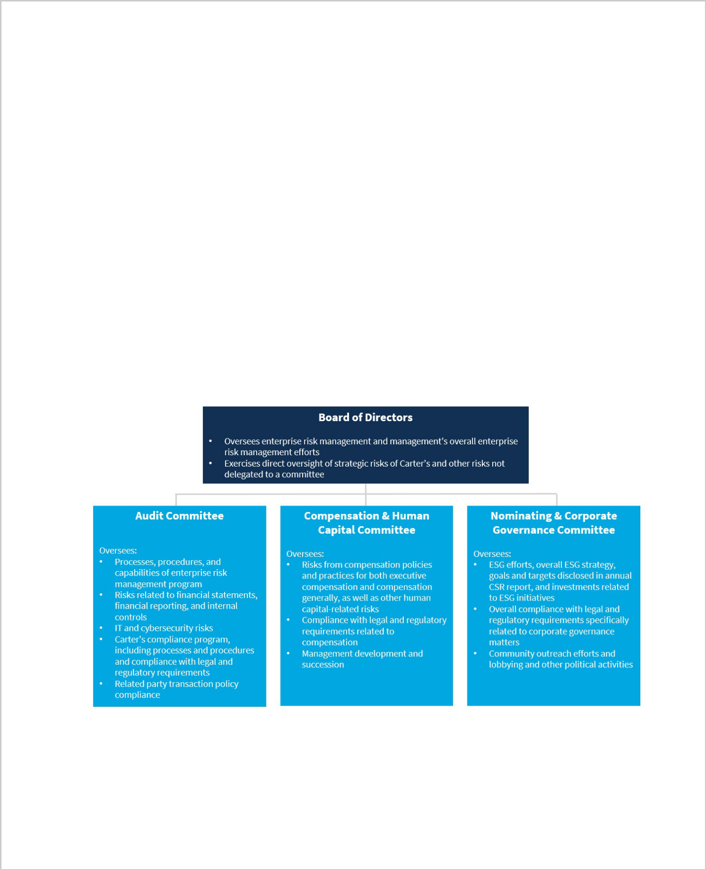

SHAREHOLDER COMMUNICATION WITH DIRECTORS

A shareholder or other interested party may submit a written communication to the Board, the Non-Executive Chairman, or other individual non-management directors. The submission should be delivered to Mr. Robinson at Carter's address:3438 Peachtree Road NE, Suite 1800, Atlanta, Georgia 30326.

The Board, the Non-Executive Chairman, or other non-management directors may require the submitting shareholder to furnish such information as may be reasonably required or deemed necessary to sufficiently review and consider the submission of such shareholder.

Each submission will be forwarded, without editing or alteration, to the Board, the Non-Executive Chairman, or individual non-management directors, as appropriate, at, or prior to, the next scheduled meeting of the Board. The Board or the Non-Executive Chairman, as appropriate, will determine, in their sole discretion, the method by which such submission will be reviewed and considered.

RISK OVERSIGHT

Oversight of the various risks we face is integral to the Board's oversight of our business. The Board, each of our committees, and management have specific roles and responsibilities with respect to those risks. Carter’s management is responsible for identifying, assessing, managing, and mitigating Carter’s strategic, financial, operational, and compliance risks. The chart below provides an overview of the Board’s and its committees’ risk oversight responsibilities.

The Board and its committees receive updates from senior management on relevant risks and management efforts in these areas at Board and committee meetings at least annually and more frequently, as appropriate.

Cybersecurity Oversight

The Audit Committee oversees risks from cybersecurity threats, including through quarterly reports to the Audit Committee by Carter’s Chief Information Security Officer (“CISO”) and Chief Information & Technology Officer (“CITO”) and, as needed, special reports to the Audit Committee and/or the

22

Chairperson of the Audit Committee. The Audit Committee includes members with technology and cybersecurity experience and certifications, including an Audit Committee member with over 28 years of experience working for Hewlett Packard Enterprise Company and an Audit Committee member with a Computer Emergency Readiness Team (“CERT”) Certificate in Cybersecurity Oversight issued by the CERT Division of the Software Engineering Institute at Carnegie Mellon University and completion of the National Association of Corporate Directors Master Course in Cybersecurity.

Management plays an integral role in assessing and managing the Company’s material risk from cybersecurity risks. The assessment and management of those risks is led by the Company’s CISO, who has over 20 years of experience working in information technology, including over 10 years specifically focused on information security, infrastructure, and strategy, and the Company’s CITO, who has over 30 years of experience in Retail, Consumer Products, Merchandising, and IT, of which 16 years have been in leadership roles, and implemented by the CISO’s team, who are responsible for leading enterprise-wide cybersecurity strategy, policy, standards, architecture, processes and operations. The CISO and CITO lead quarterly meetings of the Company’s Security Executive Steering Committee (the “Steering Committee”), which is composed of the Company’s Chief Financial Officer, General Counsel, and CITO. The Steering Committee drives awareness, ownership and alignment across broad governance and risk stakeholder groups for effective cybersecurity risk management and reporting.

Carter’s management maintains and implements a written Incident Response Plan, which is reviewed and updated on an annual basis and includes an Incident Response Plan Executive Committee consisting of Carter’s CITO, CISO, and General Counsel. In addition, members of the CISO’s and CITO’s teams monitor Carter’s systems and processes and promptly report incidents as required under the Incident Response Plan, including, but not limited to, reporting to the appropriate members of management and, as needed, the Audit Committee. We have been subject to cybersecurity incidents in the past, including within the last three years, and expect them to continue as cybersecurity threats evolve in sophistication. Although the aggregate impact of cybersecurity incidents has not been material to date, we cannot provide any assurances that such events will not occur and impacts therefrom will not be material in the future.

The Incident Response Plan has been developed to align with the four phases for the security handling lifecycle set forth in the National Institute for Standards and Technology Special Publication 800-61: (1) Preparation, (2) Detection & Analysis, (3) Containment Eradication & Recovery, and (4) Post-Incident Activity.

ESG Oversight

We believe a strong management team and governance are essential to demonstrating accountability and driving our desired results when it comes to important ESG matters, including climate change, product quality and safety, workers’ rights, product design and innovation, supply chain management, and employee engagement. The following is a high-level overview of oversight for ESG matters at our company.

23


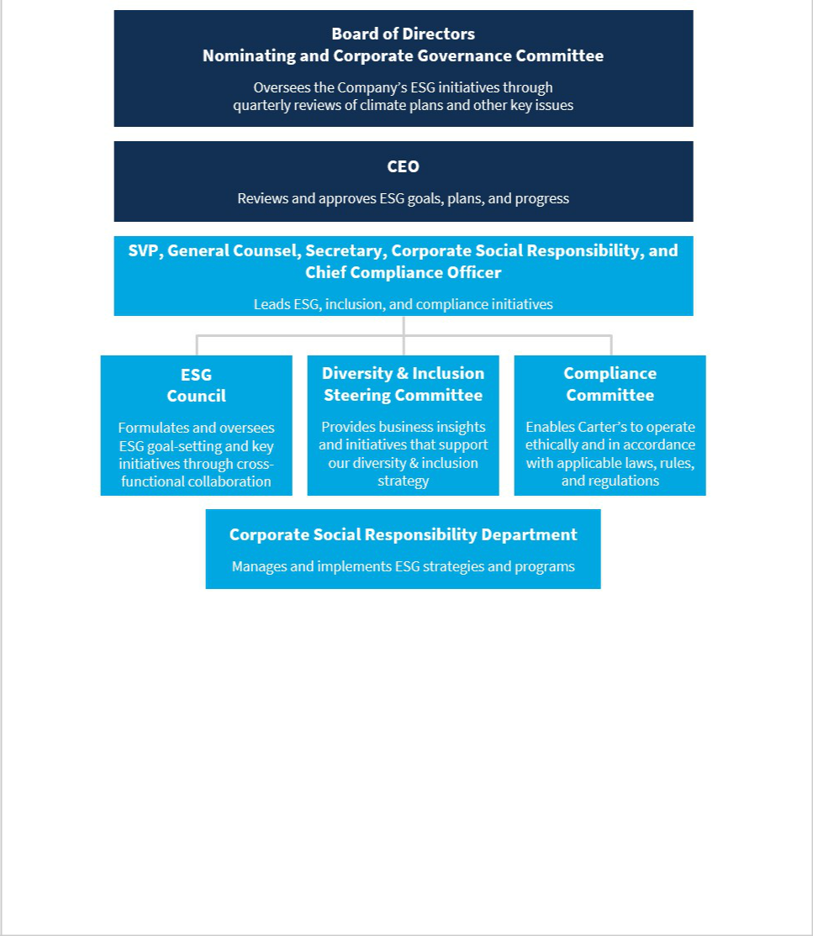

More information about our ESG efforts, including our latest sustainability report, can be found at esg.carters.com. This website and others referenced herein are not incorporated by reference into this proxy statement.

Compensation Program Risk Assessment

As part of its oversight role, the Compensation & Human Capital Committee considers the impact of our compensation program, policies and practices (both at the executive and below-executive levels) on Carter’s overall risk profile. Specifically, the Compensation & Human Capital Committee reviews Carter’s compensation policies and practices, discusses and reviews whether the incentive compensation arrangements promote appropriate approaches to the taking and management of risk, and, specifically, do not encourage executive officers to take unnecessary and excessive risks. We believe that our pay program provides an effective balance in cash and equity and a mix of short- and longer-term performance periods and also requires the Compensation & Human Capital Committee to approve payouts. Based on the Compensation & Human Capital Committee’s most recent review, the Compensation & Human Capital Committee determined that the risks arising from Carter’s compensation policies and practices are not reasonably likely to have a material adverse effect on

24


Carter’s.

CORPORATE GOVERNANCE PRINCIPLES AND CODE OF ETHICS

Carter's is committed to conducting its business with the highest level of integrity and maintaining the highest standards of corporate governance. Our Corporate Governance Principles and Code of Ethics provide the structure within which our Board and management operate Carter’s. Our Code of Ethics applies to all directors and Carter’s employees. Our Corporate Governance Principles and Code of Ethics are available in the Investor Relations section of our website at ir.carters.com or in print by contacting Mr. Robinson at Carter’s address set forth in the2025 Notice of Annual Meeting.



25


PROPOSAL NUMBER ONE — ELECTION OF DIRECTORS

The Board proposes that the following 11 director nominees be elected to the Board to serve until the next annual meeting in 2026, or until his or her earlier resignation, death, or removal. Each nominee is listed below, along with their age as of the date of the Annual Meeting. For more information about each of the director nominees, including individual biographies. Please see “Board of Directors and Corporate Governance Information—2025 Nominees for Director.”

Name | Age
Rochester Anderson, Jr. | 63
Jeffrey H. Black | 70
Hali Borenstein | 40
Luis Borgen | 55
Jevin S. Eagle | 58
Mark P. Hipp | 63
William J. Montgoris | 78
Douglas C. Palladini | 58
Stacey S. Rauch | 67
Gretchen W. Schar | 70
Stephanie P. Stahl | 58


The Board recommends a vote FOR the election of each of the director nominees listed above.

VOTE REQUIRED

Pursuant to our Bylaws and our Corporate Governance Principles, the number of votes properly cast “for” a director nominee must exceed the aggregate number of votes cast “against” that nominee for that nominee to be elected. Abstentions and broker non-votes will be counted towards a quorum.

Abstentions and broker non-votes will not have any impact on the outcome of this vote.

Any nominee who is an existing director who does not receive a majority of votes cast “for” their election is required to tender his or her resignation for consideration by the Board. The Nominating and Corporate Governance Committee is then required to make a recommendation to the Board as to whether it should accept or reject such resignation. The Board, taking into account such recommendation, will decide whether to accept such resignation. The Board’s decision will be publicly disclosed within ninety (90) days after the results of the election are certified. A director whose resignation is under consideration shall abstain from participating in any recommendation or decision regarding his or her resignation. If the resignation is not accepted, the director will continue to serve until the next annual meeting of shareholders and until such director’s successor is elected and qualified.

26


COMPENSATION OF DIRECTORS

When they are initially appointed to the Board, each of our non-management directors receives a one-time restricted stock grant, equal to the value of the annual retainer, that cliff vests after three years. Thereafter, each of our non-management directors receives an annual cash retainer and an annual stock award, and each of our committee chairpersons and our Non-Executive Chairman receives an additional annual retainer. Non-management directors also receive fees for each meeting they attend.

For fiscal2024, each director’s annual retainer was comprised of a cash payment of $90,000 (increased from $85,000 in 2023) and an immediately vested grant of our common stock valued at approximately $160,000. In addition to the annual retainer:

- our Non-Executive Chairman received a $50,000 cash retainer (an increase from $40,000 in 2023) for his service as Lead Independent Director;

- the chairpersons of our Audit Committee and our Business Transformation Committee received a $30,000 cash retainer and the chairpersons of our Compensation & Human Capital and Nominating & Corporate Governance Committees each received $25,000 cash retainers; and

- each director received meeting fees of $2,500 for each regularly scheduled Board meeting, and $1,000 for each special meeting of the Board and regularly scheduled or special meeting of the standing Board committees.

In connection with Mr. Casey's retirement from the Board and the appointment of Mr. Montgoris as Non-Executive Chairman in January 2025, Mr. Montgoris' annual cash retainer for service as Non-Executive Chairman was increased to$150,000and Mr. Montgoris received an additional fee of $36,667 for his service as Non-Executive Chairman through the 2025 annual meeting.

We also reimburse directors for travel expenses incurred in connection with attending Board and committee meetings and for other expenses incurred while conducting Company business.

Mr. Casey received no additional compensation for serving on the Board.

The following table provides information concerning the compensation of our non-management directors

serving during fiscal2024.


27


 |  |  | (a)
 | FISCAL2024 DIRECTOR COMPENSATION TABLE
 |  | Fees Earned | Stock
 |  | or Paid in
 |  | or Paid in | Awards
 |  | Cash |  |  | Total ($)
 |  | Cash | ($) |  | Total ($)
 | ($) |  | ($)
 |  |  | (c)
Name |  | (b)
Rochester Anderson, Jr. |  | $122,000 | $160,006 |  | $282,006
Jeffrey H. Black |  | $119,000 | $160,006 |  | $279,006
Hali Borenstein |  | $123,000 | $160,006 |  | $283,006
Luis Borgen |  | $132,000 | $160,006 |  | $292,006
Jevin S. Eagle |  | $148,000 | $160,006 |  | $308,006
Mark P. Hipp |  | $133,000 | $160,006 |  | $293,006
William J. Montgoris |  | $191,000 | $160,006 |  | $351,006
Stacey S. Rauch |  | $135,000 | $160,006 |  | $295,006
Gretchen W. Schar |  | $158,000 | $160,006 |  | $318,006
Stephanie P. Stahl |  | $167,000 | $160,006 |  | $327,006

- As a NEO and former management director, Mr. Casey’s compensation information is omitted from this table and presented in the Summary Compensation Table on page53.

- This column reports the amount of cash compensation earned in fiscal2024 through annual cash retainers and meeting fees.
- On May 16, 2024, we issued2,293 fully vested shares of common stock to each non-management director who was a member of the Board on that date with a grant date fair value $of69.78per share, computed in accordance with FASB ASC Topic 718.

For complete beneficial ownership information of our common stock for each director, see the information presented below the heading “Securities Ownership of Beneficial Owners, Directors, and Executive Officers” on page 70.

In November 2020, the Board approved a deferred compensation program for non-management directors, under which, beginning in 2021, directors may opt to defer cash retainer payments and stock grants in the form of deferred stock units until the fifth anniversary of the grant date or until the director leaves the Board. No directors deferred their cash retainer and/or stock grants for fiscal 2024.

Under Carter’s minimum ownership guidelines, no director may sell Carter's stock unless he or she owns shares of Carter's stock with a total market value in excess of five times his or her annual cash retainer, or $450,000, by the end of his or her sixth year of service on the Board. Each of our directors complied with these ownership guidelines in fiscal2024.

There are no family relationships among any of the directors or our executive officers and none of our non-management directors performed any services for Carter's other than services as directors.


28


EXECUTIVE OFFICERS’ BIOGRAPHICAL INFORMATION AND EXPERIENCE

 | Douglas C. Palladinijoined Carter’s on April 3, 2025 as Chief
 | Executive Officer & President and a member of the Board. Mr.
 | Palladini served as the founder and owner of Kickstand, LLC, a
 | consulting and advisory business focused on brand and consumer
 | strategy, from April 2022 until March 2025. Prior to founding
 | Kickstand, LLC, from June 2004 to March 2022, Mr. Palladini
 | served in various roles of increasing responsibility at Vans, a
 | subsidiary of V.F. Corporation, culminating in his role as Global
 | Brand President of Vans from July 2016 through March 2022.
DOUGLAS C. PALLADINI
Chief Executive Officer &
President, Director
Age:58
 | Richard F. Westenbergerjoined Carter’s in 2009 as Executive Vice
 | President & Chief Financial Officer, and was appointed Senior
 | Executive Vice President, Chief Financial Officer & Chief Operating
 | Officer in March 2024, and also served as Interim Chief Executive
 | Officer from January 2025 to April 2025. Mr. Westenberger’s
 | responsibilities in his role as Senior Executive Vice President,
 | Chief Financial Officer & Chief Operating Officer include
 | management of Carter’s finance, enterprise risk management,
 | supply chain, and real estate functions. Prior to joining Carter’s,
 | Mr. Westenberger served as Vice President of Corporate Finance
 | and Treasurer of Hewitt Associates, Inc. from 2006 to 2008. From
RICHARD F. WESTENBERGER | 1996 to 2006, Mr. Westenberger held various senior financial
RICHARD F. WESTENBERGER | management positions at Sears Holdings Corporation and its
Senior Executive Vice President, | predecessor organization, Sears, Roebuck and Co. (collectively,
Chief Financial Officer & | “Sears”), including Senior Vice President & Chief Financial Officer
Chief Financial Officer & | of Lands’ End, Inc., Vice President of Corporate Planning &
Chief Operating Officer, former
Interim Chief Executive Officer | Analysis, and Vice President of Investor Relations. Prior to Sears,
Age:56 | Mr. Westenberger was with Kraft Foods, Inc. He began his career
Age:56 | at Price Waterhouse LLP, a predecessor firm to
 | PricewaterhouseCoopers LLP, and is a certified public
 | accountant.

29


Kendra D. Krugmanjoined Carter's in 2007 as Manager, Merchandising. Ms. Krugman was named Director, Merchandising in 2008, Vice President Sales and Merchandising, Mass Channel in 2012, Senior Vice President Carter’s Brands and Licensing in 2016, Executive Vice President, Merchandising & Design in July 2018, Executive Vice President, Retail and Chief Merchandising Officer in March 2023, and Senior Executive Vice President, Chief Creative & Growth Officer in March 2024. Prior to joining Carter's, Ms. Krugman held positions at The Gap, Inc. and French Connection Group.

KENDRA D. KRUGMAN

Senior Executive Vice President,
Chief Creative & Growth Officer

Age:47

Julie A. D’Emilijoined Carter’s in 2006 as Vice President of Sales. Ms. D’Emilio was named Senior Vice President of Sales in 2013, and then Executive Vice President, Sales in 2016. In 2020, Ms. D’Emilio was appointed Executive Vice President, Global Sales. Prior to joining Carter's, Ms. D’Emilio was with Calvin Klein Jeans, a division of The Warnaco Group, Inc., in various management positions, including Executive Vice President of Juniors’ and Girls, and Vice President of the Women’s Division. Ms. D’Emilio began her career with Liz Claiborne Inc. and also worked for London Fog Industries, Inc. and Jones Apparel Group, a predecessor of The Jones Group, Inc.

JULIE A. D'EMILIO

Executive Vice President,
Global Sales

Age:58

30

Jeffrey M. Jenkinsjoined Carter’s in 2019 as Executive Vice President, Global Marketing. From July 2017 to July 2019, Mr. Jenkins was with CKE Restaurants Holdings, Inc., the parent company of the Carl’s Jr. and Hardee’s fast food restaurant brands, serving most recently as Global Chief Digital Officer and previously as Chief Marketing Officer. From June 2015 to July

2017, Mr. Jenkins was with Whole Foods Market, Inc. as Vice President, Digital Marketing & Channel Activation and Vice

President, Digital Strategy & Marketing. From 2008 to June 2015, Mr. Jenkins was with Yum! Brands, Inc. in marketing roles of increasing responsibility.

JEFFREY M. JENKINS

Executive Vice President,
Global Marketing

Age:47

Allison Petersonjoined Carter’s in July 2024 as Executive Vice President, Chief Retail & Digital Officer. From 2004 to 2023, Ms. Peterson was with Best Buy Co., Inc. (“Best Buy”), serving most recently as Executive Vice President, Chief Customer Officer with responsibilities for strategy, customer experience and insights, marketing, and loyalty. Her previous management positions at Best Buy included Senior Vice President, Chief Customer & Marketing Officer, President, E-Commerce, and Vice President, Category Marketing, Brand Strategy & Planning. Prior to Best Buy, Ms. Peterson worked for Target Corporation in merchandising and planning roles of increasing responsibility.

ALLISON PETERSON

Executive Vice President,
Chief Retail & Digital Officer

Age:50

31


Antonio D. Robinsonjoined Carter’s in 2010 as Vice President, Associate General Counsel. Mr. Robinson was named Vice President, Deputy General Counsel & Chief Compliance Officer in 2019; Senior Vice President, Corporate Social Responsibility in 2020; and Senior Vice President, General Counsel, Secretary, Corporate Social Responsibility & Chief Compliance Officer in 2023. Prior to joining Carter’s, Mr. Robinson was a shareholder and attorney in private practice in the Atlanta office of Littler Mendelson P.C.

ANTONIO D. ROBINSON

Senior Vice President,
General Counsel, Secretary,
Corporate Social Responsibility &

Chief Compliance Officer

Age:53


Raghu R. Sagijoined Carter’s in April 2024 as Executive Vice President, Chief Information & Technology Officer. From 2019 to 2024, Mr. Sagi served as the Chief Information Officer of Inspire Brands, Inc. From 2011 to 2019, Mr. Sagi served in various roles at Sephora USA, Inc., including Senior Vice President and Chief Engineering Officer responsible for the technology platforms supporting retail stores, eCommerce, and marketing.

RAGHU R. SAGI

Executive Vice President,
Chief Information & Technology

Officer

Age:54

32


Karen G. Smithjoined Carter’s in 2022 as Executive Vice President, Supply Chain. From 2019 to 2022, Ms. Smith was with Kontoor Brands, inc. (“Kontoor”), serving most recently as Executive Vice President of Supply Chain and previously as Vice President of Global Supply Chain Operations, a role she assumed after Kontoor’s 2019 spinoff from V.F. Corporation. From 2014 to 2019, she was with V.F. Corporation in various management positions, including Vice President, Supply Chain Operations, Americas East. Prior to V.F. Corporation, Ms. Smith worked for Jockey International in supply chain leadership roles of increasing responsibility.

KAREN G. SMITH

Executive Vice President,
Supply Chain

Age:58

Jill A. Wilsonjoined Carter’s in 2009 as Vice President of Human Resources. In 2010, Ms. Wilson was promoted to Senior Vice President, Human Resources & Talent Development. Ms. Wilson joined Carter's after more than 20 years with The May Company and Macy’s, Inc. ("Macy's"). While at Macy’s, Ms. Wilson held various human resource positions of increasing responsibility, including Group Vice President of Human Resources. Ms. Wilson has extensive experience in a broad range of human resource disciplines including global talent management, organizational development, learning and development, compensation,

benefits, talent acquisition, and merger integration.


JILL A. WILSON

Senior Vice President,
Human Resources &
Talent Development

Age:58

33


COMPENSATION DISCUSSION AND ANALYSIS

OVERVIEW

This Compensation Discussion and Analysis, or CD&A, is intended to provide information regarding Carter’s executive compensation program and practices. This CD&A covers a variety of topics, including Carter’s compensation philosophy regarding executive compensation, the role of our Compensation & Human Capital Committee (also referred to in this CD&A as the Committee), in setting the compensation of our executive officers, including our Named Executive Officers (“NEOs”), and our executive compensation decisions for fiscal2024.

Our NEOs (with their titles as of the filing of this proxy statement) for fiscal2024 were:

NEO | Position
1 | Senior Executive Vice President,
Richard F. Westenberger | Senior Executive Vice President,
 | Chief Financial Officer & Chief Operating Officer, and former
 | Interim Chief Executive Officer
Kendra D. Krugman | Senior Executive Vice President,
 | Chief Creative & Growth Officer
2 | Executive Vice President, Chief Retail & Digital Officer
Allison M. Peterson | Executive Vice President, Chief Retail & Digital Officer
3 | Executive Vice President,
Raghu R. Sagi
 | Chief Information & Technology Officer
4 | Former Chairman, Chief Executive Officer & President
Michael D. Casey | Former Chairman, Chief Executive Officer & President
5 | Former President & Chief Operating Officer
Brian J. Lynch

- Mr. Westenberger served as Interim Chief Executive Officer from January 2025 until the appointment of Douglas C. Palladini as Chief Executive Officer and President on April 3, 2025.

² Ms. Peterson joined Carter’s in July 2024.
³ Mr. Sagi joined Carter's in April 2024.
- Mr. Casey retired as an officer and director of Carter’s in January 2025, and after serving in an advisory capacity from January 2025 through February 28, 2025, retired from Carter’s.

⁵ Mr. Lynch retired from Carter’s in February 2024.

OVERVIEW OF EXECUTIVE COMPENSATION PROCESS FOR FISCAL 2024

This CD&A presents information regarding the Committee’s consideration of Carter’s performance in 2024 and related compensation decisions.

Consistent with previous years, the Committee approved Carter’s compensation programs and final

target metrics in the first quarter of 2024, based on forecasted financial results for the fiscal year. The Committee considered various factors in determining the design of Carter’s compensation programs for 2024, including the cumulative effect of high levels of inflation and elevated interest rates on our target consumers, and initiatives intended to reduce inventory levels, improve product sell-throughs, gross profit margin, and on-time shipping performance as well as lower ocean freight rates and product costs.

This process considered our performance during 2024, as highlighted below, and this CD&A describes the Committee’s compensation decisions and determination of the the level of achievement of 2024 performance metrics.

34
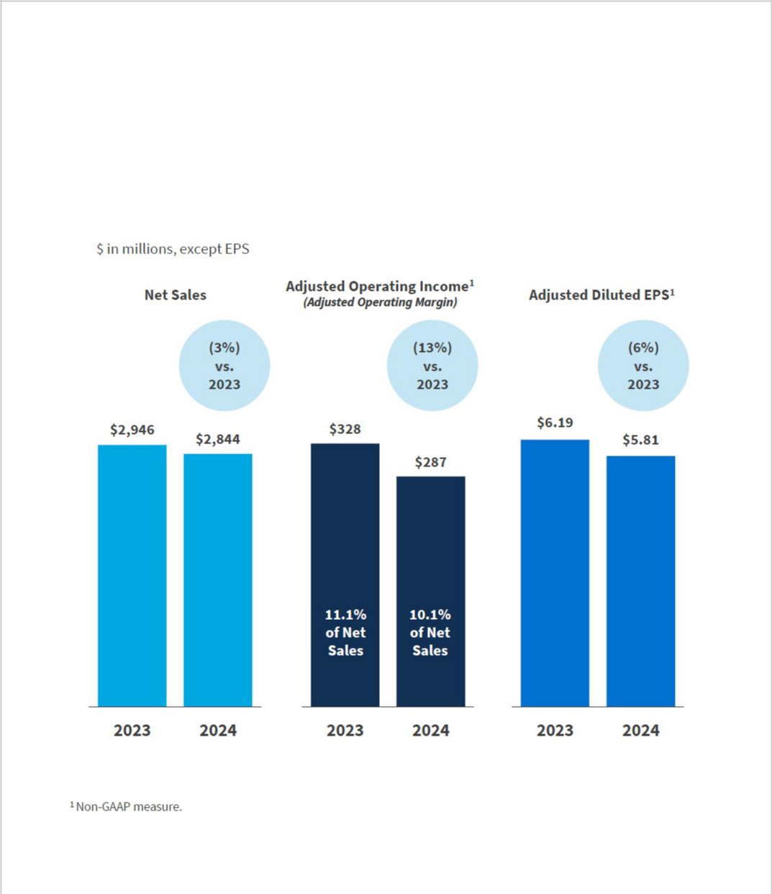

2024 CARTER’S PERFORMANCE HIGHLIGHTS

The following provides key erformancep highlights for 2024, which reflect the challenging macroeconomic environment for our business. Unless otherwise stated, comparisons are to fiscal2023and include both GAAP financial measures anadjusted, non-GAAP financial measurements. We believe the non-GAAP adjustments provide a meaningful comparison of the Company’s results and afford investors a view of what management considers to be the Company’s underlying performance. These measures are presented for informational pay-related purposes only. See the Appendix to this Proxy Statement for additional disclosures and reconciliations regarding these non-GAAP financial measures.

35
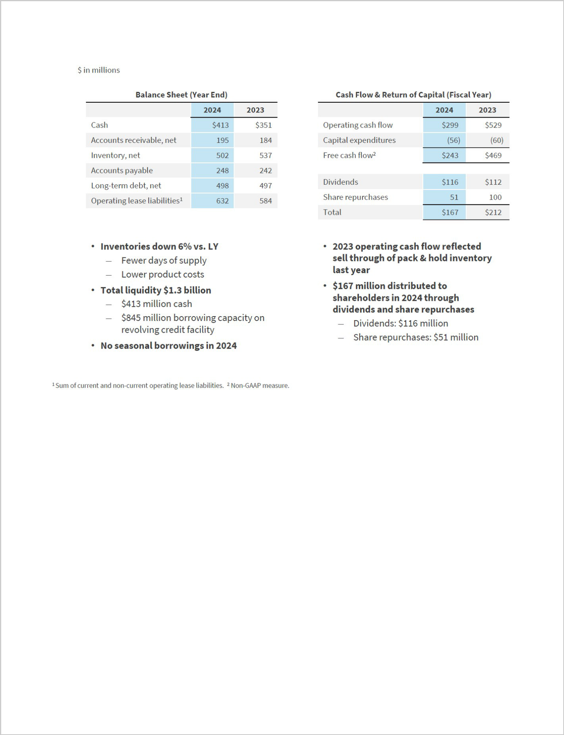

36


EXECUTIVE COMPENSATION HIGHLIGHTS FOR FISCAL2024

The Committee believes that our executive compensation program is appropriately designed to attract and retain superior executive talent and drive performance.

Reflective of this belief, approximately98% of the votes cast at our 2024 Annual Meeting of shareholders, were in favor of the advisory vote to approve executive compensation (“say-on-pay”). While this vote was non-binding, the Committee carefully considered the result of the say-on-pay vote in the context of our overall compensation philosophy, policies, and related decisions. After reflecting on the say-on-pay vote, the Committee decided that no changes to Carter's compensation philosophy were necessary. At the 2025 Annual Meeting, we will have an annual advisory vote to approve executive compensation (Proposal Number Two). The Committee plans to continue to consider the results from this year’s vote and future advisory votes on executive compensation.

We believe our pay for performance compensation philosophy is demonstrated by the alignment of shareholder experience and the payouts actually received by our NEOs. The annual incentive compensation paid out in 2024 was only5% of the target given that net sales and operating income thresholds were not attained and the strategic objectives (weighted at 20%) were attained at 25%. Additionally, none of the performance shares granted in 2022 eligible for vesting in 2024 were earned because performance thresholds were not attained.

As described more fully in this CD&A, the Committee took the following actions, among others, with respect to fiscal2024 compensation for our NEOs:

- reviewed the peer group to be used by the Committee as a source of comparative compensation data for fiscal 2024, and determined that the existing group remained appropriate with no necessary adjustments;

- benchmarked compensation for all executive officers, including the NEOs, using a combination of proxy disclosures by Carter's peer group and retail industry survey data;

    - structured annual incentive compensation for 2024 to consist of three performance metrics, weighted as follows: (1) net sales (50%); (2) operating income (with attainment to be measured based on adjusted results as reported to shareholders) (30%); and (3) strategic objectives (20%),consisting of the following: (a) improve the consumer perception of Carter's brand style and value; (b) improve U.S. Retail traffic through improved marketing effectiveness and new capabilities; and (c) demonstrate continued progress with multicultural customer acquisition;

- approved new equity awards consisting of 50% time-based restricted stock vesting annually over four years and 50% performance-based restricted stock. The2024 performance-based restricted stock awards have the following features:

  - three performance metrics, net sales, adjusted earnings per share (as reported to shareholders), and relative total shareholder return; and

  - a three-year performance period (fiscal years 2024, 2025, and 2026).

  - The Committee set target net sales and adjusted earnings per share2024,for as well as the target growth percentages for 2025 and 2026 that are based on actual net sales and adjusted earnings per share for2024 and 2025, respectively.

37

- In the first quarter of 2027, the Committee will determine the number of shares, if any, of performance-based stock that are earned under the2024 performance-based restricted stock awards.

COMPENSATION GOVERNANCE

The Committee and the Board have established executive compensation-related policies and procedures, including those discussed below, that they believe are appropriate for Carter's and its shareholders in light of the sector in which Carter's operates, its business model, and its financial and operational performance.

What We Do: |  | What We DoNot Do
• Align Pay with Carter’s Performance:Asignificant | • | No Guaranteed Annual Salary
portion of our NEOs’ total direct compensation is linked to |  | Increases or Guaranteed
Carter's performance in the form of annual incentive |  | Bonuses
compensation and long-term equity compensation tied to |  | Bonuses
performance criteria. | • No Re-Pricing of Stock Optio
• Retain an Independent Compensation Consultant:The
Committee retains an independent consultant to advise it on | • | No Hedging, Pledging, or Sho
executive and director compensation matters and to help | • | No Hedging, Pledging, or Sho
analyze comparative compensation data to confirm that the |  | Sales of Company Stock
design and pay levels of our compensation program are
consistent with market practices. | • | No Special Perquisites
• Utilize Stock Ownership Guidelines:We have minimum | • | No Special Perquisites
• Utilize Stock Ownership Guidelines:We have minimum |  | Provided to Our NEOs
stock ownership guidelines for our executive officers to |  | Provided to Our NEOs
encourage them to maintain a meaningful equity interest in | • | No Equity Grants Below 100%
Carter's in order to align their interests with those of our | • | No Equity Grants Below 100%
shareholders. |  | Fair Market Value
• Utilize Equity Retention Guidelines:Our equity retention | • | No Annual Equity Grants or
policy for executive officers requires holding periods for | • | No Annual Equity Grants or
time-based restricted stock and time-based stock option |  | Trading During Closed Inside
grants. |  | Trading Windows

- Have Double-Trigger Cash Severance Arrangements in the Event of a Change of Control:Inthe event of a change of control, our severance agreements with our NEOs provide for cash severance benefits to be paid only if there is a qualifying termination within a set period of time following the change of control.

- Effective With Equity Grants in 2024, Our Equity Incentive Arrangements Included Double-Trigger Provisions and Mandatory Clawback ProvisionAs: disclosed further in this CD&A, effective February 15, 2024, Carter's amended its Equity Incentive Plan to include double-trigger change of control provisions, as well as mandatory clawback provisions consistent with the requirements of Rule 10D-1 under the Securities Exchange Act of 1934, as amended (the “Exchange Act”), related NYSE listing standards, and our Clawback policy.

38

COMPENSATION STRUCTURE AND DETERMINATION

Our compensation philosophy is to set our NEOs’ total direct compensation at levels that will attract, motivate, and retain superior executive talent in a highly competitive environment. Carter’s compensation program for our NEOs is designed to support these objectives and encourage strong financial performance on an annual and long-term basis by linking a significant portion of our NEOs’ total direct compensation to Company performance in the form of annual cash incentive compensation and long-term performance-based restricted stock awards.

The principal components of the compensation structure for our NEOs are:

- base salary;

- annual cash incentive compensation; and

- long-term equity incentive compensation.

Together, we refer to these three components as “total direct compensation.”

GENERAL

In setting a total direct compensation target for each NEO, the Committee considers both objective and

subjective factors set forth below. The Committee also reviews total direct compensation, and its individual components, at the 25th, 50th, and 75th percentile levels paid to executives in similar positions

at the companies in our peer group and, as needed, a broader retail survey, in order to assess where the compensation it sets falls relative to market practices.

These levels are selected because the Committee reviews this peer data as a reference point in determining whether the total compensation opportunity is likely to provide sufficient motivation and retention as well as whether it properly reflects the NEO’s role and scope of responsibilities.

In setting compensation of Carter's NEOs, the Committee considered multiple objective and subjective factors, including:

- the nature and scope of each executive officer’s responsibilities;

- comparative compensation data for executive officers in similar positions at companies in our peer group and, as needed, a broader retail survey;

- each executive officer’s experience, performance, and contribution to Carter's;

- Carter’s performance;

- prior equity awards and potential future earnings from equity awards;

- retention needs; and

- any other factors the Committee deems relevant.

BASE SALARY

When setting base salaries for our NEOs, the Committee considers the objective and subjective factors set forth above and also reviews base salaries at the 25th, 50th, and 75th percentile levels paid to executives in similar positions at the companies in our peer group and a broader retail survey, as appropriate.

39


ANNUAL CASH INCENTIVE COMPENSATION

Carter’s makes annual cash incentive compensation (through the Carter's, Inc. Amended and Restated Annual Incentive Compensation Plan, the “Incentive Compensation Plan”) a significant component of our NEOs’ targeted total direct compensation in order to motivate our executive officers to meet and exceed Carter’s annual operating plans. For each NEO, the Committee approves target annual cash incentive compensation as a percentage of such NEO’s base salary. In establishing these annual cash incentive compensation targets, the Committee considers our NEOs’ potential total direct compensation in light of Carter’s compensation philosophy and comparative compensation data.

The Committee has the discretion to reduce or not to award annual cash incentive compensation, even if Carter’s achieves its financial performance targets, and to take into account personal performance in determining the percentage of each NEO’s annual cash incentive compensation to be paid, if any. Furthermore, the Board has adopted a clawback policy, consistent with the requirements of Rule 10D-1 under the Exchange Act and the related NYSE listing standards (referred to in this proxy statement as the “clawback policy”), that requires an executive officer (as defined in the clawback policy) to repay or return erroneously awarded compensation in the event of an accounting restatement of previously-reported financial results.

LONG-TERM EQUITY INCENTIVE COMPENSATION

The Carter’s, Inc. Amended and Restated Equity Incentive Plan “Equity(the Incentive Plan”) allows for various types of equity awards, including stock options, restricted stock (both time and performance-based), restricted stock units (structured as deferred restricted stock), stock appreciation rights, and deferred stock. Awards under our Equity Incentive Plan are granted to recruit, motivate, and retain employees and in connection with promotions or increased responsibility. Historically, the Committee has awarded a combination of time and performance-based restricted stock and time-based restricted stock units (structured as deferred restricted stock), although it may choose to use other forms of equity awards in the future.

All awards under our Equity Incentive Plan must be approved by the Committee. The Committee

determines the type, timing, and amount of equity awards granted to each of our NEOs after considering their previous equity awards, base salary, and target annual cash incentive compensation
in light of Carter’s compensation philosophy. The Committee also considers the comparative compensation data in our peer group and, as needed, a broader retail survey, and our desire to retain and motivate our NEOs and to align their goals with the long-term goals of our shareholders.

The Committee’s practice is toapprove equity grants at regularly scheduled meetings, but may also make equity grants at special meetings or by unanimous written consent, and could select a date subsequent to a regularly scheduled meeting on which to grant equity awardsThe. Committeedoes not take into account material non-public informationwhen determining the timing or terms of equity awards, nor does Carter's time disclosure of material non-public informationfor the purpose of affecting the value of executive compensationDuring. fiscal 2024, the Company did not grant stock options (or similar awards) to any executive officer during any period beginning four business days before and ending one business day after the filing of any periodic report on Form 10-Q or Form 10-K, or the filing or furnishing of any current report on Form 8-K that disclosed material non-public information. More broadly, the Company has not awarded stock options (or similar awards) since fiscal 2018.

In considering the value of equity awards, we calculate the value of time-based and performance-based restricted stock awards using the closing price of our common stock on the date of grant.

40

Effective February 15, 2024, Carter's amended its Equity Incentive Plan to include double-trigger change of control provisions to more closely-align Carter's pay practices with market practice. Effective with equity award grants in fiscal 2024, the vesting of the awards will be accelerated if either (1) the surviving entity does not provide replacement awards that meet criteria as set forth in the amended Equity Plan or, if applicable, the award agreement (referred to as “qualifying replacement awards”), or (2) the surviving entity provides qualifying replacement awards, but there is a termination of employment for cause or resignation for good reason (as defined in the amended Equity Incentive Plan) within two years after the change in control.

In addition, the Equity Incentive Plan was amended to include mandatory clawback provisions consistent with the requirements of Rule 10D-1 under the Exchange Act, related NYSE listing standards, and Carter’s clawback policy. Under the amended Equity Incentive Plan, and consistent with Carter’s clawback policy, the executive is required to repay or return erroneously awarded compensation in the event of an accounting restatement of previously-reported financial results. No other changes were made to the Equity Incentive Plan, including to the maximum number of shares that may be delivered under the Equity Incentive Plan.

ROLE OF THE COMPENSATION AND HUMAN CAPITAL COMMITTEE, INDEPENDENT CONSULTANT, AND MANAGEMENT

The Committee sets the total direct compensation of our NEOs, as well as the financial performance targets for our NEOs’ annual cash incentive compensation and vesting terms for their equity awards, including performance-based awards.

For fiscal2024, the Committee engaged Meridian Compensation Partners, LLC, an independent compensation consultant (“Meridian”), to advise it on executive and director compensation matters.

Meridian informs the Committee on market trends, as well as regulatory issues and developments and how they may impact Carter’s executive compensation program. Among other things, Meridian also:

- participates in the design of the executive compensation program to help the Committee evaluate the linkage between pay and performance;

- reviews market data and advises the Committee regarding the compensation of Carter’s executive officers; and

- reviews and advises the Committee regarding director compensation.

Meridian serves at the discretion of the Committee and regularly attends executive sessions with the Committee at which management is not present. At the direction of the Committee, our Chief Executive Officer works with Meridian to review comparative compensation data and makes recommendations for base salary, annual cash incentive compensation, and long-term equity incentive compensation for our NEOs, other than himself. Compensation for our Chief Executive Officer is set by the Committee, without

any_{Committee}involvement. by the Chief Executive Officer and reflecting feedback provided by Meridian to the

The Committee has assessed the independence of Meridian pursuant to applicable NYSE and SEC rules and has determined that it is independent, and the work provided by it did not raise a conflict of interest.

41


PEER GROUP ANALYSIS AND RETAIL SURVEY

To assess the market competitiveness of our NEOs’ compensation, the Committee and management review data provided by Meridian from two sources: our peer group and, as needed, a broader retail survey.

The Committee has established a peer group, which is generally comprised of companies in the retail or wholesale sectors which primarily conduct business in apparel or related accessories, sell products under multiple brands through retail stores and online, and have net sales generally between one-half and two times Carter's net sales.

In setting fiscal2024 compensation, our peer group was comprised of the following fifteen companies:

Abercrombie & Fitch Co. | Kontoor Brands, Inc.
American Eagle Outfitters, Inc. | Levi Strauss & Co.
The Children's Place, Inc. | Oxford Industries, Inc.
Columbia Sportswear Company | Tapestry, Inc.
G-III Apparel Group, Ltd. | Under Armour, Inc.
Gildan Activewear, Inc. | Urban Outfitters, Inc.
Guess?, Inc. | Victoria's Secret & Co.
HanesBrands Inc.

The Committee, with the advice of Meridian, also uses select information from a broader retail survey (that includes apparel and related products retailers or department stores which primarily sell apparel and related products) for executive compensation market assessment in order to supplement compensation data provided by the peer group analysis that may not be adequately represented in the data that is available from our peer group.

2024 TOTAL DIRECT COMPENSATION

During fiscal2024, the Committee reviewed compensation data from our peer group and, as needed, a broader retail survey, and compared that data to the compensation of our NEOs, in connection with approving total direct compensation for 2024. In setting total direct compensation for 2024, the Committee also considered the various factors noted earlier in this CD&A.

The components of total direct compensation are discussed more fully below.

2024 BASE SALARY

In February2024, the Committee approved an increase in the base salaries for each of our NEOs employed with the Company at the time, with such increases effective in May2024. These increases were based on market data, the nature and scope of each NEO’s responsibilities, and each NEO’s performance during fiscal 2023 (as applicable).The base salary for each NEO for fiscal2024 is set forth below.

42

 |  | Richard | Kendra | Allison | Raghu | Michael | Brian
 |  | F. | D. | M. | R. | D. | J.
 |  | Westenberger | Krugman | 1 | 2 | Casey | 3
 |  | Westenberger | Krugman | Peterson | Sagi | Casey | Lynch
Base salary rate—2023 |  | $715,000 | $700,000 | $— | $— | $1,300,000 | $880,000
(effective May 2023 for all
officers except for Ms.
Krugman, and effective March
2023 for Ms. Krugman)
Base salary rate—2024 |  | $775,000 | $775,000 | $750,000 | $600,000 | $1,340,000 | $—
(effective May 2024 for all
officers except for Ms.
Peterson and Mr. Sagi,
effective July 2024 for Ms.
Peterson, and effective April
2024 for Mr. Sagi)
Percentage Increase |  | 8.39% | 10.71% | —% | —% | 3.08% | —%

- Ms. Peterson joined Carter's in July 2024.

² Mr. Sagi joined Carter's in April 2024.
³ Mr. Lynch retired from Carter's in February 2024. Mr. Lynch's base salary remained the 2023 base salary rate until his retirement from Carter's in February 2024.

The total salary earned by each NEO in fiscal2024 is shown in the Summary Compensation Table in the “Salary” column and takes into account the change in each NEO’s salary as noted above.

2024 ANNUAL CASH INCENTIVE COMPENSATION

In February2024, the Committee set the following fiscal2024 annual cash incentive compensation targets for our NEOs:

- 150% of base salary for Mr. Casey; and

- 85% of base salary for Mr. Westenberger and Ms. Krugman

based on each NEO’s responsibilities, expected contribution and market data.

No fiscal 2024 annual cash incentive compensation target was set for Mr. Lynch, as he retired from Carter's in February 2024.

Upon each of Ms. Peterson and Mr. Sagi joining Carter's in July 2024 and April 2024, respectively, the Committee set the fiscal 2024 annual cash incentive compensation target75%as of each of their respective base salaries.

In light of continued consumer trends and shifting customer demographics, management recommended, and the Committee approved, a 2024 annual cash incentive compensation structure that included two financial performance metrics and a strategic objectives component that included consumer-related objectives, as well as two financial performance metrics, as follows:

- net sales (weighted ta50%);

- operating income (weighted at30%) (with attainment to be based on adjusted results as reported to shareholders); and

- strategic objectives (weightedat 20%), which consisted of the following objectives (1) improve consumer perception of Carter's brand style and value; (2) improve U.S. retail traffic through

43

improved marketing effectiveness and new capabilities; and (3) demonstrate continued progress with multicultural consumer acquisition.

The Committee selected net sales, operating income (as it may be adjusted and reported to shareholders), and strategic objectives as performance metrics because it believes these metrics are key

measures that align with the interests of our shareholders, namely growth, profitability, and strategic objectives related to shifting consumer demographics and continued consumer trends. As described below, our NEOs could have earned from 0% to 200% of their target annual cash incentive compensation in fiscal 2024 based upon Carter’s achievement of net sales and operating income (as it may be adjusted) financial performance metrics and the strategic objectives metric.

The payment grid for the2024 annual incentive compensation program is set forth below.

2024 ANNUAL CASH INCENTIVE COMPENSATION — PERFORMANCE METRICS

 |  | Net Sales |  | Adj. Operating | Strategic Objectives
 |  | (50%) |  | Income (30%) | Strategic Objectives
 |  | (in millions) |  | 1 | (20%)
 |  | (in millions) |  | (in millions) | (20%)
25% of Target (Threshold Performance) | $ | 2,890 | $ | 310 | N/A
100% of Target (Target Performance) | $ | 3,000 | $ | 345 | N/A
200% of Target (Maximum | $ | 3,093 | $ | 377 | N/A
Performance)
Fiscal2024 Performance | $ | 2,844 | $ | 287.0 | N/A

- See the Appendix to this Proxy Statement for a reconciliation of Adjusted Operating Income to its most directly comparable GAAP measure, Operating Income.

In January2025, the Committee determined that based on Carter's performance noted above, as well as the achievement of25%of the strategic objectives, Carter's achieved an overall performance5%at of Target, with the payouts to our NEOs as follows:
 |  | Annual Cash |  | Annual Cash
 |  | Incentive |  | Incentive
 |  | Compensation |  | Compensation
 |  | Targets ($) |  | Actually Paid
 |  |  |  | at 5% of
 |  |  |  | Target ($)
Richard F. Westenberger | $ | 658,750 | $ | 33,000
Kendra D. Krugman | $ | 658,750 | $ | 33,000
1 | $ | 272,774 | $ | 13,700
Allison M. Peterson
2 | $ | 304,521 | $ | 15,300
Raghu R. Sagi
Michael D. Casey | $ | 2,010,000 | $ | 100,500
3 | $ | — | $ | —
Brian J. Lynch

- Ms. Peterson joined Carter's in July 2024 and received a pro-rated bonus based on the number of days of service in 2024.

- Mr. Sagi joined Carter's in April 2024 and received a pro-rated bonus based on the number of days of service in 2024.
³ Mr. Lynch retired from Carter's in February 2024 and did not receive any 2024 annual cash incentive compensation.

44

2024 LONG-TERM EQUITY INCENTIVE COMPENSATION

We provide long-term equity incentive awards to our NEOs to balance the short-term focus of the annual cash incentive program by tying a significant portion of total compensation to performance achieved by the Company over multi-year periods. The structure and design of our long-term equity incentive awards are designed to directly link the value of the awards granted to the NEOs with the Company’s long-term financial performance and increases in stockholder value.

AWARD MIX

In fiscal 2024, the Committee approved a 50%/50% mix of annual time-based restricted stock grants (which vest over four years in 25% increments on the annual anniversary of the grant date) and two types of three year performance-based restricted stock grants (PSAs) for each NEO. These grants reflect our

historical practice of awarding a combination of time-based and performance- based restricted stock to Carter’s NEOs.


FISCAL 2024 LONG-TERM EQUITY INCENTIVE AWARD OPPORTUNITIES

Each NEO's annual equity grant is determined based on her or his performance, market pay data, and considerations of the competitiveness of their overall compensation package. Based on these factors, for Fiscal 2024 the Committee determined to grant long-term equity incentive awards to the NEOs with the aggregate grant date fair value shown below.
NEO | 1
NEO | 2024 Long-Term Equity Incentive Award
Richard F. Westenberger | $1,609,960
Kendra D. Krugman | $1,609,960
2 | $2,500,190
Allison M. Peterson | $2,500,190
3 | $1,000,120
Raghu Sagi | $1,000,120
Michael D. Casey | $6,976,664
4 | $—
Brian J. Lynch | $—
- Amounts assume target attainment of metrics under performance-based restricted stock awards.

- In connection with Ms. Peterson joining Carter's in July 2024, Ms. Peterson received an award of time-based restricted stock that vests over four years in 25% increments on the annual anniversary of the grant date.

³ In connection with Mr. Sagi joining Carter's in April 2024, Mr. Sagi received an award of time-based restricted stock that vests over four years in 25% increments on the annual anniversary of the grant date.

⁴ Mr. Lynch retired from Carter's in February 2024 and did not receive any long-term equity incentive awards in 2024.

PERFORMANCE-BASED RESTRICTED STOCK AWARD MEASUREMENT

The combined Company PSAs and relative total shareholder return (“relative TSR”) PSAs granted by the Committee in fiscal 2024 measure a mix of net sales growth, adjusted earnings per share (adjusted EPS) as reported to shareholders, and relative TSR over a three-year period from fiscal 2024 to fiscal 2026, as shown below. The Committee selected these metrics as they represent key areas of focus for Carter’s and align compensation with long-term shareholder value.

45

Fiscal 2024 to 2026 PSA
Metrics | Weighting
1 | 33%
Net Sales | 33%
1 | 33%
Adjusted EPS | 33%
2 | 34%
Relative TSR | 34%

- Target performance for these metrics was set, at the time of grant, for the first year of the performance period, and the target performance for each of the following years (2025 and 2026) is based on a set rate of growth (included in the award agreement) in the actual performance for the prior year. For example, if the net sales target for 2024 was set at $2.8 billion, but actual performance for 2024 was $2.7 billion, the target net sales for 2025 would be based on a growth rate related to $2.7 billion in net sales. The Committee sought to set challenging goals for the fiscal 2024 net sales and adjusted EPS metrics.

² Target performance was set at a three-year relative TSR that equals or exceeds the 50th percentile of a comparator group consisting of a selection of companies in the S&P 1500 Apparel, Accessories & Luxury Goods Index and the S&P 1500 Apparel Retail Index.

The number of PSAs earned will depend on Carter’s level of achievement with respect to each metric, ranging from 25% of target for performance at threshold to 200% of target for performance at maximum. No PSAs will be earned if performance falls below the threshold level of performance for all three metrics. If the performance level falls between threshold and target or between target and maximum, the level of payout is determined through linear interpolation.

46

COMPLETED AND OUTSTANDING PERFORMANCE SHARE AWARD CYCLES

The final measurement period for the fiscal 2022 to fiscal 2024 PSA cycle was completed as of the end of

fiscal 2024. A summary of the net sales and adjusted EPS metrics are below, and as indicated in the table, no payouts were attained for these PSAs.

Fiscal 2022 to Fiscal 2024

PSA Metric |  | Threshold |  |  | Target |  |  |  |  | Maximum |  |  |  | Actual |  | Payout %
Net Sales | • | 2022: $3,295 |  | • | 2022: $3,595 |  |  | • | 2022: $3,670 |  |  |  | • | 2022: |  | 0%
(50%
(50% |  |  |  |  |  |  |  |  |  |  |  |  |  | $3,212
weighting) | • | 2023: 1% |  | • | 2023: 3% growth |  |  | • |  | 2023: 5% growth
(in millions) |  |  |  |  |  |  |  | • |  |  |  |  |  | 2023:
(in millions) | • | growth in |  | • | in actual 2022 net |  |  | • | in actual 2022 net |  |  | •
 |  | actual 2022 net |  |  | sales |  |  |  | sales |  |  |  |  | $2,946
 |  | sales |  | • | 2024: 3% growth |  |  | • | 2024: 5% growth |  |  |  | • | 2024:
 |  | 2024: 1% |  | • |  |  |  | • |  |  |  |  | •
 | • |  |  |  | in actual 2023 net |  |  |  | in actual 2023 net |  |  |  |  | $2,844
 |  |  |  |  | sales |  |  |  | sales
 |  | growth in actual
 |  | 2023 net sales
Adjusted | • | 2022: $7.50 |  | • | 2022: $9.02 |  |  | • | 2022: $9.21 |  |  |  | • | 2022: |  | 0%
EPS (50%
EPS (50% |  |  |  |  |  |  |  |  |  |  |  |  |  | $6.90
weighting) | • | 2023: 2% |  | • | 2023: 9% growth |  |  | • | 2023: 11% |  |  |  | • | 2023:
 |  | growth in |  |  | in actual 2022 |  |  |  | growth in actual |  |  |  | •
 |  | actual 2022 |  |  | adjusted EPS |  |  |  | 2022 adjusted |  |  |  |  | $6.19
 |  | adjusted EPS |  | • | 2024: 9% growth |  |  |  | EPS |  |  |  | • | 2024:
 |  | 2024: 2% |  | • |  |  |  |  | 2024: 11% |  |  |  | •
 | • |  |  |  | in actual 2023 |  |  | • |  |  |  |  |  | $5.81
 |  |  |  |  | adjusted EPS
 |  | growth in actual |  |  |  |  |  |  | growth in actual
 |  | 2023 adjusted |  |  |  |  |  |  | 2023 adjusted
 |  | EPS |  |  |  |  |  |  | EPS
Total |  |  |  |  |  |  |  |  |  |  |  |  |  |  |  | 0%
Attainment

TIME-BASED RESTRICTED STOCK

All of the time-based restricted stock awards granted to our NEOs in fiscal2024:

- are subject to the equity retention policy described below;

- are contingent on the NEO’s continued employment with Carter's through each vesting date; and

- vest in four equal annual installments on the first through fourth anniversaries of each grant date.

STOCK OWNERSHIP GUIDELINES AND EQUITY RETENTION POLICY

The Committee regularly reviews the equity ownership of our NEOs compared to our minimum ownership guidelines. Under our minimum ownership guidelines, no NEO may sell shares of Carter’s stock (other than to cover the tax obligations resulting from the vesting of Carter’s restricted stock (both time and performance-based) or from exercising vested stock options) until they own shares of Carter’s stock with a total market value in excess of a specified multiple of his or her base salary and continue to maintain such level of ownership after such sale. For fiscal2024 (similar to the multiples for2023), the ownership multiples for our NEOs were as follows:

47


 | Multiple of
 | Base Salary
Chief Executive Officer & President | 7x
Senior Executive Vice Presidents & Executive Vice Presidents | 3x

Under our minimum ownership guidelines, all unvested restricted stock and vested shares are included in determining compliance with the ownership multiple, but unvested performance-based restricted stock are excluded from the calculation of shares of stock held by the executive.

In addition, our equity retention policy for NEOs requires that any time-based restricted stock granted to a NEO be held for four years following the date of grant before those shares may be sold, except for any withholding to cover tax obligations resulting from the vesting of such shares. The policy also requires that shares underlying time-based options granted be held for at least one year from the date of vesting. During fiscal2024, each of our NEOs was in compliance with his or her applicable minimum ownership requirement.

401(K) PLAN

Carter’s 401(k) program provides for a Company match of employee contributions, including contributions by NEOs, at the discretion of Carter's, based on Carter’s performa.InceJanuary2025, the Committee approved that employee contributions made to Carter’s 401(k) plan in fiscal2024 would be matched by Carter's 100% up to 4%f theo employee’s eligible compensation for all eligible employees, up to the maximum amount permitted by the Internal Revenue Service. This matching contribution was approved by the Committee following its consideration of our employees’ efforts for fiscal 2024.

PERQUISITES AND OTHER BENEFITS

Our NEOs do not receive any perquisites or other benefits on an annual basis that are not otherwise available to all employees. The cost of providing these benefits and perquisites to the NEOs is included in the amounts shown in the “All Other Compensation” column of the Summary Compensation Table and detailed in the footnotes to such table.

INSIDER TRADING POLICY

We maintain anInsider Trading Policygoverning the purchase, sale, and/or other dispositions of our securities by our directors, officers, and employees, as well as by Carter’s, that we believe is reasonably designed to promote compliance with insider trading laws, rules, and regulations, and the exchange listing standards applicable to us.A copy of our Insider Trading Policy was filed as an exhibit to our Annual Report on Form 10-K for the fiscal year ended December 28, 2024.

CLAWBACK AND HEDGING POLICIES

Carter's has adopted a clawback policy, consistent with the requirements of Rule 10D-1 under the

Exchange Act and the related NYSE listing standards, that requires an executive officer to repay or return erroneously awarded compensation in the event of an accounting restatement of previously-
reported financial results.

Further, hedging and pledging of Company stock by any Board member or employee of Carter’s, including our NEOs, is prohibited under our policies to ensure that the interests of the holders of

48


Carter’s stock are fully aligned with those of shareholders in general. During fiscal2024, none of our NEOs entered into a hedging arrangement or pledged any shares of Carter's stock.

RETIREMENT OF FORMER PRESIDENT & CONSULTING AGREEMENT

In connection with Mr. Lynch's retirement in February 2024, the Company entered into a consulting agreement with Mr. Lynchpursuant to which Mr. Lynch served as a consultant to the Company following his retirement to assist with an orderly transition. The consulting agreement provides for, among other things: (i) a term of twelve months through the end of February 2025; and (ii) a consulting fee$125,000of

per month payable by the Company to Mr. Lynch for the consulting services provided to the Company during the period of the consulting agreement, which consulting services include consultations with executive officers and other management personnel of the Company related to the business of the Company and assistance with leadership transitions at the Company.

In addition, pursuant to the terms of the outstanding award agreements governing Mr. Lynch's unvested performance-based restricted stock, Mr. Lynch received “retirement” treatment for those outstanding awards upon his retirement in February 2024. This treatment resulted in pro-rated vesting of his performance-based restricted stock (calculated based on the number of days he worked at the Company from the grant date through the retirement date) subject to the achievement, by the Company, of the performance metrics under the applicable award agreements.

RETIREMENT OF FORMER CHAIRMAN AND CHIEF EXECUTIVE OFFICER & RETIREMENT AGREEMENT

In connection with Mr. Casey's retirement in February 2025, Carter’s and Mr. Casey entered into a Retirement Agreement and Release, datedFebruary 20, 2025Under. the Retirement Agreement and Release, Mr. Casey received accelerated vesting of his outstanding unvested time-based restricted stock awards and pro-rated vesting of his PSAs issued in 2023 and 2024 (subject to the attainment of the performance metrics under those awards).

APPOINTMENT OF INTERIM CHIEF EXECUTIVE OFFICER

In connection with Mr. Casey's retirement as Chairman and Chief Executive Officer, the Board appointed Richard F. Westenberger as Interim Chief Executive Officer, effective January 5, 2025. Mr. Westenberger’s appointment ended on April 3, 2025 in connection with the appointment of Douglas C. Palladini as Chief Executive Officer & President. Mr. Westenberger is continuing to serve in his role as Senior Executive Vice President, Chief Financial Officer & Chief Operating Officer.

In his capacity as Interim CEO, Mr. Westenberger received a monthly cash stipend of $110,000, and also received restricted stock awards in an amount of $300,000 pursuant to the Company’s Amended and Restated Equity Incentive Plan on a quarterly basis (the “Westenberger Awards”), each vesting within one year of the grant date of the relevant Westenberger Award. The Westenberger Awards will be immediately vested in the event that Mr. Westenberger is terminated without cause or resigns for good reason prior to the applicable vesting date, or in the event of his death or disability prior to the vesting date.

APPOINTMENT OF CHIEF EXECUTIVE OFFICER & PRESIDENT

On March 26, 2025, the Company announced that the Board approved the appointment of Douglas C. Palladini as Chief Executive Officer and President of the Company and a member of the Board, effective

April 3, 2025 (theEffective“ Date”). On the Effective Date, Richard F. Westenberger, who was serving as the Company’s Interim Chief Executive Officer, ceased to serve in that capacity but is continuing with the Company as its Senior Executive Vice President, Chief Financial Officer & Chief Operating Officer.

49


In connection with Mr. Palladini’s appointment, Mr. Palladini and the Company executed an offer letter on March 21, 2025 (the Offer“ Letter”). Pursuant to the Offer Letter, during Mr. Palladini’s employment with the Company, he will receive an initial base salary of $1,200,000 per year, and an annual cash incentive opportunity at target of 150%, which will be prorated for fiscal year 2025. Commencing in the Company’s fiscal year 2026, Mr. Palladini will be eligible to receive annual equity awards with a target value of $5,500,000, pursuant to the terms of the Company’s shareholder-approved equity plan.

Pursuant to the Offer Letter, on April 3, 2025, Mr. Palladini received a $7,000,000 sign-on equity grant, with 50% of the grant in the form of time-based restricted stock and 50% in the form of performance-based restricted stock. The time-based restricted stock vests in four equal increments over a four-year period on each of the anniversaries of the grant date. The performance-based restricted stock will be earned upon achieving share price hurdles for 20 consecutive trading days over a three-year performance period, starting on the award grant date (April 3, 2025) and ending on the third anniversary of the award grant date (April 3, 2028). These share price hurdles are based on the closing price of stock on the grant date, using the following growth rates:

- 1/3 at 30% growth;

- 1/3 at 60% growth;

- 1/3 at 90% growth.

The growth objectives may be achieved at any time over the three-year period, and the corresponding number of shares earned, but the shares will not vest until the end of the three-year period.

Mr. Palladini is expected to enter into the Company’s previously disclosed Severance Agreement and participate in the employee benefit plans and programs provided by the Company to other senior executives. Mr. Palladini will be covered by any Company directors and officers insurance policies. Mr. Palladini will also be subject to the Company’s restrictive covenants included in the Severance Agreement, which include restrictions relating to non-competition and non-solicitation for 24 months after the termination date and protection of confidential information.

SEVERANCE AGREEMENTS WITH NEOS

Each of our NEOs has a severance agreement with Carter’s. In the event that an NEO is terminated by Carter’s for any reason, the NEO or his or her estate will be provided: (a) the NEO’s base salary earned but not paid during the final payroll period, (b) pay for any vacation time earned but not used through the separation date, and (c) any business expenses incurred by the NEO but unreimbursed on the separation date.

If an NEO is terminated without “cause,” or an NEO terminates their employment for “good reason” (with “cause” and “good reason” defined in each NEO’s respective severance agreement and summarized below), the Company will be obligated to pay such NEO’s base salary for 12 months in the cases of Messrs. Westenberger and Sagi and Mses. Krugman and Peterson. In each case, base salary will be paid in bi-weekly installments. The Company is also obligated to pay each NEO a pro-rated annual cash incentive compensation amount that would have been earned by each such executive if he or she had been employed at the end of the year in which his or her employment was terminated. The determination of whether annual cash incentive compensation is payable to the NEO will not take into account any individual performance goals and shall be based solely on the extent to which Company performance goals have been met.

50

Further, the Company is obligated to pay the Company’s contribution to the medical and dental benefits for Messrs. Westenberger and Sagi and Mses. Krugman and Peterson, until the earlier of (i) 12 months following his or her separation date, (ii) the date the NEO becomes eligible for coverage under the health and/or dental plans of another employer, or (iii) the date the NEO otherwise ceases to be eligible to continue participation in the Company’s health and dental plans under COBRA. Additionally, the Company is obligated to pay the Company’s contribution to the life insurance benefits for 12 months in

the case of Messrs. Westenberger and Sagi and Mses. Krugman and Peterson. The payment of severance is contingent on the NEO (a) executing an effective release of claims, and (b) complying with post-

termination obligations including confidentiality, noncompetition, and non-solicitation covenants.

In the event that, within two years following a “change of control” (with “change of control” defined in each executive’s severance agreement) the Company terminates the NEO’s employment, other than for “cause” or such executive terminates his or her employment for “good reason,” the Company shall pay such NEO’s the following severance benefits in addition to the severance benefits in the preceding paragraph: (a) base salary for an additional 12 months for all NEOs, (b) the Company’s contribution to the medical and dental benefits, if following the expiration of the 12-month anniversary of such termination, the NEO has not yet become eligible for coverage under the health and/or dental plans of another employer, then for an additional 6-month period thereafter (or, if earlier, until the date the NEO becomes eligible for coverage under the health and/or dental plans of another employer), and (c) the Company’s contribution to the life insurance benefits, for an additional 12 months in the case of all NEOs. In the event of a “change of control” of the Company: (1) for all unvested stock options and all unvested shares of restricted stock (both time and performance-based) held by the NEO that were awarded prior to February 15, 2024, such awards will fully vest; and (2) for all unvested equity awards made on or after February 15, 2024, such awards will fully vest if there is a qualifying termination of employment within two years after the change in control or if the surviving entity does not provide qualifying replacement awards.

Under the severance agreements with each of our NEOs, “cause” is generally deemed to exist when such NEO has: (a) been convicted of a felony or entered a plea of guilty or no contest to a felony; (b) committed fraud or other act involving dishonesty for personal gain which is materially injurious to the Company; (c) materially breached his obligations of confidentiality, intellectual property assignment, non-competition, non-solicitation, or non-disparagement against the Company after a cure period, provided such breach by its nature was curable; (d) willfully engaged in gross misconduct which is injurious to the Company; or (e) after a cure period, willfully refused to substantially perform his or her duties or is grossly negligent in performance of such duties.

Under the agreements with our NEOs, “good reason” is generally deemed to exist when there is: (a) a material reduction in the executive’s title, duties, or responsibilities; (b) a material change in the geographic location at which the executive must perform services; or (c) a material breach of the executive’s agreement by the Company, provided the NEO complies with the written notice requirements and the cure period provided to Carter's.

See “Potential Payments Upon Termination or Change of Control” below for a discussion and presentation of amounts our NEOs may be entitled to in the event of their termination, including following a change in control.

51


COMPENSATION & HUMAN CAPITAL COMMITTEE REPORT

The Compensation & Human Capital Committee of the Board has reviewed and discussed with Company management the Compensation Discussion and Analysis included in this proxy statement. Based on such review and discussions, the Compensation and Human Capital Committee has recommended to the Board that the Compensation Discussion and Analysis be included in this proxy statement for filing with the SEC.

Submitted by the Compensation & Human Capital

Committee

Mr. Jevin S. Eagle,

Mr. Rochester Anderson, Jr.

Mr. Luis Borgen

Mr. Mark P. Hipp

Ms. Stephanie P. Stahl


COMPENSATION & HUMAN CAPITAL COMMITTEE INTERLOCK AND INSIDER PARTICIPATION

The Compensation & Human Capital Committee is composed entirely of the five independent directors listed above. No member of the Compensation & Human Capital Committee is a current, or during fiscal 2024 was a former, officer or employee of the Company or any of its subsidiaries. During fiscal 2024, no member of the Compensation & Human Capital Committee had a relationship that must be described under the SEC rules relating to disclosure of transactions with related persons. In fiscal 2024, none of our executive officers served on the board of directors or compensation committee of any entity that had one or more of its executive officers serving on the Board or the Compensation & Human Capital Committee.

52


FISCAL2024 SUMMARY COMPENSATION TABLE*

The table below provides information concerning the compensation of our NEOs.

 |  |  |  |  |  | Non-Equity |  | All Other
 |  |  | Salary | Bonus | Stock | Incentive Plan |  | All Other
Name and |  | Fiscal | Salary | Bonus | Stock | Compensation |  | Compensation | Total
 |  | Fiscal | ($) | ($) | Awards ($) | ($) |  | ($) | Total
Principal Position |  | Year | (a) | (b) | (c) | (d) |  | (e) | ($)
Richard F. Westenberger |  | 2024 | $763,462 | $— | $1,609,960 | $33,000 |  | $176,496 | $2,582,918
Senior Executive Vice President, |  | 2023 | $704,615 | $— | $1,550,520 | $471,900 |  | $169,734 | $2,896,769
Chief Financial Officer & Chief |  | 2022 | $674,615 | $128,500 | $1,250,166 | $— |  | $125,585
Operating Officer, former Interim
Chief Executive Officer |  |  |  |  |  |  |  |  | $2,178,866
Kendra D. Krugman |  | 2024 | $760,577 | $— | $1,609,960 | $33,000 |  | $180,810 | $2,584,347
Senior Executive Vice President, |  | 2023 | $683,846 | $— | $1,800,489 | $462,000 |  | $149,459 | $3,095,794
Chief Creative & Growth Officer |  | 2022 | $609,231 | $118,200 | $1,000,862 | $— |  | $97,229 | $1,825,522
Allison M. Peterson |  | 2024 | $346,154 | $— | $2,500,190 | $13,700 |  | $224,104 | $3,084,148
Executive Vice President, |  | 2023 | $— | $— | $— | $— |  | $— | $—
Chief Retail & Digital Officer |  | 2022 | $— | $— | $— | $— |  | $— | $—
Raghu R. Sagi |  | 2024 | $392,308 | $— | $1,000,120 | $15,300 |  | $43,479 | $1,451,207
Executive Vice President, |  | 2023 | $— | $— | $— | $— |  | $— | $—
Chief Information & Technology |  | 2022 | $— | $— | $— | $— |  | $—
Officer |  |  |  |  |  |  |  |  | $—
Michael D. Casey |  | 2024 | $1,326,154 | $— | $6,976,664 | $100,500 |  | $743,451 | $9,146,769
Former Chairman, |  | 2023 | $1,282,692 | $— | $6,500,098 | $1,716,000 |  | $589,342 | $10,088,133
Chief Executive Officer & President |  | 2022 | $1,192,885 | $468,800 | $6,500,136 | $— |  | $444,933 | $8,606,754
Brian J. Lynch |  | 2024 | $169,231 | $— | $— | $— |  | $1,340,089 | $1,509,320
Former President & |  | 2023 | $867,885 | $— | $2,500,266 | $774,400 |  | $241,106 | $4,383,656
Chief Operating Officer |  | 2022 | $831,154 | $211,300 | $2,000,266 | $— |  | $165,949 | $3,208,669

- Amounts in rows may not add exactly to the total due to rounding.


- Base salary for each NEO was based on a 364-day fiscal year for fiscal years 2024, 2023 and 2022.

- Reflects the discretionary bonus that was awarded in2023 based on fiscal 2022 performance, in light of the challenges faced by the Company due to the COVID-19 pandemic, inflationary impact on consumers, and responses to other challenges in the Company’s business including supply chain disruptions.

- The amounts disclosed in this column represent the total grant date fair value for the following grants computed in accordance with FASB ASC Topic 718:

  - The time-based restricted stock granted in 2024, 2023, and 2022 vest in four equal, annual installments beginning one year from the date of the grant, except for a special restricted stock award granted to Ms. Krugman(inconnection with her promotion in 2023) that includes a portion that cliff vests
on the third anniversary of the date of grant.

  - Vesting of the performance-based restricted stock granted in fiscal 2024 is contingent upon meeting specific performance targets for each of the three fiscal years 2024, 2025, and 2026, individually, and vest, as and to the extent performance criteria are met, in 2027 following completion of fiscal 2026. For 2024, 34% of the total award of performance-based restricted shares included a relative TSR component (the “Market-Based Restricted Shares”).

 |  | Time-Based Time-Based Performance |  |  | Market- |  | Grant
 |  | Restricted | Restricted | - | Market- |  | Grant
 |  | Shares – 4 | Shares – 3 | Based | Based | Date Fair
Name | Grant Date | Year | Year | Restricted | Restricted | Value per
Name | Grant Date | Vest | Cliff Vest | Shares | Shares |  | Share
Richard F. Westenberger | 2/28/2024 | 9,152 | — | 6,040 | — | $ | 81.95
 | 2/28/2024 | — | — | — | 3,112 | $ | 117.28
 | 2/27/2023 | 10,468 | — | 10,468 | — | $ | 74.06
 | 2/16/2022 | 6,860 | — | 6,860 | — | $ | 91.12
Kendra D. Krugman | 2/28/2024 | 9,152 | — | 6,040 | — | $ | 81.95
 | 2/28/2024 | — | — | — | 3,112 | $ | 117.28
 | 2/27/2023 | 5,404 | — | 5,404 | — | $ | 74.06
 | 3/21/2023 | — | 14,022 | — | — | $ | 71.32
 | 2/16/2022 | 5,492 | — | 5,492 | — | $ | 91.12
Allison M. Peterson | 8/9/2024 | 39,920 | — | — | — | $ | 62.63
 | 2/27/2023 | — | — | — | — | $ | 74.06
 | 2/16/2022 | — | — | — | — | $ | 91.12
Raghu R. Sagi | 5/10/2024 | 14,484 | — | — | — | $ | 69.05

53

 | 2/27/2023 | — | — | — | — | $ | 74.06
 | 2/16/2022 | — | — | — | — | $ | 91.12
Michael D. Casey | 2/28/2024 | 39,660 | — | 26,176 | — | $ | 81.95
 | 2/28/2024 | — | — | — | 13,484 | $ | 117.28
 | 2/27/2023 | 43,884 | — | 43,884 | — | $ | 74.06
 | 2/16/2022 | 35,668 | — | 35,668 | — | $ | 91.12
Brian J. Lynch | 2/28/2024 | — | — | — | — | $ | 81.95
 | 2/28/2024 | — | — | — | — | $ | 117.28
 | 2/27/2023 | 16,880 | — | 16,880 | — | $ | 74.06
 | 2/16/2022 | 10,976 | — | 10,976 | — | $ | 91.12

- Reflects dollar value of all compensation earned in fiscal 2024, 2023, and 2022 pursuant to the Incentive Compensation Plan, including all annual cash incentive compensation.

- The amounts shown as “All Other Compensation” for fiscal2024 consist of the following:

 |  |  | Dividends
 |  | 401 (k) | Paid on
 |  | 401 (k) | Unvested | Other
Name |  | Company | Restricted |  |  | Total
Name |  | Match | Stock | (i) |  | Total
Richard F. Westenberger |  | $13,800 | $159,098 | $3,599 |  | $176,497
Kendra D. Krugman |  | $13,800 | $164,762 | $2,249 |  | $180,811
Allison M. Peterson |  | $8,077 | $63,872 | $152,155 |  | $224,104
Raghu R. Sagi |  | $7,385 | $34,762 | $1,333 |  | $43,480
Michael D. Casey |  | $13,800 | $723,818 | $5,834 |  | $743,452
Brian J. Lynch |  | $— | $89,139 | $1,250,950 |  | $1,340,089

- These amounts include imputed income from health and life insurance contributions, imputed income from bring-your-own technology to work programs, and benefits from healthcare programs, each of which are available to all employees, as well as: (1) $136,151 in relocation benefits for Ms. Peterson and (2) $1,250,000 in consulting fees for Mr. Lynch.

54

FISCAL2024 GRANTS OF PLAN-BASED AWARDS

The following table provides information concerning each grant of plan-based awards made to an NEO in fiscal 2024. This includes incentive compensation awards granted under our Incentive Compensation Plan and restricted stock awards granted under our Equity Incentive Plan. The threshold, target, and maximum columns reflect the range of estimated payouts under these plans for fiscal2024. The last column reports the aggregate grant date fair value of all awards made in fiscal2024 as if they were fully vested on the grant date, computed in accordance with FASB ASC Topic 718.

 |  |  | Estimated |  |  |  | Estimated |  |  | Grant
 |  |  | Future |  |  |  | Future |  |  | Grant
 |  |  | Payouts |  |  |  | Payouts |  |  | Date Fair
 |  |  | Under |  |  |  | Under |  |  | Value of
 |  |  | Non-Equity |  |  |  | Equity |  |  | Stock and
 |  |  | Incentive |  |  |  | Incentive |  |  | Option
 |  |  | Plan |  |  |  | Plan |  |  | Name
 |  |  | Awards (a) |  |  |  | Awards |  |  | Awards
Name | Award | Grant | Threshold |  | Target | Maximum Threshold |  | Target | Maximum
Name | Type | Date | ($) |  | ($) | ($) | (#) | (#) | (#)
Richard F. | Cash Incentive | — | $164,688 |  | $658,750 | $988,125 | — | — | — | $—
Westenberger | Compensation
 | Shares (b) | 2/28/2024 | — |  | — | — | — | 9,152 | 9,152 | $750,006
 | Shares (c) | 2/28/2024 | — |  | — | — | 1,510 | 6,040 | 12,080 | $494,978
 | Shares (d) | 2/28/2024 | — |  | — | — | 778 | 3,112 | 6,224 | $364,975
Kendra D. | Cash Incentive | — | $164,688 |  | $658,750 | $988,125 | — | — | — | $—
Krugman | Compensation
 | Shares (b) | 2/28/2024 | — |  | — | — | — | 9,152 | 9,152 | $750,006
 | Shares (c) | 2/28/2024 | — |  | — | — | 1,510 | 6,040 | 12,080 | $494,978
 | Shares (d) | 2/28/2024 | — |  | — | — | 778 | 3,112 | 6,224 | $364,975
Allison M. | Cash Incentive | — | $68,193 |  | $272,774 | $409,161 | — | — | — | $—
Peterson | Compensation
 | Shares (b) | 8/9/2024 | — |  | — | — | — | 39,920 | 39,920 | $2,500,190
Raghu R. Sagi | Cash Incentive | — | $76,130 |  | $304,452 | $456,781 | — | — | — | $—
 | Compensation
 | Shares (b) | 5/10/2024 | $— |  | $— | $— | — | 14,484 | 14,484 | $1,000,120
Michael D | Cash Incentive | — | $502,500 |  | $2,010,000 | $3,015,000 | — | — | — | $—
Casey. | Compensation
 | Shares (b) | 2/28/2024 | — |  | — | — | — | 39,660 | 39,660 | $3,250,137
 | Shares (c) | 2/28/2024 | — |  | — | — | 6,544 | 26,176 | 52,352 | $2,145,123
 | Shares (d) | 2/28/2024 | — |  | — | — | 3,371 | 13,484 | 26,968 | $1,581,404
Brian J. | Cash Incentive | — | $— |  | $— | $— | — | — | — | $—
Lynch | Compensation
 | Shares (b) | 2/28/2024 | — |  | — |  | — | — | — | $—
 | Shares (c) | 2/28/2024 | — |  | — |  | — | — | — | $—
 | Shares (d) | 2/28/2024 | — |  | — | — | — | — | — | $—

- The amounts shown under the “Threshold” column represent 25% of the target cash incentive compensation, assuming threshold-level performance is achieved under the financial performance measures and strategic objectives component. The amounts shown under the “Target” column represent 100% of the target cash incentive compensation, assuming target-level performance is achieved under the financial performance measures and strategic objectives component. The amounts shown under the “Maximum” column represent 150% of the target cash incentive compensation, assuming maximum-level performance is achieved under the financial performance measures and the strategic objectives component. The Company achieved 5% of "Target" for 2024.

- Shares of time-based restricted stock were granted pursuant to the Equity Incentive Plan. These restricted shares vest ratably in four equal, annual installments beginning one year from the date of the grant.
- Shares of performance-based restricted stock were granted pursuant to the Equity Incentive Plan. The amounts shown under the “Threshold” column represent 25% of the target grant award, assuming threshold-level performance is achieved under the performance vesting criteria in each of the fiscal years 2024, 2025, and 2026. The amounts shown under the “Target” column represent 100% of the target grant award, assuming target-level performance is achieved under the performance vesting criteria in each of the fiscal years 2024, 2025, and 2026. The amounts shown under the “Maximum” column represent 200% of the target grant award, assuming maximum-level performance is achieved under the performance vesting criteria in each of the fiscal years 2024, 2025, and 2026. Additional shares above Target performance, if any, will be issued following completion of the performance period and determination by the Compensation and Human Capital Committee that the additional shares above Target were earned. Shares above Target have not been issued and do not carry voting rights or rights to receive dividends. The dollar amounts under the “Grant Date Fair Value of Stock and Option Awards” are calculated based on the number of awards reported under the “Target” column.

- theMarkettarget-basedgrantrestrictedaward,aharesssumingwerethresholdgranted-levelpursuantperformancetotheEquityisachievedIncentiveunderPlanthe.ThrelamountstiveTSRshownvestingundercriteriathein“Threshold”eachofthecolumnfiscalyearsrpresent2024,25%2025,of and 2026. The amounts shown under the “Target” column represent 100% of the target grant award, assuming target-level performance is achieved under the relative TSR vesting criteria in each of the fiscal years 2024, 2025, and 2026. The amounts shown under the “Maximum” column represent 200% of the target grant award, assuming maximum-level attainment under the relative TSR vesting criteria in each of the fiscal years 2024, 2025, and 2026. Additional

55

shares above Target performance, if any, will be issued following completion of the performance period and determination by the Compensation and Human Capital Committee that the additional shares above Target were earned. Shares above Target have not been issued and do not carry voting rights

or rights to receive dividends. The dollar amounts under the “Grant Date Fair Value of Stock and Option Awards” are calculated based on the number of awards reported under the “Target” column.

56

OUTSTANDING EQUITY AWARDS AT FISCAL2024YEAR-END

The following table provides information regarding unexercised stock options, stock that has not yet vested, and equity incentive plan awards for each NEO outstanding as of the end of 2024fiscal. Each outstanding award is represented by a separate row that indicates the number of securities underlying the award.

 |  | Options Awards |  |  |  |  |  |  |  | Stock Awards
 |  |  |  |  | Equity Incentive |  |  |  |  | Equity Incentive |  |  | Equity Incentive
 |  |  |  |  |  |  |  |  |  | Plan Awards: |  |  | Plan Awards:
 |  | Number of | Number of |  | Plan Awards: |  |  |  |  | Number of |  |  | Market or
 |  | Number of |  |  | Number of |  |  |  |  | Unearned |  |  | Payout Value
 |  | Securities | Securities |  | Securities |  |  |  |  | Shares, |  |  | of
 |  | Underlying | Underlying |  | Underlying |  |  | Option |  | Units or |  | Unearned Shares,
 |  | Unexercised | Unexercised |  | Unexercised |  |  | Option | Option | Other Rights |  |  | Units or Other
 |  | Options | Options |  | Unearned |  | Exercise |  | Option | That Have |  |  | Rights That Have
Name |  | (#) | (#) |  | Options |  |  | Price | Expiration | Not Vested |  |  | Not Vested
Name |  | (Exercisable) | (Unexercisable) |  | (#) |  |  | ($) | Date | (#) (a) |  |  | ($) (b)
Richard F. |  | 5,048 | — |  |  | — | $ | 120.25 | 2/21/2028
Westenberger
 |  | 7,000 | — |  |  | — | $ | 83.84 | 2/14/2027
 |  | 5,220 | — |  |  | — | $ | 90.66 | 2/16/2026
 |  | 3,400 | — |  |  | — | $ | 82.40 | 2/18/2025
 |  |  |  |  |  |  |  |  |  | 49,718 |  | $ | 2,706,151
Kendra D. |  | 1,508 | — |  |  | — | $ | 120.25 | 2/21/2028
Krugman
 |  | 1,508 | — |  |  | — | $ | 120.25 | 2/21/2028
 |  | 2,068 | — |  |  | — | $ | 83.84 | 2/14/2027
 |  | 1,404 | — |  |  | — | $ | 83.84 | 2/14/2027
 |  | 2,260 | — |  |  | — | $ | 98.98 | 8/17/2026
 |  | 960 | — |  |  | — | $ | 90.66 | 2/16/2026
 |  | 960 | — |  |  | — | $ | 90.66 | 2/16/2026
 |  | 2,360 | — |  |  | — | $ | 86.88 | 11/11/202
 |  |  |  |  |  |  |  |  | 5
 |  | 1,200 | — |  |  | — | $ | 82.40 | 2/18/2025
 |  | 400 | — |  |  | — | $ | 82.40 | 2/18/2025
 |  |  |  |  |  |  |  |  |  | 51,488 |  | $ | 2,802,492
Allison M. |  | — | — |  |  | — | $ | — | —
Peterson
 |  |  |  |  |  |  |  |  |  | 39,920 |  | $ | 2,172,846
Raghu R. Sagi |  | — | — |  |  | — | $ | — | —
 |  |  |  |  |  |  |  |  |  | 14,484 |  | $ | 788,364
Michael D. |  | 49,268 | — |  |  | — | $ | 120.25 | 2/21/2028
Casey
 |  | 69,000 | — |  |  | — | $ | 83.84 | 2/14/2027
 |  | 44,500 | — |  |  | — | $ | 90.66 | 2/16/2026
 |  | 28,000 | — |  |  | — | $ | 82.40 | 2/18/2025
 |  |  |  |  |  |  |  |  |  | 226,193 |  | $ | 12,311,685
Brian J. Lynch |  | — | — |  |  | — |  | 120.25 | 2/21/2028
 |  | — | — |  |  | — | $ | 120.25 | 2/14/2027
 |  | — | — |  |  | — | $ | 83.84 | 2/16/2026
 |  | — | — |  |  | — | $ | 83.84 | 2/18/2025
 |  |  |  |  |  |  |  |  |  | 27,856 |  | $ | 1,516,202

[See next page for footnotes to table]

57

- Equity Incentive Plan awards relate to the following grants:

 |  | Time-Based | Time-Based | Performance- | Market- | Grant
 | Grant | Restricted | Restricted | Based | Based | Date Fair
Name | Grant | Shares – 4 Year | Shares – 3 Year | Restricted | Restricted | Value per
Name | Date | Vest # | Cliff Vest # | Shares | Shares | Share
Richard F. Westenberger | 2/28/2024 | 9,152 | — | 6,040 | — $ | 81.95
 | 2/28/2024 | — | — | — | 3,112 $ | 117.28
 | 2/27/2023 | 7,851 | — | 10,468 | — $ | 74.06
 | 2/16/2022 | 3,430 | — | 6,860 | — $ | 91.12
 | 2/10/2021 | 2,805 | — | — | — $ | 98.05
Kendra D. Krugman | 2/28/2024 |  |  | 6,040 | — $ | 81.95


 | 2/28/2024 | 9,152 | — | — | 3,112 $ | 117.28
 | 2/28/2024 | — | — | — | 3,112 $ | 117.28
 | 2/27/2023 | 4,053 | — | 5,404 | — $ | 74.06
 | 3/21/2023 | — | 14,022 | — | — $ | 71.32
 | 2/16/2022 | 2,746 | — | 5,492 | — $ | 91.12
 | 2/10/2021 | 1,467 | — | — | — $ | 98.05
Allison M. Peterson | 8/9/2024 | 39,920 | — | — | — $ | 62.63
Raghu R. Sagi | 5/10/2024 | 14,484 |  |  | $ | 69.05
Michael D. Casey | 2/28/2024 | 39,660 | — | 26,176 | — $ | 81.95
 | 2/28/2024 | — | — | — | 13,484 $ | 117.28
 | 2/27/2023 | 32,913 | — | 43,884 | — $ | 74.06
 | 2/16/2022 | 17,834 | — | 35,668 | — $ | 91.12
 | 2/10/2021 | 16,574 | — | — | — $ | 98.05
Brian J. Lynch | 2/28/2024 | — | — | — | — $ | 81.95
 | 2/28/2024 | — | — | — | — $ | 117.28
 | 2/27/2023 | — | — | 16,880 | — $ | 74.06
 | 2/16/2022 | — | — | 10,976 | — $ | 91.12
 | 2/10/2021 | — | — | — | — $ | 98.05

- Amount based on the closing market price per share of the Company’s common stock as traded on the NYSE on December 27, 2024, the last trading day of fiscal2024, of $54.43.

58

OPTION EXERCISES AND STOCK VESTED IN FISCAL2024

The following table provides information concerning our NEOs’ exercises of stock options and vesting of restricted stock (both time and performance-based) during fiscal2024. The table reports, on an aggregate basis, the number of securities acquired upon exercise of stock options, the dollar value realized upon exercise of stock options, the number of shares of restricted stock that have vested, and the dollar value realized upon the vesting of restricted stock.

 | Option Awards |  | Stock Awards
 | Number of |  | Number of
 | Shares | Value Realized | Shares | Value Realized
 | Acquired | Value Realized | Acquired | Value Realized
Name | on Exercise | on Exercise | on Vesting | on Vesting
Name | (#) | ($) (a) | (#) | ($) (b)
Richard F. Westenberger | — | $— | 19,604 | $1,591,388
Kendra D. Krugman | — | $— | 15,043 | $1,221,402
Allison M. Peterson | — | $— | — | $—
Raghu R. Sagi | — | $— | — | $—
Michael D. Casey | — | $— | 43,259 | $3,511,595
Brian J. Lynch | — | $— | 25,012 | $2,029,844

- Aggregatetheunderlyingdollarsecuritiesamount atwasthecalculatedtimeofexercisebymultiplyingandthetheexercisenumberpriceofsharesofthe stockacquiredoptionsbythe. difference between the market price of

- Aggregate dollar amount was calculated by multiplying the number of shares acquired on vesting by the closing market price of the Company’s common stock as traded on the NYSE on the date of vesting.

59

NONQUALIFIED DEFERRED COMPENSATION

Eligible employees, including our NEOs, may elect annually to defer a portion of their base salary and annual cash incentive compensation under The William Carter Company Deferred Compensation Plan (the “Deferred Compensation Plan”). Under this plan, participants can defer up to 75% of their salary and/or 90% of their cash bonus. At the option of the participant, these amounts may be deferred to a specific date at least two years from the last day of the year in which deferrals are credited into the participant’s account. Interest on deferred amounts is credited to the participant’s account based upon the earnings and losses of one or more of the investments selected by the participant from the various investment alternatives available under the Deferred Compensation Plan.

At the time of deferral, a participant must indicate whether he or she wishes to receive the amount deferred in either a lump sum or in substantially equal annual installments over a period of up to five years for “Specified Date” accounts or up to ten years for “Retirement” accounts. If a participant who is an employee of the Company separates from service prior to the elected commencement date for distributions and has not attained age 62, or age 55 and completed ten years of service, then the deferred amounts will be distributed as a lump sum, regardless of the method of distribution originally elected by the participant. If the participant in question has attained age 62, or age 55 with ten years of service and has previously elected to do so on a timely basis, then the participant may receive the amounts in substantially equal annual installments over a period of up to ten years. There is a six-month delay in the commencement of distributions for all participants, if triggered by the participant’s termination or retirement. Changes to deferral elections with respect to previously deferred amounts are permitted only under the limited terms and conditions specified in the Code and early withdrawals from deferred accounts are permitted only in extreme cases, such as unforeseen financial hardship resulting from an illness or accident of the participant that is demonstrated to the Company’s Retirement Committee.

Employee |  |  | Aggregate | Aggregate
Employee | Company | Aggregate | Withdrawals | Balance at
Contributions in


Name | 2024 | Contributions | Earnings in | or | End of2024
Name | (a) | in 2024 | 2024 (b) | Distributions | (c)
Richard F. | $7,592 | $— | $33,283 | $— | $334,552
Westenberger
Kendra D. Krugman | $— | $— | $— | $— | $—
Allison M. Peterson | $— | $— | $— | $— | $—
Raghu R. Sagi | $150,000 | $— | $3,519 | $— | $153,519
Michael D. Casey | $— | $— | $— | $— | $—
Brian J. Lynch | $— | $— | $365,304 | $— | $3,018,859

- All of the amounts reported in this column for Ms. Wilson are also included within the amount reported for that officer in the Summary Compensation Table.

- None of the amounts reported in this column are reported in the All Other Compensation column of the Summary Compensation Table because the Company does not pay guaranteed or preferential earnings on deferred compensation.

- Amounts reported in this column for each NEO include amounts previously reported in the Company’s Summary Compensation Table in previous years when earned if that NEO’s compensation was required to be disclosed in a previous year.

60


POTENTIAL PAYMENTS UPON TERMINATION OR CHANGE OF CONTROL

TERMINATION

As described in more detail above under the heading “Severance Agreements with NEOs,” we have entered into certain agreements and maintain certain plans that may require us in the future to make certain payments and provide certain benefits in the event of a termination of employment.

For purposes of the table below, a hypothetical termination without “cause” or resignation for “good

reason” is assumed to have occurred asDecemberof 28, 2024, the last day of fiscal2024. The table

below indicates the payment and provision of other benefits that would be owed to each of our NEOs as the result of such a termination, as well as unvested performance-based restricted stock that is eligible for “retirement” treatment under the applicable award agreements. There can be no assurance that a termination of employment of any of our NEOs would produce the same or similar results as those set forth below on any other date. The terms “without cause” and “good reason” are defined in the agreements with our executives and summarized above under the heading “Severance Agreements with NEOs.” In addition, in the table below, we have included the potential vesting of performance-based restricted stock for those executives who are eligible to receive “retirement” treatment for those outstanding awards. Under the award agreements for the outstanding performance-based restricted stock grants, a recipient is eligible for “retirement” treatment if the executive ends his or her employment with the Company on or after the date that they have reached age 60 and completed at least five years of service with the Company (but only to the extent that circumstances constituting “Cause”, as defined under the agreement, do not exist). For awards that receive “Retirement” treatment, the executive is eligible to receive pro-rated vesting (if any) of the performance-based restricted stock (calculated based on the number of days the executive worked at the Company from the grant date through the retirement date) subject to the ultimate achievement, by the Company, of the performance metrics under the applicable award agreements.

 | Richard | Kendra | Allison | Raghu | Michael | Brian
 | F. | D. | M. | R. | D. | J.
 | Westenberger | Krugman | Peterson | Sagi | Casey | Lynch
Base Salary | $775,000 | $775,000 | $750,000 | $600,000 | $2,680,000 | $—
Cash Incentive Compensation (a) | 33,000 | 33,000 | 13,700 | 15,300 | 100,500 | —
Health and Other Benefits | 17,538 | 6,533 | 16,502 | 16,502 | 35,073 | 15,915
Retirement Treatment of | — | — | — | — | 4,238,309 | 1,206,072
Performance-Based Restricted
Stock (b)
Total | $825,538 | $814,533 | $780,202 | $631,802 | $7,053,882 | $1,221,987

- Cash incentive compensation calculations are based on cash incentive compensation targets achieved in2024fiscaldescribed in more detail under the heading “Annual Cash Incentive Compensation” above.

- Calculated based on the closing stock price$54(.43) of the Company’s stock on the last trading day (December 27, 2024) of the Company 2024 fiscal year, and assuming that the Committee certifies performance at “Target” under the applicable award agreements for the performance-based restricted stock.

In connection with Mr. Lynch's retirement in February 2024, the Company entered into a consulting agreement with Mr. Lynchpursuant to which Mr. Lynch served as a consultant to the Company following his retirement to assist with an orderly transition. The consulting agreement provides for, among other things: (i) a term of twelve months concluding on March 1, 2025; and (ii) a consulting fee of $125,000 per month payable by the Company to Mr. Lynch for the consulting services provided to the Company during the period of the consulting agreement, which consulting services include consultations with executive

61

officers and other management personnel of the Company related to the business of the Company and assistance with leadership transitions at the Company.

In connection with Mr. Casey's retirement in February 2025, Carter's and Mr. Casey entered into a Retirement Agreement and Release, dated February 20, 2025. Under the Retirement Agreement and Release, Mr. Casey received accelerated vesting of his outstanding unvested restricted stock awards and pro-rated vesting of his performance share awards issued in 2023 and 2024 (subject to the attainment of the performance metrics under those awards).

62

CHANGE OF CONTROL AND TERMINATION FOLLOWING CHANGE OF CONTROL

In the event of a change of control, which is defined under the Equity Incentive Plan and individual awards as a “Covered Transaction”, all unvested stock options and all unvested shares of time-based restricted stock will fully vest, and all unvested shares of performance-based restricted stock will vest at their respective “target” amounts. In addition, as described in more detail above under the heading “Severance Agreements with NEOs,” we have entered into certain agreements that may require us to make certain payments and provide certain benefits to our NEOs in the event of their termination in relation to a change of control (with “change of control” defined in each executive’s severance agreement).

For purposes of the table below, we have assumed that all unvested stock options, and all unvested shares of time-based restricted stock and performance-based restricted stock, have fully vested immediately prior to a change of control onDecember 28, 2024, the last day of fiscal2024, and that a termination without “Cause” (as defined under the Equity Incentive Plan) occurred immediately following a change of control onDecember 28, 2024.The estimated benefit amount for unvested options was calculated by multiplying the number of in-the-money unvested options held by the

applicable NEO by the difference between the closing price of our common stockDecemberon 27, 2024

(which was the last trading day before the end of fiscal2024), as reported by the NYSE, which was
$54.43, and the exercise price of the option. The estimated benefit amount of unvested restricted stock

was calculated by multiplying the number of restricted shares held by the applicable NEO by the closing
price of our common stock onDecember 27, 2024(which was the last trading day before the end of
fiscal 2024), as reported by the NYSE, which was$54.43. As noted in our Compensation Discussion &
Analysis section, ffectivee February 15, 2024, the Company amended its Equity Incentive Plan to include
double-trigger change of control provisions to more closely-align the Company's pay practices with
market practice. For equity awards in fiscal 2024 and beyond, the vesting of the awards will be
accelerated if either (1) the surviving entity does not provide replacement awards that meet criteria as
set forth in the Equity Incentive Plan or, if applicable, the award agreement (referred to as “qualifying
replacement awards”), or (2) the surviving entity provides qualifying replacement awards, but there is a
termination of employment for Cause or resignation for Good Reason (as defined in the Equity Incentive

Plan) within two years after the change in control.

There can be no assurance that a change of control would produce the same or similar results as those set forth below on any other date or at any other price. These amounts do not include vested stock options, vested shares of time-based restricted stock, or vested shares of performance-based restricted stock. For a list of earned vested stock options, see the “Outstanding Equity Awards at Fiscal 2024 Year-End” table beginning on page57.

 | Richard | Kendra | Allison | Raghu | Michael | Brian
 | F. | D. | M. | R. | D. | J.
 | Westenberger | Krugman | Peterson | Sagi | Casey | Lynch
Base Salary | $1,550,000 | $1,550,000 | $1,500,000 | $1,200,000 | $4,020,000 | $—
Cash Incentive | 33,000 | 33,000 | 13,700 | 15,300 | 100,500 | —
Compensation (a)
Health and Other | 35,075 | 13,066 | 33,004 | 33,004 | 52,609 | 26,525
Benefits
Stock Value | 1,264,844 | 1,711,279 | 2,172,846 | 788,364 | 5,822,976 | —
Total | $2,882,919 | $3,307,345 | $3,719,550 | $2,036,668 | $9,996,085 | $26,525

- Cash incentive compensation calculations are based on cash incentive compensation targets achieved in2024fiscaldescribed in more detail under the heading “Annual Cash Incentive Compensation” above.

63

PAY RATIO DISCLOSURE

The following information about the relationship between the compensation of our employees and the compensation of Mr. Casey, our former Chief Executive Officer (our Principal Executive Officer, or “PEO,” for fiscal 2024), is provided in compliance with the requirements of Item 402(u) of Regulation S-K (the “Pay Ratio Disclosure Requirement”). In fiscal 2024, the total compensation of our median-compensated employee was$12,008.

We selected a new Median Employee in fiscal2024 due to last year’s median employee’s substantial change in hours worked for the Company.

Our Median Employee is a part-time employee at one of our U.S. retail store locations whose annual total compensation for fiscal2024 (as calculated pursuant to Item 402(c)(2)(x) of Regulation S-K) $was12,008.

The annual total compensation for fiscal2024 for our PEO was$9,146,769. The resulting ratio of our PEO’s pay to the pay of our Median Employee for fiscal2024 was762:1.

METHODOLOGY TO IDENTIFY OUR MEDIAN EMPLOYEE

In order to identify our Median Employee, we began with a list of all of our employees, world-wide, who

were employed by Carter’s or one of its wholly-owned subsidiariesOctoberon 1, 2024.Of these employees, approximately37% were full-time employees,47% were part- time employees, and 15% were seasonal or temporary employees. Approximately 75% of our employees were employed in our retail stores in North America, and approximately 79% of those retail employees were part-time.

We then calculated each employee’s compensation 2024for. When making this calculation, we:

- consistently used each employee’s total salary for the2024 calendar year as stated on the gross compensation line on their Form W-2 (or international equivalent);

- annualized salaries for those full-time and part-time employees that were not employed for the full calendar year of2024 (but we did not annualize seasonal or temporary employee data);

- excluded benefits, such as health care contributions; and

- for compensation paid in currencies other than U.S. dollars, applied an exchange rate into

U.S. dollars that was based on rates published by xe.comOctoberon 1, 2024.

64

PAY VERSUS PERFORMANCE DISCLOSURE

As required by Section 953(a) of the Dodd-Frank Act and Item 402(v) of Regulation S-K, the table summarizing executive compensation paid versus financial performance measures for our five most recently completed fiscal years is set forth below:

 |  |  |  |  |  |  |  |  |  | Value of Initial Fixed $100
 |  |  |  |  |  |  |  |  |  | investment based on:
 |  |  |  |  |  | Average |  | Average |  |  |  |  |  |  | Adjusted
 |  | Summary |  |  |  | Summary |  | Average |  |  |  | Peer Group |  |  | Operating
 |  | Summary |  | Compensation | Compensation |  |  | Compensation |  | Total |  | Peer Group |  | Net Income | Income
 |  | Compensation |  | Compensation | Table Total for |  |  | Actually Paid |  | Total |  | Total |  | Net Income | (dollars in
Year |  | Table Total |  | Actually Paid |  | Non-PEO |  | to Non-PEO |  | Shareholder |  | Shareholder |  | (dollars in | thousands)
Year |  | for PEO |  | (1) |  | NEOs |  | (2) |  | (3) |  | (4) |  | (5) | (6)
(a) |  | for PEO |  | to PEO |  | NEOs |  | NEOs |  | Return |  | Return |  | thousands) | (i)
(a) |  | (b) |  | (c) |  | (d) |  | (e) |  | (f) |  | (g) |  | (h) | (i)
2024 | $ | 9,146,769 | $ | 2,030,618 | $ | 2,242,388 | $ | 586,590 | $ | 57.59 | $ | 69.31 | $ | 185,509 | $ 286,550

2023 | 10,088,133 | 7,858,875 | 3,061,079 | 2,624,467 | 75.89 | 73.34 | 232,500 | 327,816
2022 | 8,606,754 | 4,760,564 | 2,264,230 | 1,619,056 | 72.36 | 67.87 | 250,038 | 388,171
2021 | 11,056,385 | 13,931,119 | 3,801,288 | 4,249,437 | 94.49 | 103.90 | 339,748 | 500,764
2020 | 7,297,118 | (185,504) | 1,648,590 | 579,698 | 86.62 | 92.36 | 109,717 | 279,764


- The dollar amounts reported in the column “Compensation Actually Paid to PEO” (column (c)) represent the amount of Compensation ActuallyMichaelto Casey, our former CEO, as computed in accordance with Item 402(v) of Regulation S-K. The dollar amounts do not reflect the actual amount of compensation earned by or paid to the CEO during the applicable year. To calculate CAP to the CEO, for each of the years shown, the following amounts were deducted from and added to Summary Compensation Table total compensation:

 |  |  | PEO Summary Compensation Table Total to Compensation Actually Paid Reconciliation
 |  |  |  |  |  |  |  |  |  |  | Deductions
 |  |  |  |  |  |  | Summary |  |  | from Summary
 |  |  |  |  |  |  | Compensation |  |  | Compensation Table |  |  | Equity Award |  |  | Compensation
 | Year |  |  |  |  |  | Table Total |  |  |  | (i) |  |  | (ii) |  | Actually Paid
 |  |  |  |  |  |  |  |  |  |  | Total |  | Adjustments
2024 |  |  |  |  |  | $ | 9,146,769 |  | $ | (6,976,664) |  | $ | (139,487) |  | $ | 2,030,618
 | 2023 |  |  |  |  |  | 10,088,133 |  |  | (6,500,098) |  |  | 4,270,840 |  |  | 7,858,875
2022 |  |  |  |  |  |  | 8,606,754 |  |  | (6,500,136) |  |  | 2,653,947 |  |  | 4,760,564
 | 2021 |  |  |  |  |  | 11,056,385 |  |  | (6,500,323) |  |  | 9,375,057 |  |  | 13,931,119
 | 2020 |  |  |  |  |  | 7,297,118 |  |  | (6,000,392) |  |  | (1,482,230) |  |  | (185,504)

- Represents the grant date fair value of equity-based awards granted each year, as shown in the Stock Awards column of the Summary Compensation Table.
- Reflects the value of equity-based awards calculated in accordance with the SEC methodology for determining Compensation Actually Paid for each year shown under generally accepted accounting principles. The fair value of our performance-based restricted stock is calculated based on the probable outcome of the performance conditions determined as of the last day of the fiscal year and our closing stock price on such day. The determination of equity award adjustments to Summary Compensation Table total compensation is detailed in the supplemental table below.

 |  | PEO Equity Component of Compensation Actually Paid
 | Fair Value of
 | Equity |  | Year over Year |  |  |  |  | Value of
 | Awards |  | Change in Fair |  |  | Year over Year |  | Dividends or
 | Granted in |  | Value of Equity |  |  | Change in Fair |  | other Earnings
 | the Year |  | Awards Granted |  | Fair Value as of | Value of | Fair Value at the | Paid on Equity
 | and |  | in Prior Years |  | Vesting Date of | Equity Awards | End of the Prior | Awards not
 | Outstanding |  | and |  | Equity Awards | Granted in | Year of Equity | Otherwise | Total
 | and |  | Outstanding |  | Granted and | Prior Years | Awards that were | Reflected in Fair | Equity
 | Unvested as |  | and Unvested |  | Vested in the | that Vested in | Forfeited in the | Value or Total | Award
Year | of Year End |  | as of Year End |  | Year | the Year | Year | Compensation | Adjustments
2024 | $3,470,704 |  | $(3,882,120) |  | $— | $271,929 | $— | $— | $(139,487)
2023 | 5,587,004 |  | (1,441,983) |  | — | 125,819 | — | — | 4,270,840
2022 | 4,923,201 |  | (1,890,720) |  | — | (378,534) | — | — | 2,653,947
2021 | 6,710,481 |  | 2,626,294 |  | — | 38,282 | — | — | 9,375,057
2020 | 2,557,575 |  | (3,438,221) |  | — | (601,584) | — | — | (1,482,230)

- The dollar amounts reported in the column “Average Compensation Actually Paid to Non-PEO NEOs” (column (e)) represent the average amount of Compensation Actually Paid to thenon-CEO named executive officers (“Non-CEO NEOs”) as a group, as computed in accordance with Item 402(v) of Regulation S-K. The dollar amounts do not reflect the actual average amount of compensation earned by or paid to the Non-CEO NEOs during the applicable year. The Non-CEO NEOs reflected in columns (d) and (e) consist of the following individuals for each of the years shown: 2024—Richard Westenberger, Kendra Krugman, Allison Peterson, Raghu Sagi, and Brian Lynch; 2023—Richard Westenberger, Brian Lynch, Kendra Krugman, and Julie D'Emilio; 2022— Richard Westenberger, Brian Lynch, Patrick Moore, and Kendra Krugman; 2021—Richard Westenberger, Brian Lynch, Patrick Moore, and Peter Smith; 2020—

65


Richard Westenberger, Brian Lynch, Patrick Moore, and Peter Smith. To calculate Compensation Actually Paid to our Non-CEO NEOs for each of the years shown, the following amounts were deducted from and added to Summary Compensation Table total compensation.

Average Non-PEO NEOs Summary Compensation Table Total to

Compensation Actually Paid Reconciliation*

 |  |  | Deductions
 |  |  | from Summary Compensation | Equity
 |  | Summary Compensation Table | Table | Award | Compensation
Year |  | Total | Total^{(i)} | Adjustments^{(ii)} | Actually Paid
2024 |  | $2,242,388 | $(1,680,057) | $24,259 | $586,590
2023 |  | 3,061,079 | (1,662,929) | 1,226,317 | 2,624,467
2022 |  | 2,264,230 | (1,313,039) | 667,866 | 1,619,056
2021 |  | 3,801,288 | (1,987,866) | 2,436,014 | 4,249,437
2020 |  | 1,648,590 | (887,992) | (180,899) | 579,698

- Amounts in rows may not add exactly to the total due to rounding.

- Represents the grant date fair value of equity-based awards granted each year, as shown in the Stock Awards column of the Summary Compensation Table.
- Reflects the value of equity-based awards calculated in accordance with the SEC methodology for determining CAP for each year shown under generally accepted accounting principles. The fair value of our performance-based restricted stock is calculated based on the probable outcome of the performance conditions determined as of the last day of the fiscal year and our closing stock price on such day. The determination of equity award adjustments to SCT total compensation is detailed in the supplemental table below.

 | Average Non-PEO NEOs Equity Component of Compensation Actually Paid
 |  |  |  |  | Value of
 | Year over Year |  |  |  | Dividends or
 | Change in Fair |  |  | Fair Value at | other
 | Value of | Fair Value as | Year over Year | the End of | Earnings Paid
Fair Value of | Equity Awards | of Vesting | Change in Fair | the | on Equity
Equity Awards | Granted in | Date of | Value of | Prior Year of | Awards not
Granted in the | Prior Years | Equity | Equity Awards | Equity | Otherwise
Year and | and | Awards | Granted in | Awards | Reflected in | Total


 | Outstanding | Outstanding | Granted and | Prior Years | that were | Fair Value or | Equity
 | and Unvested | and Unvested | Vested in | that Vested in | Forfeited in | Total | Award
Year | as of Year End | as of Year End | the Year | the Year | the Year | Compensation | Adjustments
2024 | 1,140,756 | (919,949) | — | 124,924 | (321,472) | — | 24,259
2023 | 1,476,966 | (269,558) | — | 18,909 | — | — | 1,226,317
2022 | 994,495 | (272,340) | — | (54,289) | — | — | 667,866
2021 | 2,052,134 | 372,284 | — | 11,596 | — | — | 2,436,014
2020 | 378,538 | (487,886) | — | (71,551) | — | — | (180,899)

- The amounts in the column “Total Shareholder Return” (column (f)) are calculated by dividing the sum of the cumulative amount of dividends for the measurement period, assuming reinvestment of all dividends, if any, and the difference between the Company’s share price at the end and the beginning of the measurement period by the Company’s share price at the beginning of the measurement period.

- Represents the weighted peer group Total Shareholder Return, weighted according to the respective companies’ stock market capitalization at the beginning of each period for which a return is indicated. The peer group used for this purpose is the S&P Composite 1500 Apparel, Accessories & Luxury Goods.
- The dollar amounts reported represent the amount of net income reflected in the Company’s audited financial statements for the applicable year.
- Management defines and calculatesAdjusted Operating Incomeas Operating Income as calculated under generally accepted accounting principles, excluding infrequent or extraordinary items. Adjusted Operating Income is a non-GAAP measure. A reconciliation of Operating Income to Adjusted Operating Income can be found in the Appendix to this Proxy Statement.

PAY VERSUS PERFORMANCE LIST OF IMPORTANT FINANCIAL MEASURES

The list below consists of our most important performance measures used to link “Compensation Actually Paid” to our NEOs for our performance, over the fiscal year endingDecember 28, 2024.These measures are used to determine annual incentive payouts and are also key metrics under our performance-based restricted stock awards. The performance measures included in this list are not ranked by relative importance:

- Net Sales

- Adjusted Operating Income

- Adjusted Diluted EPS

- Operating Cash Flow

66
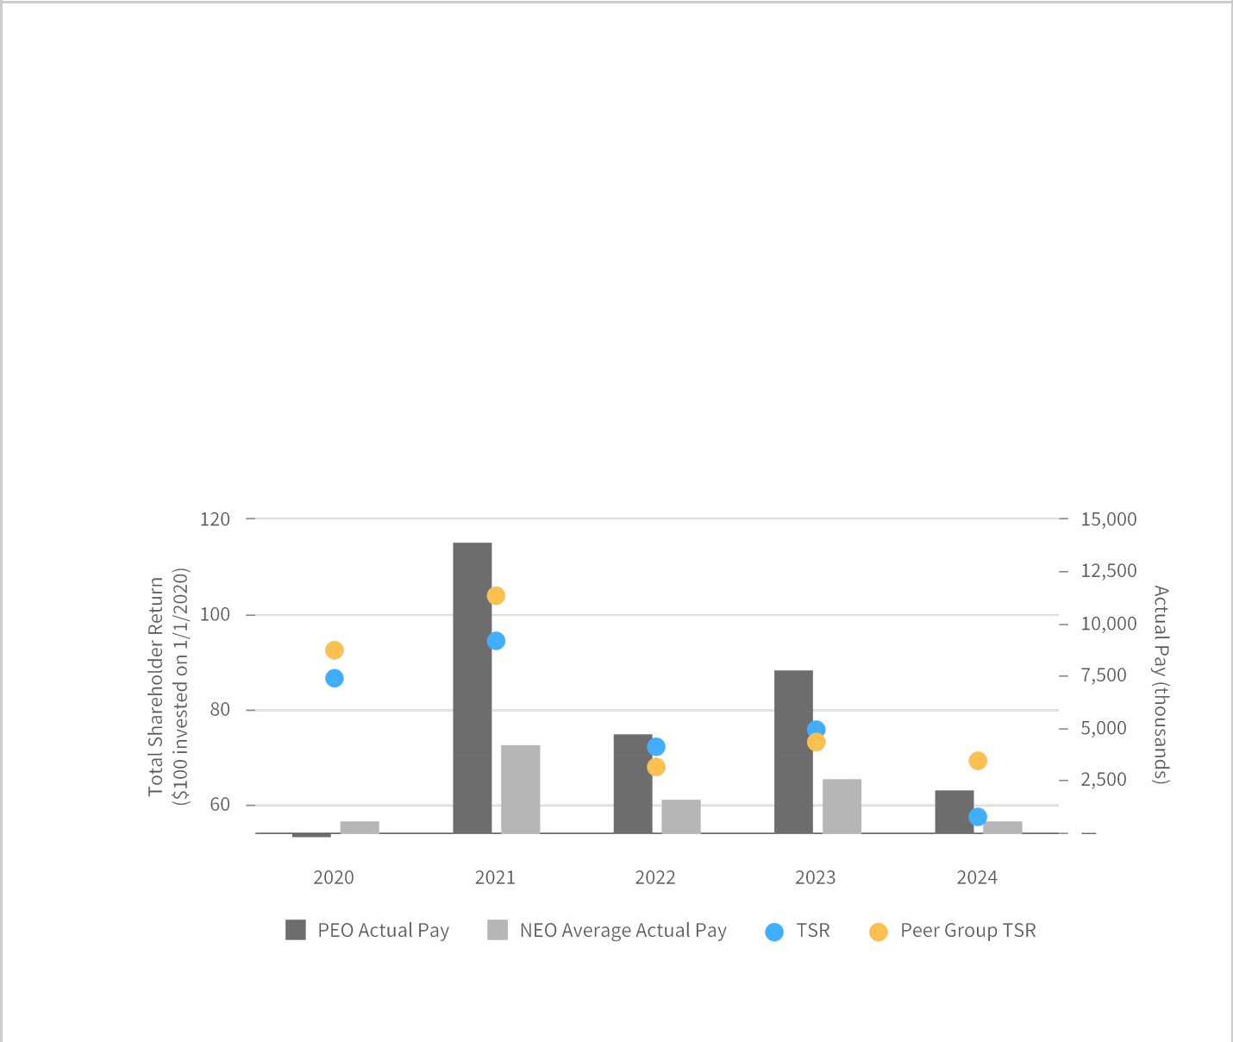

Net Sales and Operating Cash Flow are calculated in accordance with generally accepted accounting principles. As noted above, management defines and calculates Adjusted Operating Income as Operating Income as calculated under generally accepted accounting principles, excluding infrequent or extraordinary items, and management defines Adjusted Diluted EPS as Diluted EPS as calculated under generally accepted accounting principles, excluding infrequent or extraordinary items.

PAY VERSUS PERFORMANCE DESCRIPTIVE DISCLOSURE

Actual compensation paid ultimately depends on 1) the ability to meet the specific Company targets (net sales, adjusted operating income, adjusted diluted EPS, and operating cash flow) and/or the progress in meeting the specific Company targets and 2) the performance of the Company’s stock price.

The following graph summarizes the relationship between Total Shareholder Return (“TSR”) and executive compensation actually paid to the CEO and the Non-CEO NEOs and the relationship between the TSR of the Company and its peer group over the last four completed years:

The following graph summarizes the relationship between the adjusted operating income and net

income performance measures included in the table and the executive compensation actually paid to the CEO and the Non-CEO NEOs over the last four completed years:

67
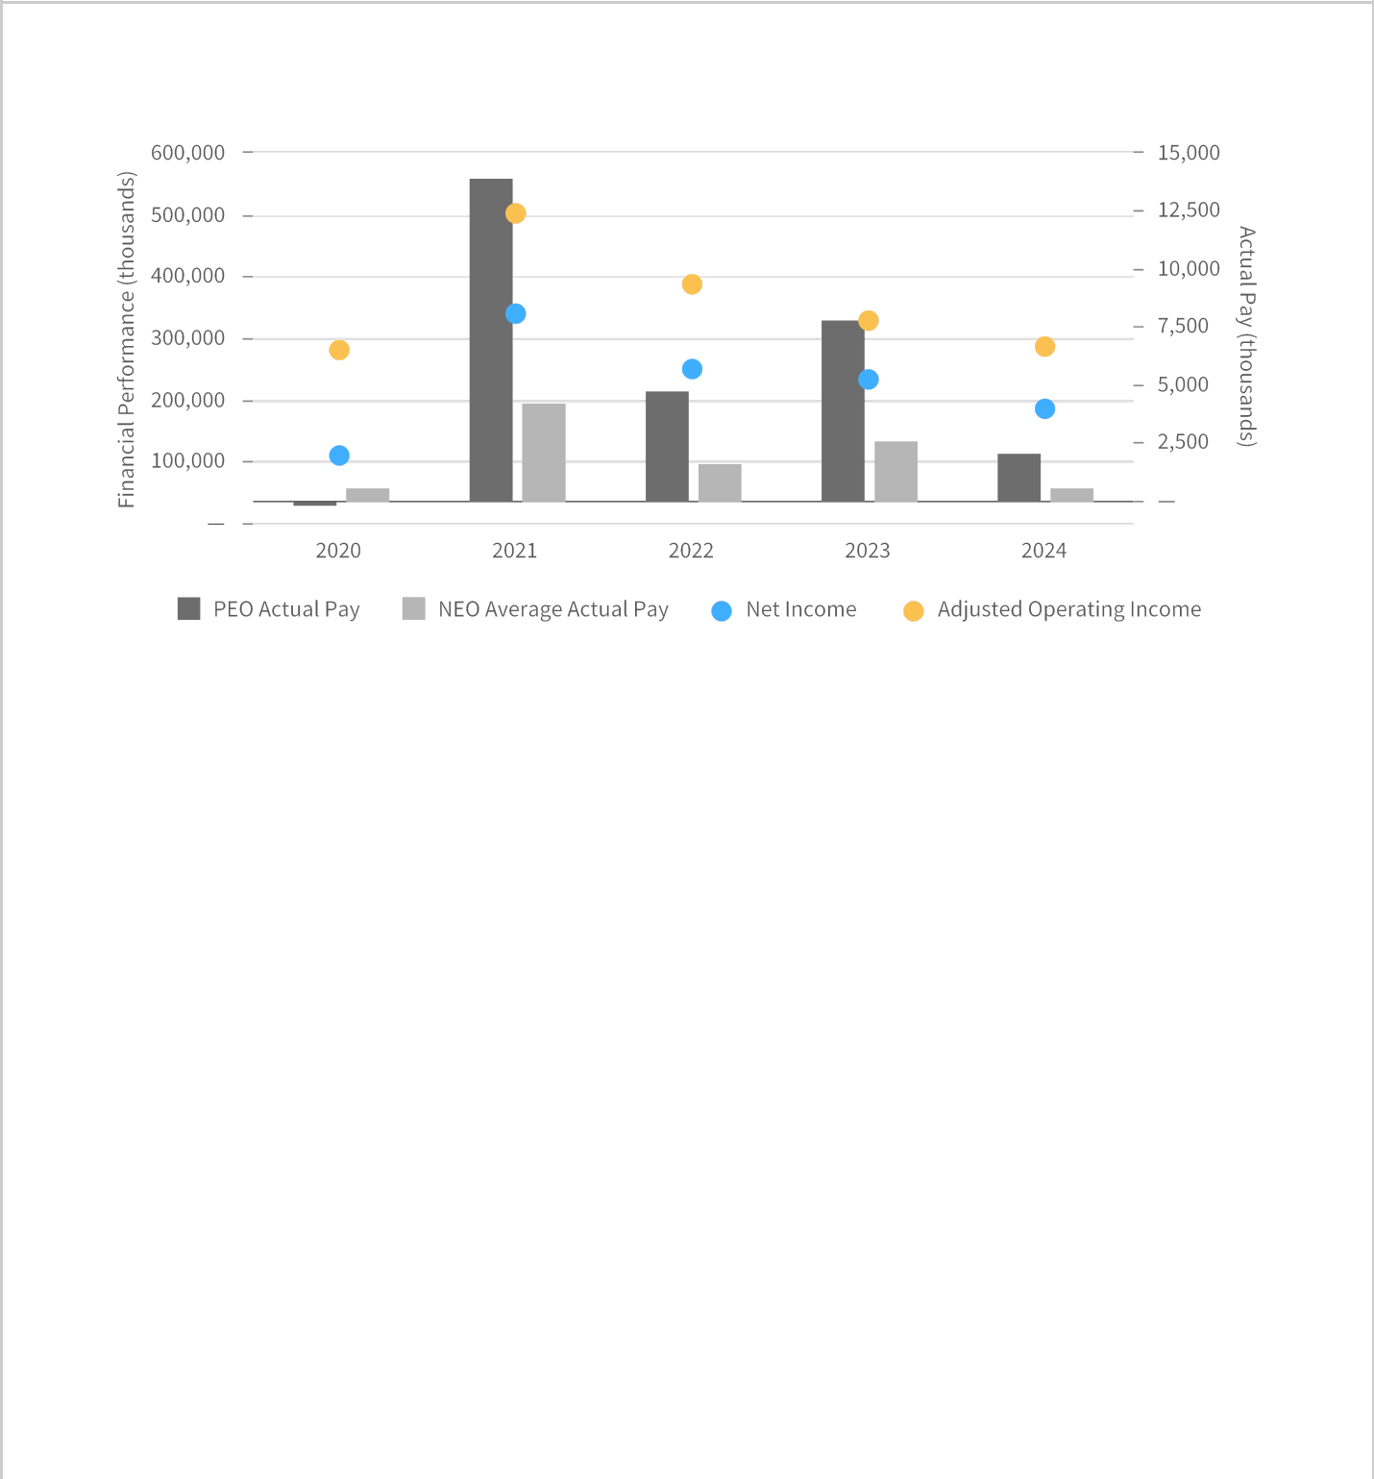

68

TRANSACTIONS WITH RELATED PERSONS, PROMOTERS, AN CERTAIN CONTROL PERSONS

The Company has a written policy that requires all transactions with related persons required to be disclosed under Item 404(a) of Regulation S-K, promulgated under the Exchange Act, to be reviewed by our Chief Financial Officer and General Counsel (or their designees) with our Audit Committee and approved by our Audit Committee. There were no such transactions during fiscal 2024.

The Company considers the following to be related parties: any director or executive officer of the Company; any nominee for election as a director; any security holder who is known to the Company to own more than five percent of any class of the Company’s voting securities; and any member of the immediate family of any of the parties listed above including such party’s spouse, parents, children, siblings, mothers and fathers-in-law, sons and daughters-in-law, and brothers and sisters-in-law.

69

SECURITIES OWNERSHIP OF CERTAIN BENEFICIAL OWNERS, DIRECTORS, AND EXECUTIVE OFFICERS

The following table sets forth the number of shares of Carter’s common stock owned by each of the following parties as of the record date ofMarch 20, 2025, or as of such other date as indicated: (a) each person known by Carter’s to own beneficially more than five percent of the outstanding common stock;

- our NEOs; (c) each director; and (d) all directors and executive officers as a group. Unless otherwise indicated below, the holder’s address is 3438 Peachtree Road NE, Suite 1800, Atlanta, Georgia 30326.

Name of Beneficial Owner | Shares | Percent
BlackRock, Inc. (1) | 4,442,539 | 12.3%
The Vanguard Group, Inc. (2) | 3,652,006 | 10.1%
JPMorgan Chase & Co. (3) | 2,838,591 | 7.8%
First Trust Portfolios L.P. (4) | 1,952,194 | 5.4%
Michael D. Casey (5) | 529,859 | 1.5%
Kendra D. Krugman (5) | 100,861 | *
Brian J. Lynch (5) | 16,880 | *
Douglas C. Palladini (6) | * | *
Allison M. Peterson (5) | 55,280 | *
Raghu R. Sagi (5) | 29,844 | *
Richard F. Westenberger (5) | 162,157 | *
Rochester Anderson, Jr. (7) | 8,628 | *
Jeffrey H. Black (7) | 8,628 | *
Hali Borenstein | 12,519 | *
Luis Borgen | 8,996 | *
Jevin S. Eagle | 18,241 | *
Mark P. Hipp | 12,509 | *
William J. Montgoris | 45,203 | *
Stacey S. Rauch (7) | 8,628 | *
Gretchen W. Schar | 13,066 | *
Stephanie P. Stahl (7) | 8,628 | *
All directors, including nominees, and current executive officers as a | 733,405 | 2.0%
group (20 persons) (5)

- Indicates less than 1% of our common stock.

  - This information is based on Schedule 13G, filed with the SEC on January 8, 2025. BlackRock, Inc. has sole voting power covering 4,358,831shares and sole dispositive power covering4,442,539shares of our common stock. The address for BlackRock, Inc. is 50 Hudson Yards, New York, NY 10001.

  - This information is based on Schedule 13G/A filed with the SEC on June 10, 2024. The Vanguard Group, Inc. has sole dispositive power covering3,597,707shares of our common stock, shared voting power covering12,591shares of our common stock, and shared dispositive power covering54,299shares of our common stock. The address for The Vanguard Group, Inc. is 100 Vanguard Boulevard, Malvern, PA 19355.

  - This information is based on Schedule 13G/A, filed with the SEC on February 11, 2025. JPMorgan Chase & Co. has sole voting power covering 2,762,903shares and sole dispositive power covering2,838,327shares of our common stock. The address for JPMorgan Chase & Co. is 383 Madison Avenue, New York, NY 10179.

  - This information is based on a joint Schedule 13G, filed with the SEC on January 31, 2025. First Trust Portfolios L.P. has shared dispositive power covering5,211 shares of our common stock.First Trust Advisors L.P. has sharedvoting power covering1,964,195 shares and shared dispositive power covering1,952,194shares of our common stock. The Charger Corporationhas sharedvoting power covering1,964,195shares and shared dispositive power covering1,952,194shares of our common stock. The address for First

Trust Portfolios L.P., First Trust Advisors L.P., and The Charger Corporation is 120 East Liberty Drive, Suite 400, Wheaton, Illinois 60187.

70

- This amount includes the (a) number of shares subject to exercisable stock options, including stock options that will become exercisable during the 60 days after March 20,2025, and (b) shares of unvested restricted stock and unvested performance-based restricted stock. See the detail for each NEO and all current executive officers as a group below.

Owned & Unvested

Vested Restricted Performance-

Name | Common | Exercisable Stock | Common | Based Restricted
Name | Stock | Options | Stock | Stock
Richard F. Westenberger | 70,130 | 17,268 | 55,139 | 19,620
Kendra D. Krugman | 24,684 | 13,028 | 48,593 | 14,556
Allison M. Peterson | — | — | 55,280 | —
Raghu R. Sagi | — | — | 29,844 | —
Michael D. Casey | 283,547 | 162,768 | — | 83,544
Brian J. Lynch | — | — | — | 16,880
All current executive officers as a group | 378,361 | 193,064 | 188,856 | 134,600


- After the record date, on April 3, 2025, Mr. Palladini received a $7,000,000 sign-on equity grant, with 50% of the grant in the form of time-based restricted stock and 50% in the form of performance-based restricted stock. For additional information, see the section “Compensation Discussion and Analysis - Appointment of Chief Executive Officer & President”.

- Each of Messrs. Anderson and Black and Mses. Rauch and Stahl (who each1,975holdshares of restricted stock) are the only independent directors who hold restricted stock.

71

DELINQUENT SECTION 16 REPORTS

Section 16(a) of the Securities Exchange Act requires that the Company’s executive officers and directors, and persons who beneficially own more than ten percent (10%) of the Company’s common stock, file initial reports of ownership and changes in ownership with the SEC. Based on a review of the copies of such forms furnished to the Company with respect to fiscal2024, the Company believes that all forms

were filed in a timely manner during fiscal2024, with the exception ofone (1) Form 4 filed on March 22, 2024 reporting the sales of shares by Mark P. Hipp on March 6, 2024.

72

PROPOSAL NUMBER TWO

ADVISORY VOTE ON APPROVAL OF EXECUTIVE COMPENSATION

The Compensation Discussion and Analysis section of this proxy statement beginning on page34 describes Carter’s executive compensation program and the compensation decisions that the Compensation and Human Capital Committee and Board of Directors made in fiscal 2024 with respect to the compensation of Carter’s NEOs.

Carter's is committed to achieving long-term, sustainable growth and increasing shareholder value. Carter’s compensation program for its NEOs is designed to support these objectives and encourage strong financial performance on an annual and long-term basis by linking a significant portion of the NEOs’ total direct compensation to Carter's performance in the form of incentive compensation.

The Board of Directors is asking shareholders to cast a non-binding, advisory FORvotethe following resolution:

“RESOLVED, that the compensation paid to Carter’s NEOs, as disclosed in Carter’s Proxy Statement for the2025 Annual Meeting of Shareholders, including the Compensation Discussion & Analysis, compensation tables and narrative discussion, is hereby APPROVED.”

This proposal is commonly referred to as the “say-on-pay” vote and is required pursuant to Section 14A of the Exchange Act. This vote is not intended to address any specific item of compensation, but rather the overall compensation of our NEOs and the policies and practices described in this proxy statement. Although the vote we are asking you to cast is non-binding, the Compensation & Human Capital Committee and the Board value the views of our shareholders and intend to consider the outcome of the vote when determining future compensation arrangements for our NEOs.

The Board recommends a voteFORthe
approval of compensation of Carter’s
NEOs as disclosed in this proxy
statement.

VOTE REQUIRED

Because this Proposal Number Two asks for a non-binding, advisory vote, there is no required vote that would constitute approval. We value the opinions expressed by our shareholders in this advisory vote, and our Compensation & Human Capital Committee will consider the outcome of the vote when designing our compensation programs and making future compensation decisions for our NEOs. Abstentions and broker non-votes, if any, will not have any impact on this advisory vote.

73

AUDIT COMMITTEE REPORT

The Audit Committee reviews the Company’s accounting, auditing, and financial reporting process on behalf of the Board. The Audit Committee’s charter is available in the investor relations section of our website at ir.carters.com. Management has the primary responsibility for establishing and maintaining adequate internal financial controls, for preparing the financial statements, and for the public reporting process. PricewaterhouseCoopers LLP (“PwC”), the Company’s independent registered public accounting firm, is responsible for expressing opinions on the conformity of the Company’s audited consolidated financial statements with accounting principles generally accepted in the United States and on the effectiveness of the Company’s internal control over financial reporting.

In fulfilling its oversight responsibilities, the Audit Committee reviewed and discussed the Company’s audited financial statements for the year ended December 28, 2024 with management, including a discussion of the quality of financial reporting, the reasonableness of significant judgments, and the clarity of disclosures in the financial statements. The Audit Committee also discussed with PwC the matters required to be discussed by Auditing Standard No. 1301, as adopted by the Public Company Accounting Oversight Board, relating to communication with audit committees.

In addition, the Audit Committee received the written disclosures and the letter from the independent registered public accounting firm required by the applicable requirements of the Public Company Accounting Oversight Board regarding the independent registered public accounting firm’s communications with the Audit Committee concerning independence and discussed with PwC its independence from the Company and the Company’s management.

Based on the reviews and discussions described in the preceding paragraphs, the Audit Committee recommended to the Board that the audited financial statements of the Company be included in the Annual Report on Form 10-K for filing with the SEC.

Submitted by the Audit Committee

Ms. Gretchen W. Schar, Chairperson
Mr. Jeffrey H. Black
Mr. Luis Borgen
Mr. Mark P. Hipp

Ms. Stacey S. Rauch

The Audit Committee Report does not constitute soliciting material and shall not be deemed to be filed or incorporated by reference into any other filing under the Securities Act of 1933, as amended, or the Exchange Act, except to the extent that we specifically incorporate the Audit Committee Report by

reference therein.

74

PROPOSAL NUMBER THREE

RATIFICATION OF INDEPENDENT REGISTERED PUBLIC ACCOUNTING FIRM

The Audit Committee of the Board has appointed PwC to serve as Carter’s independent registered public accounting firm for fiscal2025. The Board is submitting the appointment of PwC as Carter’s independent registered public accounting firm for shareholder ratification and recommends that shareholders ratify this appointment. The Board recommends that shareholders ratify this appointment at the Annual Meeting. Shareholder ratification of the appointment of PwC is not required by law or otherwise. The Board is submitting this matter to shareholders for ratification because the Board believes it to be a good corporate governance practice. If the shareholders do not ratify the appointment, the Audit Committee may reconsider whether or not to retain PwC. Even if the appointment is ratified, the Audit Committee may appoint a different independent registered public accounting firm at any time during the year if, in its discretion, it determines that such a change would be in Carter’s best interest and that of Carter’s shareholders. A representative of PwC is expected to virtually attend the Annual Meeting, and he or she will have the opportunity to make a statement and will be available to respond to appropriate questions. For additional information regarding Carter’s relationship with PwC, please refer to the Audit Committee Report above.

The Audit Committee has also adopted policies and procedures for pre-approving all non-audit work performed by PwC. The Audit Committee has pre-approved the use, as needed, of PwC for specific types of services that fall within categories of non-audit services, including various tax services. The Audit Committee receives regular updates as to the fees associated with the services that are subject to pre-approval. Services that do not fall within a pre-approved category require specific consideration and pre-approval by the Audit Committee. All services rendered by PwC in the table below were pre-approved by the Audit Committee.

The aggregate fees that Carter's incurred for professional services rendered by PwC for fiscal2024years and 2023 were as follows:

 |  | 2024 |  | 2023
Audit Fees | $ | 2,331,100 | $ | 2,079,000
Tax Fees |  | 155,000 |  | —
All Other Fees |  | 2,000 |  | 4,500
Total Fees | $ | 2,488,100 | $ | 2,083,500

- Audit Feesfor fiscal years2024 and 2023 were for professional services rendered for the integrated audit of the consolidated financial statements and internal control over financial reporting of Carter's, other auditing procedures related to goodwill and intangible asset impairment testing, and related out-of-pocket expenses.

- Tax Feesfor fiscal year 2024 were for tax compliance services. There were no tax fees for fiscal 2023.

- All Other Feesfor fiscal years2024 and 2023 consisted of software license fees.

75

The Board recommends a voteFORthe ratification of the appointment of PricewaterhouseCoopers LLP as the Company’s independent registered public accounting firm

for fiscal2025.

VOTE REQUIRED

The approval of Proposal Number Three requires the affirmative vote of a majority of the votes properly cast at our Annual Meeting. Abstentions will not affect the outcome of this proposal. A broker or other nominee will generally have discretionary authority to vote on this proposal because it is considered a routine matter, and, therefore, we do not expect broker non-votes with respect to this proposal.

76

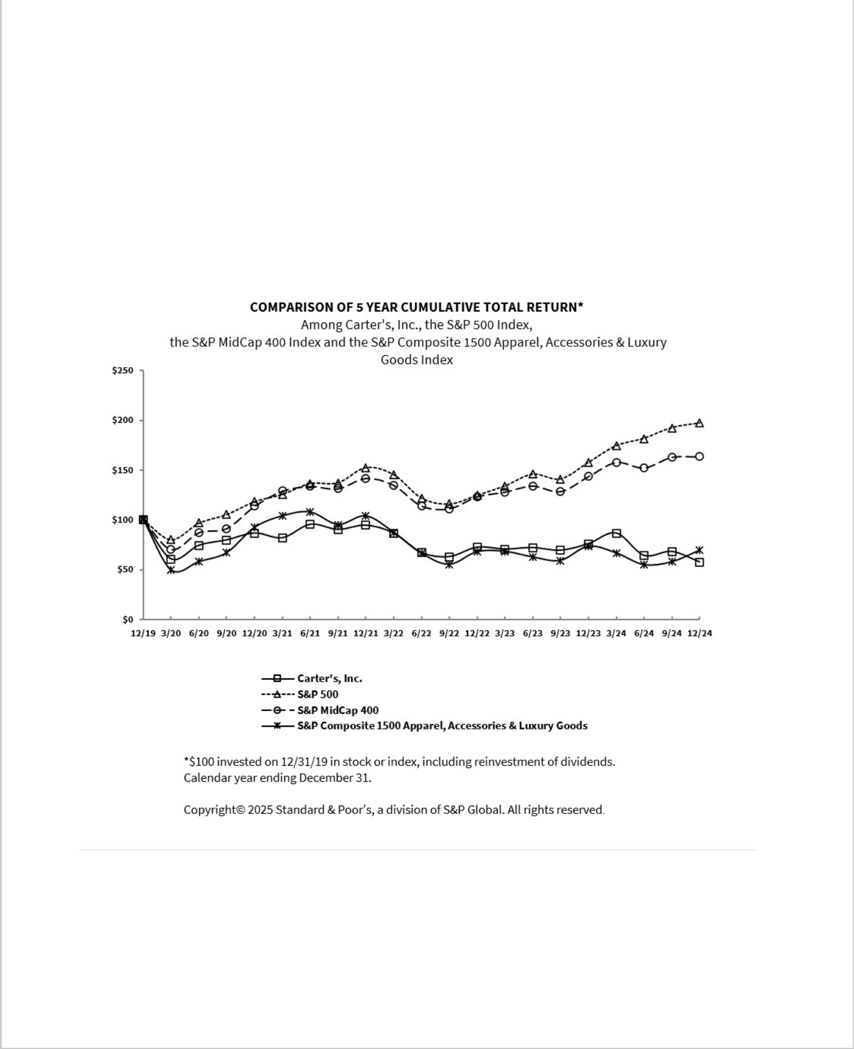
OTHER MATTERS

As of the date of this proxy statement, we know of no business that will be presented for consideration at the Annual Meeting, other than the items referred to above. If any other matter is properly brought before the Annual Meeting for action by shareholders, proxies in the enclosed form returned to Carter's will be voted in accordance with the recommendation of the Board or, in the absence of such a recommendation, in accordance with the judgment of the proxy holder.

* * *

The following performance graph and return to shareholders information shown below are provided pursuant to Item 201(e) of Regulation S-K promulgated under the Exchange Act. The graph and information are not deemed to be “filed” under the Exchange Act or otherwise subject to liabilities thereunder, nor are they to be deemed to be incorporated by reference in any filing under the Securities Act or Exchange Act unless we specifically incorporate them by reference.

77

QUESTIONS AND ANSWERS ABOUT THE 2025 ANNUAL MEETING

1. WHY AM I RECEIVING THIS PROXY STATEMENT?

The Board of Directors (the “Board”) of Carter’s, Inc. (“we,” “us,” “our,” “Carter’s,” or the “Company”) is soliciting proxies for our virtual2025 Annual Meeting of Shareholders onMay 15, 2025, at 1:00 p.m. Eastern Time (the “Annual Meeting”). This proxy statement and accompanying proxy card are being mailed on or about April 4, 2025, to shareholders of record asMarchof 20, 2025, the record date (the

“Record Date”) for the Annual Meeting.


You are receiving this proxy statement because you owned shares of Carter’s common stock on the Record Date and are therefore entitled to vote at the Annual Meeting. By use of a proxy, you can vote regardless of whether or not you attend the Annual Meeting. This proxy statement provides information on the matters on which the Board would like you to vote so that you can make an informed decision.

2. WHAT IS THE PURPOSE OF THE ANNUAL MEETING?

The purpose of the Annual Meeting is to address the following business matters:

  - Election of the 11 nominated directors (see page26);

  - Advisory approval of the compensation for our named executive officers2024for (“NEOs”) (the “say-on-pay” vote) (see page73);

  - Ratification of the appointment of PricewaterhouseCoopers LLP (“PwC”) as Carter’s independent registered public accounting firm for fiscal2025 (see page75); and

  - All other business that may properly come before the meeting.

- WHO IS ASKING FOR MY VOTE?

Carter's is soliciting your proxy on behalf of the Board and is paying for the costs of this solicitation and
proxy statement. Okapi Partners LLC has been retained by the Company to assist in the solicitation of proxies for a base fee not to exceed $12,500, (with select additional campaign services to be provided if
requested at an additional fee), plus reimbursement for out-of-pocket expenses, to be borne by the Company.

4. WHO CAN ATTEND THE ANNUAL MEETING?

All shareholders of record, or their duly appointed proxies, may attend the virtual Annual Meeting. Beneficial holders who hold shares “in street name” may also be admitted to the virtual Annual Meeting, provided they obtain the appropriate control number from their broker or other nominee in order to access the virtual meeting. As of the Record Date, there were36,237,114shares of common stock issued and outstanding.

In order to attend the Annual Meeting, you must register at www.proxydocs.com/CRI. Upon completing your registration, you will receive further instructions via email, including a unique link that will allow you access to the Annual Meeting and the ability to vote and submit questions during the Annual Meeting.

As part of the registration process, you must enter the control number located on your proxy card or voting instruction form. If you are a beneficial owner of shares registered in the name of a broker, bank or other nominee, you will also need to provide the registered name on your account and the name of your broker, bank or other nominee as part of the registration process.

On the day of the Annual Meeting,May 15, 2025, shareholders may begin to login to the virtual Annual Meeting fifteen minutes prior to the meeting, which will begin promptly at 1:00 p.m. Eastern Time.

78

5. HOW WILL THE VIRTUAL MEETING WORK?

We have designed the format of the Annual Meeting to provide our shareholders with the same rights and opportunities to participate as they would have at an in-person meeting.

During the Annual Meeting, we will hold a question and answer session during which we intend to answer questions submitted during the meeting that are pertinent to Carter's, as time permits, and in accordance with our Rules and Procedures for Conduct of the Annual Meeting. On the day of and during the Annual Meeting, you can view our Rules and Procedures for Conduct of the Annual Meeting and submit any questions on the virtual meeting platform by using your unique link included in the email that you will receive one hour prior to the start of the Annual Meeting. Answers to any questions not addressed during the meeting will be posted following the meeting on the Investor Relations page of our website at ir.carters.com. Questions and answers will be grouped by topic, and substantially similar questions will be answered only once. To promote fairness, efficiently use Carter’s resources, and ensure all shareholder questions are able to be addressed, we will respond to no more than three questions from any single shareholder.

Prior to and during the Annual Meeting, we will have support available to assist shareholders with any technical difficulties they may have accessing or hearing the virtual meeting. The technical support telephone number will be included in the access email you will receive one hour prior to the start of the Annual Meeting.

6. WHAT ARE MY VOTING RIGHTS?

Each share of common stock is entitled to one vote on each matter submitted to shareholders at the Annual Meeting.

- WHAT IS THE DIFFERENCE BETWEEN HOLDING SHARES AS A SHAREHOLDER OF RECORD AND AS BENEFICIAL OWNER “IN STREET NAME”?

If your shares are registered directly in your name with the Company’s transfer agent, Equiniti Trust Company, you are considered the shareholder of record for these shares. As the shareholder of record, you have the right to grant your voting proxy directly to the person(s) listed on your proxy card or vote in person (virtually) at the Annual Meeting.

If your shares are held in a brokerage account or through another nominee, such as a trustee, you are considered the beneficial owner of shares held “in street name.” These proxy materials are being forwarded to you together with a voting instruction card. As a beneficial owner, you have the right to direct your broker or other nominee how to vote, and you are also invited to attend the Annual Meeting. Because you are a beneficial owner and not the shareholder of record, you may not vote your shares in
person (virtually) at the Annual Meetinunlessg you obtain a proxy from the broker or other nominee

that holds your shares. Your broker or other nominee should have provided directions for you to instruct the broker or nominee on how to vote your shares.

8. WHAT IS A BROKER NON-VOTE?

If you are a beneficial owner whose shares are held “in street name” and you do not provide voting instructions to your broker, your shares will not be voted on any proposal as to which the broker does not have discretionary authority to vote. This is called a “broker non-vote.” Your brokeronly has discretionary authority to vote on Proposal Number Three. Therefore, your broker will not have discretion to vote on any other proposalunless you specifically instruct your broker how to vote your shares by returning your completed and signed voting instruction card.

79

9. WHAT CONSTITUTES A QUORUM?

A quorum is the minimum number of shares required to be present to transact business at the Annual Meeting. Pursuant to Carter’s Bylaws, the presence at the Annual Meeting, in person (not available at this virtual Annual Meeting), by proxy, or by remote communication of the holders of at least a majority of the shares issued and outstanding and entitled to vote at the Annual Meeting will constitute a quorum. Broker non-votes and abstentions will be counted as shares that are present at the meeting for purposes of determining a quorum. If a quorum is not present, the meeting will be adjourned until a quorum is obtained.

- WHAT ARE MY CHOICES WHEN CASTING A VOTE WITH RESPECT TO THE ELECTION OF T ELEVEN NOMINATED DIRECTORS, AND WHAT VOTE IS NEEDED TO ELECT THE DIRECTOR NOMINEES?

In voting on the election of the director nominees (“Proposal Number One”), shareholders may:

- vote for any of the nominees;

- vote against any of the nominees; or

- abstain from voting on any of the nominees.

Pursuant to our Bylaws, a nominee will be elected if the number of votes properly cast “for” such director nominee exceed the number of votes cast “against” that nominee. Any nominee not receiving such majority, who is then serving as a director, must tender his or her resignation for consideration by the Board. Any nominee appointed to the Board, subject to shareholder approval, will not have been elected as a director at the Annual Meeting. Abstentions and broker non-votes will not have any impact on the outcome of this vote.

- WHAT ARE MY CHOICES WHEN CASTING AN ADVISORY VOTE ON APPROVAL OF COMPENSATION OF CARTER’S NEOS, COMMONLY REFERRED TO AS THE “SAY-ON-PAY” VOT AND WHAT VOTE IS NEEDED TO APPROVE THIS PROPOSAL?

In voting on the compensation of Carter’s NEOs (“Proposal Number Two”), shareholders may:

- vote for the approval of compensation of Carter’s NEOs, on an advisory basis, as described in this proxy statement;

- vote against the approval of compensation of Carter’s NEOs, on an advisory basis, as described in this proxy statement; or

- abstain from voting on compensation of Carter’s NEOs, on an advisory basis, as described in this proxy statement.

Because Proposal Number Two asks for a non-binding, advisory vote, there is no required vote that would constitute approval. We value the opinions expressed by our shareholders in this advisory vote, and our Compensation & Human Capital Committee will consider the outcome of the vote when evaluating our compensation programs and making future compensation decisions for our NEOs. Abstentions and broker non-votes, if any, will not have any effect on this advisory vote.

- WHAT ARE MY CHOICES WHEN VOTING ON THE RATIFICATION OF THE APPOINTMENT OF PWC AS THE COMPANY’S INDEPENDENT REGISTERED PUBLIC ACCOUNTING FIRM FOR FISC 2025, AND WHAT VOTE IS NEEDED TO APPROVE THIS PROPOSAL?

In voting on the ratification of PwC (“Proposal Number Three”), shareholders may:

  - vote to ratify PwC’s appointment;

  - vote against ratifying PwC’s appointment; or

- abstain from voting on ratifying PwC’s appointment.

80

The approval of Proposal Number Three requires the affirmative vote of a majority of the votes properly cast at our Annual Meeting. Abstentions are not considered votes cast and thus will not affect the outcome of this proposal. A broker or other nominee will generally have discretionary authority to vote on this proposal because it is considered a routine matter, and, therefore, we do not expect broker non-votes with respect to this proposal.

- HOW DOES THE BOARD RECOMMEND THAT I VOTE?

The Board recommends a vote:

FORthe election of the 11 nominated directors (Proposal Number One);

FORthe approval of the compensation of Carter’s NEOs, on an advisory basis, as described in this proxy statement (Proposal Number Two); and

FORthe ratification of the appointment of PwC (Proposal Number Three).

14. HOW DO I VOTE?

You may hold Company shares in multiple accounts and therefore receive more than one set of the proxy materials. To ensure that all of your shares are voted, please submit your proxy or voting instructions for each account for which you have received a set of the proxy materials.

Shares Held of RecordIf.you hold your shares in your own name as a holder of record with our transfer agent, Equiniti Trust Company, you may authorize that your shares be voted at the Annual Meeting in one of the following ways:

By Internet

If you received a printed copy of the proxy materials, follow the instructions on the proxy card.

By Telephone

If you received a printed copy of the proxy materials, follow the instructions on the proxy card.

By Mail

If you received a printed copy of the proxy materials, complete, sign, date, and mail your proxy card in the enclosed, postage-prepaid envelope.

In Person (Virtual) You may also vote by attending the meeting virtually through www.proxydocs.com/CRI. To attend the Annual Meeting and vote your shares, you must register for the Annual Meeting and provide the control number located on your proxy card.

Shares Held in Street NameIfyou. hold your shares through a broker, bank or other nominee (that is, in street name), you will receive instructions from your broker, bank or nominee that you must follow in order to submit your voting instructions and have your shares voted at the Annual Meeting. If you want

to_{instructed}votein person_{toobtain}(virtually),_{alegalpr}y_{o}u_{xy}must_{from}register_{yourbroker,}inadvance_{bankor}at_{other}www._{nominee}proxydocs_{and}.com/CRI_{tosubmit}.You_{a cop}ma_{y} be_{in} advance of the meeting. Further instructions will be provided to you as part of your registration process.
Even if you plan to attend the Annual Meeting, we recommend that you submit your proxy or voting instructions in advance of the meeting as described above so that your vote will be counted if you later decide not to attend or are unable to attend.

81

15. CAN I CHANGE MY VOTE AFTER I RETURN MY PROXY CARD?

Yes. If you are a shareholder of record, you may revoke your proxy at any time before it is exercised in any of the following three methods:

- by submitting written notice of revocation to Mr. Robinson at Carter’s address set forth in2025the Notice of Annual Meeting;

- by submitting another proxy by telephone, over the Internet, or by mail that is later dated and, if by mail, that is properly signed; or

- by voting at the virtual Annual Meeting.

If you hold your shares through a broker or other nominee and would like to change your voting instructions, please review the directions provided to you by that broker or nominee.

16. MAY I VOTE CONFIDENTIALLY?

Yes. Our policy is to keep your individual votes confidential, except as appropriate to meet legal requirements, to allow for the tabulation and certification of votes, or to facilitate proxy solicitation.

17. WHO WILL COUNT THE VOTES?

A representative of Mediant, Inc. will count the votes and act as the inspector of election for the Annual Meeting.

18. WHAT HAPPENS IF ADDITIONAL MATTERS ARE PRESENTED AT THE ANNUAL MEETING?

As of the date of this proxy statement, the Board knows of no matters other than those set forth herein that will be presented for determination at the Annual Meeting. If, however, any other matters properly come before the Annual Meeting and call for a vote of shareholders, the Board intends proxies to be voted in accordance with the judgment of the proxy holders.

19. WHERE CAN I FIND THE VOTING RESULTS OF THE ANNUAL MEETING?

We intend to announce preliminary voting results at the Annual Meeting and publish final results in our current report on Form 8-K within four business days after the Annual Meeting.

20. WHAT IS “HOUSEHOLDING” OF THE ANNUAL MEETING MATERIALS?

The SEC has adopted rules that permit companies and intermediaries, such as brokers, to satisfy delivery requirements for proxy statements with respect to two or more shareholders sharing the same address, by delivering a single proxy statement to those shareholders. This process, which is commonly referred to as “householding,” potentially provides extra convenience for shareholders and cost savings for companies. Carter's and some brokers “household” proxy materials, delivering a single proxy statement and annual report to multiple shareholders sharing an address unless contrary instructions have been received from the affected shareholders. If, at any time, you no longer wish to participate in householding and would prefer to receive a separate proxy statement and annual report, or if you are receiving multiple copies of the proxy statement and annual report and wish to receive only one, please notify your broker if your shares are held in a brokerage account, or Carter's if you hold shares registered directly in your name. You can notify Carter's by sending a written request to Mr. Robinson at Carter’s address set forth in the2025 Notice of Annual Meeting or by calling us at (678) 791-1000.

21. HOW MAY I OBTAIN A COPY OF CARTER’S ANNUAL REPORT?

A copy of our fiscal 2024 Annual Report on Form 10-K (the “Annual Report”) accompanies this proxy statement and is available at https://ir.carters.com/financial-information/annual-reports. Shareholders may also obtain a free copy of our Annual Report by sending a request in writing to Mr. Robinson at Carter’s address at 3438 Peachtree Road NE, Suite 1800, Atlanta, Georgia 30326, or by calling us at (678) 791-1000.

82

- HOW DO I SUBMIT A PROPOSAL OR NOMINATE A DIRECTOR CANDIDATE FOR THE 2026 ANNUAL MEETING?

Any shareholder proposals or director nominations must be submitted in writing to our Secretary c/o Carter's, Inc., 3438 Peachtree Road NE, Atlanta, Georgia 30326. Additional details for those submissions are as follows.

Shareholder Proposals

This section relates to shareholder proposals for the 2026 Annual Meeting other than director nominations. If you wish to nominate a director candidate, please see the section that follows under the heading “Nomination of Director Candidates”. The deadlines and requirements for submitting a shareholder proposal depend on whether the shareholder seeks to have the proposal included in the 2026 Proxy Statement using Rule 14a-8 under the Exchange Act:

- Proposals of Business Not Using Rule 14a:Under-8 our Bylaws, if a shareholder wants to propose an item of business to be considered at the 2026 Annual Meeting, the shareholder must give advance written notice to our Secretary, which must be received no earlier than the close of business on January 14, 2026, and no later than the close of business on February 13, 2026. If, however, our 2026 Annual Meeting is held more than 30 days before or after May 14, 2026 (the one-year anniversary of our 2025 Annual Meeting), the notice must be received no earlier than the close of business on the 120th day before such annual meeting and no later than the close of business on the later of (1) the 90th day before such annual meeting or (2) the tenth day following the date on which the public announcement of the date of such meeting is first made by Carter's. The advance written notice must comply with all applicable statutes and regulations, as well as certain other provisions contained in our Bylaws, which generally require the shareholder to provide a brief description of the proposed business, reasons for proposing the business, and certain information about the shareholder and Carter's securities held by the shareholder.

- Proposals of Business Using Rule 14a:A-8shareholder who wants to propose an item of business to be included in our 2026 Proxy Statement using Rule 14a-8 must follow the procedures provided in Rule 14a-8. In addition, the proposal must be received by our Secretary by December 3, 2025.

Nomination of Director Candidates

This section relates to nomination of director candidates. The deadlines and requirements for director candidates recommended for consideration or nominated by a shareholder are as follows:

- Recommending a Candidate for Nominating & Corporate Governance Committee Consideration: Any shareholder who wishes to recommend a candidate for our Nominating & Corporate Governance committee to consider nominating as a director at the 2026 Annual Meeting should submit a written request and related information to our Secretary no later than December 31, 2025, in order to allow for sufficient time to consider the recommendation.

- Directly Nominating a Director Candidate Under our Bylaws:Under our Bylaws, if a shareholder plans to directly nominate a person as a director at the 2026 Annual Meeting, the shareholder must give advance written notice of the director nomination to our Secretary, which must be received no earlier than the close of business on January 14, 2026, and no later than the close of business on February 13, 2026. If, however, our 2026 Annual Meeting is held more than 30

83

days before or after May 14, 2026 (the one-year anniversary of our 2025 Annual Meeting), the notice must be received no earlier than the close of business on the 120th day before such annual

meeting and no later than the close of business on the later of (1) the 90th day before such annual meeting or (2) the tenth day following the date on which the public announcement of the
date of such meeting is first made by Carter's. The notice must comply with all applicable statutes and regulations, as well as certain other provisions contained in our Bylaws, which generally require the shareholder to provide certain information about the proposed nominee, the shareholder, and Carter's securities held by the shareholder, the nominee, and associated persons. In addition to satisfying those advance notice and other requirements in our Bylaws within the window set forth above, any shareholder who intends to solicit proxies in support of director nominees other than the Board’s nominees must comply with the Universal Proxy Rules set forth in Rule 14a-19 under the Exchange Act.

23. WHAT DO YOU MEAN BY FISCAL YEARS IN THIS PROXY STATEMENT?

Our fiscal year ends on the Saturday, in December or January, nearest the last day of December, resulting in an additional week of results every five or six years. Fiscal 2024 (which ended on December 28, 2024), Fiscal 2023 (which ended on December 30, 2023), Fiscal 2022 (which ended on December 31, 2022), and Fiscal 2021 (which ended on January 1, 2022) contained 52 weeks. Fiscal 2025 (which will end on December 27, 2025) contains 53 weeks.

24. WHO CAN HELP ANSWER MY QUESTIONS?

If you have any questions about the Annual Meeting or how to submit or revoke your proxy, or to request an invitation to the Annual Meeting (which is being held virtually), contact Mr. Robinson at Carter’s address set forth in the2025 Notice of Annual Meeting or by calling us at (678) 791-1000.

84

APPENDIX

RECONCILIATION OF NON-GAAP FINANCIAL MEASURES TO GAAP MEASURES

We have provided non-GAAP adjusted operating income and diluted net income per common share measures, which exclude certain items presented below. We believe that this information provides a meaningful comparison of our results and affords investors a view of what management considers to be our core performance, and we also, from time to time, use some of these non-GAAP measures, such as adjusted operating income, as performance metrics in awards under our annual and long-term incentive compensation plans. These measures are not in accordance with, or an alternative to, generally accepted accounting principles in the U.S. (GAAP). The most comparable GAAP measures are operating income and diluted net income per common share, respectively. Adjusted operating income and diluted net income per common share should not be considered in isolation or as a substitute for analysis of our results as reported in accordance with GAAP. Other companies may calculate adjusted operating income and diluted net income per common share differently than we do, limiting the usefulness of the measure for comparisons with other companies.

Fiscal Year Ended

(*)

 |  |  | December 28, 2024 |  |  |  |  |  | December 30, 2023 |  |  |  |  |  | December 31, 2022 |  |  |  |  |  |  | January 1, 2022 |  |  |  |  |  | January 2 2021
 |  |  |  |  |  |  |  |  |  |  | Diluted |  |  |  |  |  |  | Diluted |  |  |  |  |  | Diluted |  |  |  |  |  | Diluted
 |  |  |  |  | Diluted |  |  |  |  |  | Net |  |  |  |  |  |  | Net |  |  |  |  |  |  | Net |  |  |  |  |  | Net
 |  |  |  |  | Net |  |  |  |  |  | Income |  |  |  |  |  |  | Income |  |  |  |  |  | Income |  |  |  |  |  | Income
(In millions, |  |  |  | Income per |  |  |  |  |  |  | per |  |  |  |  |  |  | per |  |  |  |  |  |  | per |  |  |  |  |  | per
except earnings Operating |  |  |  | Common |  |  |  | Operating |  | Common |  |  |  | Operating |  |  | Common |  |  |  | Operating |  |  | Common |  |  | Operating |  |  | Common
per share) |  |  | Income |  | Share |  |  |  | Income |  | Share |  |  |  | Income |  |  | Share |  |  |  | Income |  |  | Share |  |  | Income |  |  | Share
As reported
(GAAP) |  | $ | 254.7 | $ | 5.12 |  |  | $ | 323.4 | $ | 6.24 |  |  | $ | 379.2 |  | $ | 6.34 |  |  | $ | 497.1 |  | $ | 7.81 |  | $ | 189.9 |  | $ | 2.50
Organizational
restructuring ⁽¹⁾ |  |  | 1.8 |  | 0.04 |  |  |  | 4.4 |  | 0.09 |  |  |  | — |  |  | — |  |  |  | 2.4 |  |  | 0.04 |  |  | 16.6 |  |  | 0.29
Intangible asset
impairment ⁽²⁾ |  |  | 30.0 |  | 0.63 |  |  |  | — |  | — |  |  |  | 9.0 |  |  | 0.17 |  |  |  | — |  |  | — |  |  | 26.5 |  |  | 0.46
Partial pension
plan settlement
(3) |  |  | — |  | 0.02 |  |  |  | — |  | — |  |  |  | — |  |  | — |  |  |  | — |  |  | — |  |  | — |  |  | —
Legal
settlement ⁽⁴⁾ |  |  | — |  | — |  |  |  | — |  | (0.14) |  |  |  | — |  |  | — |  |  |  | — |  |  | — |  |  | — |  |  | —
Loss on
extinguishment
of debt ⁽⁵⁾ |  |  | — |  | — |  |  |  | — |  | — |  |  |  | — |  |  | 0.38 |  |  |  | — |  |  | — |  |  | — |  |  | —
COVID-19
expenses⁽⁵⁾ |  |  | — |  | — |  |  |  | — |  | — |  |  |  | — |  |  | — |  |  |  | 3.9 |  |  | 0.07 |  |  | 21.4 |  |  | 0.37
Retail store
operating
leases and
other long-lived
asset
impairments,
_{net} (7) |  |  | — |  | — |  |  |  | — |  | — |  |  |  | — |  |  | — |  |  |  | (2.6) |  |  | (0.05) |  |  | 7.6 |  |  | 0.13
Goodwill
impairment ⁽⁸⁾ |  |  | — |  | — |  |  |  | — |  | — |  |  |  | — |  |  | — |  |  |  | — |  |  | — |  |  | 17.7 |  |  | 0.40
As adjusted |  | $ | 286.6 | $ | 5.81 |  |  | $ | 327.8 | $ | 6.19 |  |  | $ | 388.2 |  | $ | 6.90 |  |  | $ | 500.8 |  | $ | 7.87 |  | $ | 279.8 |  | $ | 4.16
(
*) Fiscal year | 2020 included 53 weeks |  |  |  |  | , |  | compared to 52 weeks i |  |  |  | n | f | iscal 2024, |  | 2 | 023, 2022, |  | and 2021.


85

- Related to charges for organizational restructuring in fiscal 2024. Fiscal 2023 relates to charges for organizational restructuring and related corporate office lease amendment actions. Fiscal 2021 and 2020 amounts relate to certain lease exit, severance and related costs resulting from restructuring actions (not related to COVID-19).

- Related to a non-cash impairment charge on theOshKoshindefinite-lived tradename asset in fiscal 2024Fiscal. 202 write-down relates toSkip Hop tradename asset. Fiscal 2020 write-down relates to OshKosh and Skip Hop tradename assets.
- Related to a non-cash partial pension settlement charge in the fiscal in 2024.

- In fiscal 2023, a pre-tax adjustment of approximately $6.9 million ($5.3 million net of tax, or $0.14 per diluted share) was made related to a gain on a court-approved settlement in December 2023.

- In fiscal 2022, a pre-tax adjustment of approximately $19.9 million ($15.2 million net of tax, or $0.38 per diluted share) was made related to a loss on extinguishment of debt in fiscal 2022.

- Net expenses incurred due to the COVID-19 pandemic.

- Impairments include an immaterial gain on the remeasurement of retail store operating leases.

- Goodwill impairment charge recorded in the International segment.

Note: Results may not be additive due to rounding.

86





